The Hazard Analysis and Risk Assessment Part 3 of 3. Defining Crash Avoidance Requirements and Safety Goals
Overview: This section will show how to define and link each of the Vehicle Level Function’s (VLF’s) failure modes/fault states to each National Highway Transportation and Safety Administration (NHTSA) precrash scenario. The NHTSA patterns are all “after the fact” groupings of scenario as to what immediately precedes a crash. These patterns are across all possible road configurations, weather, and vehicle conditions. To explain after the fact means that if one watched the crashes occur, they could describe the spatial and time sequence relationships as definable by the human mind. The goal is to slice an ODD into tractable and solvable road segments that are homogeneous to each other where these patterns become recognizable. While documenting the patterns that must be recognized and to which the AV must respond, the HARA will uncover unsafe Item Definition assumptions and functional limitations. New design elements, functions and functional interrelations are added to remove risks. Functional Safety Requirements are assigned to elements and functions to reduce or eliminate the probability that a VLF will enter a failure mode/fault state (enter or create a precrash scenario). Safety goals define when VLFs can be considered free from unreasonable risk.
The final chapter is Functional Safety Concept. The full functional sequence from sensors to VLFs are identified. Each of these function’s failure modes are identified and this produces the 7FM Fault State Map. Fault detections and safety mechanisms are designed to detect every failure mode/fault state. Safety mechanisms are designed to prevent concept failure modes from producing the VLF failure modes identified in the HARA. This is the Functional Safety Concept and it is the first level Functional Safety System Design. Every change to the concept design eliminates the need to “make-test-fix” VLFs. 7FM ensures that all first order causes and most second order cause relationships will be found and removed from the concept level design.
The System Design Phase finalizes the AI/ML world view to the point that it can recognize and avoid all precrash scenario. Validation is performed after system/vehicle integration. Much of the context required to fully understand HARA Part 3 of 3 is included in HARA Part 1 of 3 and Part 2 of 3. The basics of Parts 1 and 2 are included in this section. However, the deeper understanding requires the reading of Parts 1 and 2.
HARA Part 3 of 3, The functions studied in the HARA are supersystem level functions. A vehicle is made of systems working together to produce vehicle level responses. Each system's primary functions (their outputs) are designed to interrelate and to use each other's functions to achieve their objectives. The most complex autonomy functions are to execute statistically safe precalculated emergency avoidance solutions when all eight first level spaces are occupied. One of these eight spaces has the least risk of harm. The system must know at all times if there is a fully safe emergency response or if it must make a fully constrained choice of the least harm to society. This was explained in the last section (HARA part 2 of 3). The HARA defines the factors that must be understood to determine the safest decision.
There are 36 NHTSA precrash scenario structures that cover the millions of crashes that occur every year. All crashes fall into these 36 patterns which must be defined by macro/micro spatial and time sequence patterns which the system can recognize and to which it can safely respond. Precrash scenario include AV/vehicle failure causes, single AV crashes, AV crashing into HazObs, and HazObs crashing into the AV. How to minimize vehicle failure causes will be solved at the System Design Phase. The ODD is collapsed into representative road segments. Each road segment must be homogeneous in structure, flow entrances, exits, and pass-through flow. How single and multivehicle crashes occur must be clearly defined and structured into spatial and time sequence patterns. These become the AI/ML lesson plans which build their worldview. At the same time, comparative references (authorized choices) must be developed that disallow the AV from accepting new nondeterministic relationships from becoming vehicle level commands until they have been reviewed and a safety-release has been performed by “humans in the loop.” Each scenario defines Functional Safety Requirements for recognizing and mitigating risks based on road category, object positions, speeds, road surface conditions, and distances. Functional Safety Requirements are assigned to the Functional Safety Concept Elements for sensors, map, localization, perception, object recognition, object details, object tracking, motion constraints, near term object prediction, and the response is determined by motion planning, modelled by dynamic control and executed by vehicle controls. These are elements with sequential and interrelated system level functions.
Each representative road segment is studied to determine the HazObs present, the AV’s planned path through the segment, and how rationally predictable emergent and sudden emergent patterns form. The following comments are contained within each respective representative road segment. Dynamic Driving Tasks (DDT) are homogeneous across all representative road segments and represents the mastery of all planned paths within an ODD. DDT is laminar right of way driving of any given planned path and is inherently free from risks. Rights of way are respected in DDT driving (Mastery of Function level 3). A single AV crash is a failure of DDT and this includes road condition causes.
Point to point driving through an ODD links the exit and entrance requirements of sequences of road segments. As road segments are studied, they will show common macro spatial and time sequence pattern matches for control devices, right of way, entrance flow, exit flow, through flow, cross flow, turbulent flow, gradual/sudden flow changes, traffic constraints, acceleration, deceleration, left turn, right turn, and braking response patterns (HARA Part 2 of 3).
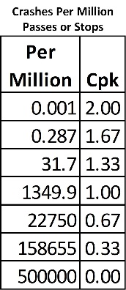
There are a tractable number of rational ways that HazObs can create an intercept precrash scenario statically/positionally, emergently (manageable), and suddenly emergent (emergency reaction) across the AV’s planned path. Normal HazOb movement into the AV’s planned path should never cause a problem with or without warning/signals. Right of way driving is recognizable by common HazOb choices alone. There are individual HazOb Choices. Flow adjusts around the change and flow settles into laminar flow. Normal driving’s steering, braking, and throttle have expected statistical ranges that safely allow HazObs to enter a path, cross a path, or exit a path. An emergent entry requires statistically safe and assertive braking, steering, or throttle to avoid an intercept (crash, injury, or fatality). Emergents are the expected events that must be understood and safely avoided with a time/distance Cpk ≥ 2.0. Crash avoidance paths include all legal drivable surfaces and all safe and free of HazOb non-drivable surfaces. Safe emergency escape paths include fully safe and open off-road and oncoming/opposite flow driving surfaces. The map of every road segment must include designation of a surface’s drivability as well as static and unmovable objects. An emergent allows sufficient OEDR time for braking to a full safe stop before a crash. An emergent becomes a sudden emergent when an emergency forward crash avoidance time/distance to a full safe stop is Cpk < 2.0. The sudden emergent becomes a safety critical emergent when Cpk ≤ 1.0. If forward emergency braking begins at the Cpk = 1.0 stopping distance, 99.9% of the AV’s Kinetic/Hazard Energy can be reduced before a crash. 100% of Hazard Energy is transferred into the HazOb when Cpk = 0. Sudden slowdowns/stops carry the risk of causing a rear end collision with the AV. Sudden emergent intrusions create an unacceptable statistical probability of causing a crash unless the AV uses a steering solution. Steering solutions require changing lanes and carry the risk of side, forward, and rear impacts.
The teams that perform the HARA must include representatives from each concept design element. The team members must see their own functions and talk with the team members regarding sequential and interrelated functions. Crash avoidance requirements are based on macro spatial and time sequence pattern recognition. Macro includes the road structure, control devices, position of motion constraints, and the time sequence patterns of each HazOb. Macro performs pattern recognition to NHTSA precrash scenario. Each road configuration is physically different which constrains the same category of precrash scenario into slightly or very different patterns to match. The memory of these patterns comes from the AV’s road-segment entrance requirements stored in Map. The AV’s worldview is based on mastery of representative road segments with its recall linked to Map segment memory entrance requirements, exit, and pass through flow. AI/ML is not a fluid “understand everything at once the first time it is viewed,” human mind. There are large differences between two single lanes that drive in different directions and two sets of three-way lanes separated by a median. The pattern matches for each scenario are specific to each representative road segment. Macro uses localization, map, sensors, perception, object recognition, object prediction, and motion constraints to determine the positions, speeds, and acceleration of objects and to identify the few HazObs which based on their positions, behavior, or paths, are intercept/crash risks. Map contains each representative road segment’s likely precrash scenario pattern matches, entrance/exit flow patterns and probabilities, and so on as prioritized for first consideration matches with responses and if needed on/off driving surface escape paths. This is the same as all human drivers who learn to be careful in certain areas while driving. It is a learned memory response. HARA part 2 of 3 covered strategies for identifying when individual HazObs become an intercept risk based on behavior, their available choices, or current path.
The Object Tracking List contains the macro/micro-object attributes used to understand current and predict immediate future HazOb behavior. Macro object detail is object position, path, speed determined from positional changes (x,y,z,t) or from LiDAR/iRadar. Macro spatial patterns are flow constraints and HazOb flow patterns in the driving environment. Flow are objects over time. Micro are the intent signals from different parts of the object. It includes turn signals, flashing lights, change in location/path, turning of head, movement of arm, movement of the knee, and so on. Each object’s behavioral and predictive attribute locations on each HazOb must be defined.
Each sensor has a window of signal information. This contains signal and noise information. Noise is background/clutter information free of OEDR information (clouds, dirt, fields, fences, and so on). Each object has the equivalent of a Bayesian window of what the object is and is not. Within each object’s window is the form of the object (what the object is). Within this form are smaller Bayesian windows for tracking/predictive attribute pattern matches. This means that if a sensor can barely match the object for recognition, it might not have enough signal to noise to match the attribute. For example, a camera that can barely match a motorcycle might not have enough pixels to match the driver’s hand/arm signals or the motorcycle’s turn signal or brake light. The motor cycle as a hazard has a safety critical detection distance. The motor cycles brake lights and turn signals have a different safety critical distance requirement. This is why a 550-meter sensor only means that the object’s Macro Hazard Information (spatial/time sequence, position, path, and speed) must be understood at 550 meters. That same sensor will have to detect predictive attributes before the HazOb reaches the next closer safety critical distance. Every sensor has a large number of object attribute safety critical distances and each of these must be documented and validated at distance under all operating conditions. For example, turn signals and brake lights are always detected for all vehicles in, near, or approaching the AV’s planned path. They must be detected, tracked, and understood so the AV can safely and smoothly adjust its planned path to allow expected and communicated intrusions into its planned path.
Three tables will be used to understand and document hazardous situations, Tables 3.4, 3.5, and 3.6. These tables exceed the ISO 26262-3 requirements that a systematic approach be used to study all hazardous situations for risks. One set of tables is used for each representative road segment, specific point on the map, and general/regional road constraints such as accidents, construction, and farm equipment. The teams will find that risks have common structures that overlap and core solutions that will solve these common risks. The Pareto Principle is useful at this point. Eighty percent of risks are solved by twenty percent of solution efforts. These are the right of way/DDT solutions. This is the AV’s core design. Fifteen percent of the risks are emergent and road/path blockage risks. These will be thirty percent of the solution efforts. Failure to solve any of these will cause extreme negative public reactions. Public comments will be that the AV could not handle obvious and easily understandable situations and caused a crash, injury, or fatality. Five percent of the risks are sudden emergent risks and this will cover roughly fifty percent of the total solution efforts. Sudden emergent risks occur with and without predictive information of intent. In other words, a HazOb might be isolated as a potential emergent and it’s micro HazOb predictive information is being recorded. The HazOb delays insertion in front of the AV to the point that the AV cannot fully decelerate before the HazOb is struck. So, the AV must turn, turn and brake, or turn and accelerate to avoid a crash. The AV will not have enough time to create a solution. It must activate a pre-solved solution.
Linking risks to vehicle level functions. There are seven useful potential function-based failure modes. The foundation of each will be discussed in the following chapter on the Functional Safety Concept. All technical safety requirements can be fully defined from these seven failure modes/fault states. Potential failure modes relate to when the planned path creates a precrash scenario which means that the AV’s planned and executed functions were inappropriate, or the AV approaches a developing or fully formed precrash scenario and it must respond to reduce risks.
Minimum VLF variation occurs when every function from sensors to the commanded VLFs are flawless. All functions have variation. This is the nature of the world. All normal variation of functions from sensors to VLFs represents the expected variation and statistical capability of the AV’s response. The statistical passing and stopping specifications are six speed dependent standard deviations left/right and forward/reverse of the AV (6σ_{x,y,z,v} or 2Cpk_{v}). Lateral and longitudinal variation increases with speed. The largest risks of variation are failure to maintain a safe planned path in the AV’s assigned lane and to control speed and stop before an object is struck. This is single AV variation risk. This is Mastery of Function Level 3 driving or safe right of way driving where the AV will never cause a single AV, or AV to HazOb crash to society. A Mastery of Function Level 3 VLF enters a failure mode when its behavior creates a single AV or AV to HazOb crash. These are the NHTSA precrash scenario. Steering, throttle, and braking enter a failure mode/fault state when their commanded function creates a Cpk_{v} < 2.0. Safe commanded functions must never violate Cpk_{v} < 2.0 for maintain lane, safe pass, or stop.
Functions, from sensors to VLFs, are like dominos. They fall into each other flawlessly or problematically. Every function is controlled by its design parameters. Think of these as the size, weight, alignment, and distance between the dominos. If a weight/speed is too little it will not “topple” the following single or double domino. If the speed/weight is too great it will scatter the following dominos. Design parameters are each function’s “conditions for success.” Safety critical design parameters define how a function satisfies its Functional Safety Requirements. Functional Safety Requirements that a function must satisfy are the input design parameters of following safety critical functions. The VLF design requirements are safety goals. There are seven meaningful ways that a function can fail and each failure defines, directionally, how a design parameter fails the function. Changes to correct the design parameter become directional to avoid specific function failure modes. A new Functional Safety Requirement is assigned to the function that controls this design parameter. The seven failure modes are [O] Omission of function or required change, [+] Excessive function, [-] Incomplete function, [V] Erratic/Unstable function, [U] Uneven/Biased function, [+T] Too slow/late function, and [-T] too fast/soon function. It is rare that all seven failure modes apply for a given function for a single road segment. The cell contains the precrash scenario or a specific crash into another vehicle, pedestrian, or pedal cyclist. This means that if the AV is performing a maneuver, even if it is going straight, the failure mode would create or enter a precrash scenario.
Use the 7FM Concept Level Functional Block Diagram from the Item Definition along with the forms, the ODD, and the representative road segments. The different functional blocks are the elements of the design. Functions exit one block and enter another block. The receiving block, or following blocks, have functional safety requirements of the function. Make sure that your team can track/trace functional sequence and interrelations from sensors to VLFs. The HARA will identify risks that need to be avoided by functions and their sequences. This will create new elements, functions, interrelations, and functional safety requirements. Continuously redraw the 7FM Functional Block Diagram to show how the world is interpreted, how functions develop, what functions need from each other, and how the changes better understand and respond to the world. Every change to the Functional Block diagram (elements, functions, interrelations, and functional safety requirements) avoids making a design with the causes that were just eliminated by the change. Time and money are saved. Hazards are avoided.
If Acceleration is excessive [+], it is because the acceleration will lead to one of the forward precrash scenario or loss of control. Since the NHTSA crash tables are being used, the failure mode will always correctly relate to an unreasonable risk. There is no assumption that the function behaved as intended and entered/created a forward precrash scenario or loss of control. To accelerate when the AV should not accelerate can only be based on wrong or missing functions. Failure modes are directional and rational to specific hazards. There are only a few ways that responsible concept elements and their functions can cause each specific failure mode and its specific precrash scenario. When acceleration is larger than it should be, the algorithms determined that the area was free of harm and it is not or will not be free when the AV reaches the collision point. There are sensor risks, HazOb trajectory risks, relationships between the AV and HazOb risks, HazOb change risks, and so on. Did the sensors gather the information but not detect a HazOb? Did the sensors provide too little contrast/discrimination to isolate the HazOb? Did the sensors provide the information but the algorithms did not detect the HazOb? Did the algorithms detect the HazOb but did not track or predict its current/future location? Follow the functions from sensors to the VLFs. Determine how they need to work together. How did object-tracking fail? Were the object flow predictions correct? Were current and future motion constraints missed? Did motion control fail to solve for intercept avoidance? With each of these questions, ask how the function failed and what functional requirements will minimize the risk. What condition for success does the function need to be successful (the quality of a function’s inputs). For example, the 550-meter sensor can detect an object at 550 meters but not at 625 meters and then provide its path information. So, the function cannot make a critical decision at 550 meters. The fault is that the functional safety requirements for the sensor were poorly stated and the sensor could not be purchased or validated properly. All macro spatial and time sequence information is missing at 550 meters. The sensor fails to provide the quality of information before the function must make a safety critical decision. The function fails its functional safety requirements because its conditions for success have been violated. Ask what a function might not be doing well enough and change the design of that function. If a human driver can understand and react to the driving environment, the system must understand the same information and command safe VLF responses. Sensor distances without specific object or object attribute requirements are meaningless. When speeds increase the risks become end of road, horizon, around the corner, and over-the crest of the hill, and detection becomes safety critical blockages and changes. Cameras match with Map to evaluate Bayesian windows and continuously look for end of sight/road blockage pattern matches (construction, traffic jams, accidents, vehicle/objects blocking the road, lane reductions, and such). Cameras are horrible at estimating speeds at horizon/end of road. Their natural logarithm distance from the virtual horizon estimates has poor distance resolution. More pixels help but do not solve the problem at 1,600-3,200 meters (end of road). The actual distance is where the camera’s angle intercepts the road and the distance is calculated from map. At this distance, when objects maintain their virtual horizon angle (pixel count down from the virtual horizon), they are moving at roughly the relative speed of the AV. An object goes over the crest of the hill. When the AV goes over the same crest it looks to see if the object is the same distance or if it stopped (sudden stop, accident, blockage, etc.). The start of detection is blockage pattern matches of “stopped/slowed” HazObs. The blockage is potential and the vehicle prepares to reduce speed at the earliest statistically certain distance match. A high-resolution camera can validate static/slow moving objects by 600 meters. LiDARs and iRadars are exceptional at this type of detection. However, their signal to noise is horrible at extreme distances. The iRadar’s power and resolution requirements at extreme distance have military solutions but is currently size and power prohibitive for AI vehicle applications. Understand the functions of the driving environment. Turn these into functions solved by the system. End of road can include every bridge that the AV will cross. Bridge failure is extremely rare (act of God exposure). However, it is simple to challenge each bridge before it is reached. A bridge outage/failure becomes the exact same response as any road blockage. Have stored object digital signatures for each specific bridge in the ODD for camera, LiDAR, and iRadar stored in Map and perform a simple digital signature match before a safe stop distance is reached. This is an extremely easy “solve.”
ISO 26262 Part 3-6.4 Documenting the Hazard Analysis and Risk Assessment: HARA
ISO 26262 Part 3-6.4.1 Initiation of the HARA
6.4.1.1 as is required, the HARA is based on the item definition which describes the assumptions of the starting design. The Item Definition was covered thoroughly in its own article/chapter. The following example will include an Item Definition. The design is a closed loop forward crash avoidance goal seeking mechanism and is not specific to any operational domain definition (ODD). It will be active in all road segments. Its abbreviated Item Definition and HARA will be covered in the following paragraphs.
6.4.1.2 The HARA will be performed without the assumption of safety mechanisms. The team cannot suggest that a failure mode cannot occur because a planned failsafe exists. The goal is to design perfect functional sequences that do not rely on fail-safes.
ISO 26262 Part 3-6.4.2 Situation analysis and hazard identification
6.4.2.1 The risks of Representative Road Segments and NHTSA precrash scenario will be used to explore operational situations and operating modes in which an item's malfunctioning behavior enters into or creates a precrash scenario regardless of correct or incorrectly assumed behavior.
6.4.2.3 Table 3.4 will identify all misbehaving VLFs that can result in a Hazard.
6.4.2.4 Table 3.4 will clearly identify hazards that are outside the scope of the Item Definition’s technical solution.
6.4.2.5 The target hazardous events are clearly identified in Table 3.4 as well as the stated percent reduction of NHTSA resultant crashes (solution effectivity).
6.4.2.6 The percent injury/fatality rates are clearly definable in or through modifications of Table 3.4.
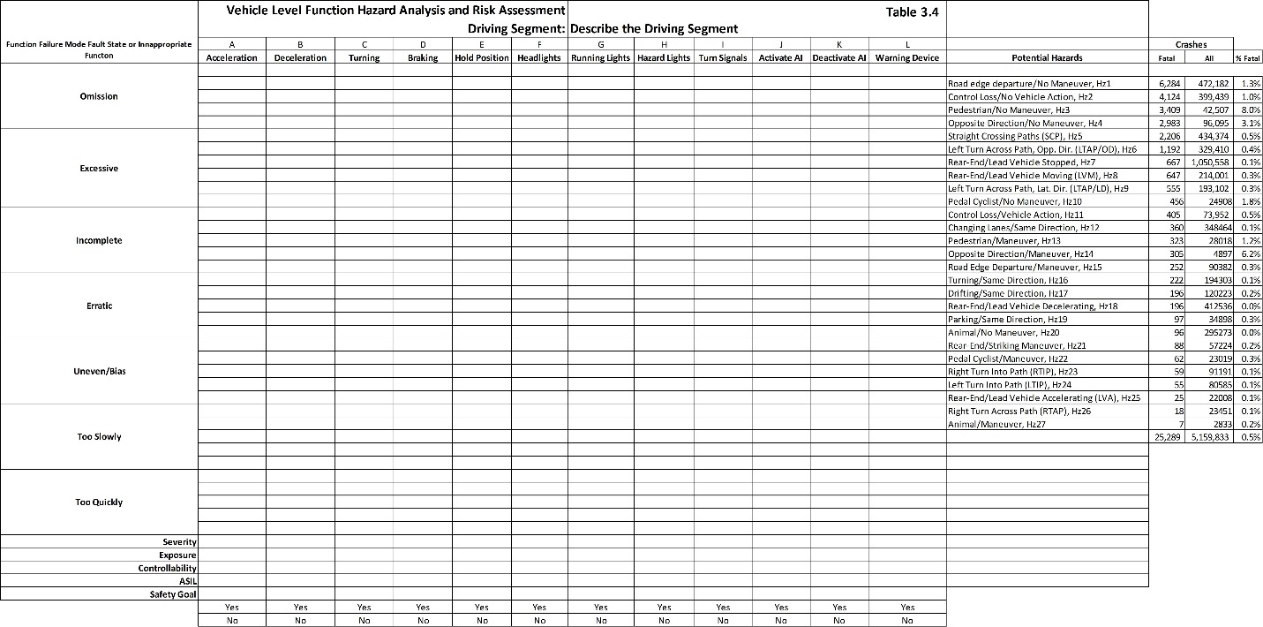
6.4.2.7 The definition of representative road segments ensures that ASILs are not inappropriately lowered as will be covered in the following conversations.
Table 3.4 can be used for all autonomy SAE L1 – L5 autonomous designs. It can also be used for Vehicle Level Functions controlled by Automotive Electronics and Software closed loop systems L0 – L2. The Precrash Scenario column contains the hazards that will be copied into each of the VLF’s failure mode’s cells. For example, failure to accelerate (omission of acceleration) will mean that the AV does not clear an area and might get struck. Any rear or side crash into the AV can be caused by this omission.
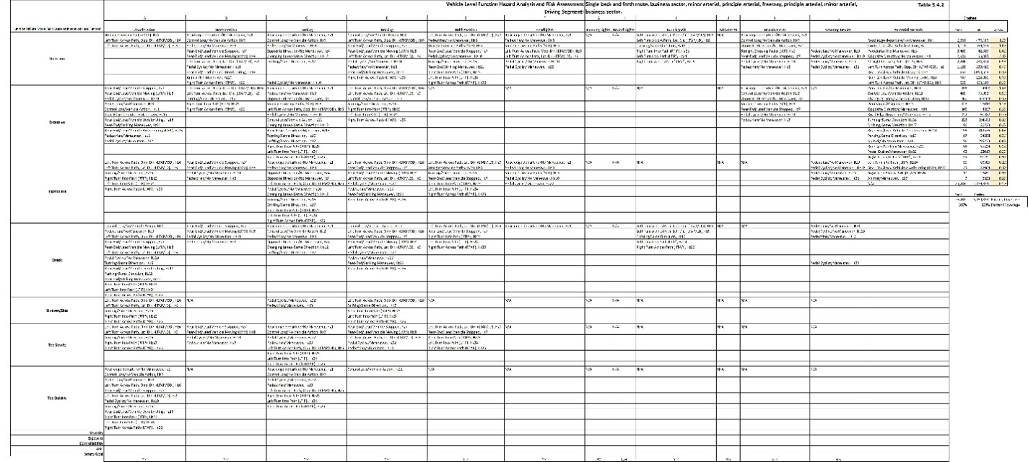
Table 3.4.2 is an example of a pre-filled SAE L3-5 HARA form. It is a high-definition picture and can be zoomed and the words are clear. Discussing each cell would require a full chapter called SAE L3-L5 which is beyond the intended scope of this chapter. The form is included as an exercise. Zoom in and review the columns, assume any known road segment, and ask how each VLF failure mode creates the precrash scenario. What elements and functions had to fail and how might they fail to produce each VLF failure mode? What did the design miss? The design incorrectly commanded the function to be inappropriate (produce a failure mode).
The Precrash scenarios in table 3.4 come from Table 3.20. The goal is to relate each potential VLF failure mode to all possible precrash scenarios it might potentially enter or create. If a specific HazOb will not be present in the road segment, it is removed from the analysis. This analysis will show that multiple VLF’s share responsibilities of portions of some of the precrash scenario. This means that perfecting one VLF might not fully remove risk. Following a planned path requires steering, throttle, and braking.
Table 3.5 documents the representative road segment’s driving environment. This defines what the sensors can observe, the events that will be created, what must be detected, and the constraints for the AV’s responses.
Table 3.6 will assign functional safety requirements to each of the concept phase design elements. This includes cameras [core sensor], imaging radars [core sensor], LiDARs [core sensor], MAP [core functions], localization [core functions], perception [core functions], object recognition [core functions], object attributes [core functions], object tracking [core functions], flow analysis and prediction [core functions], motion constraints [core functions], motion planning [core functions], pre-approved alternate paths [functional safety requirement], emergency constrained paths [functional safety requirement], dynamic control [core functions], vehicle control [core functions, vehicle health monitoring [core functions], and so on. For example, continuously update the safety critical distance base on speed, lateral/longitudinal AV variation, road condition, and safe distinctness of image distance (sensor degradation) at which the AV must change its state and safely derate the speed of its planned path [functional safety requirement]. The safety critical decision, and all safe escape path solutions must be ready to execute with statistically capable responses of safe steering, throttle, and braking at all times [stability prediction modelling - functional safety requirement]. This means that the sensors must be able to identify, track, predict HazOb position/path, and estimate its variation about its path before this safety critical distance is reached [functional safety requirement].
VLF failure modes, with the exception of Omission, have differing strengths or differences from perfection. Their technical specification begins when they begin to threaten safety. Safety is measured by their impact on VLFs as related to precrash scenario. The HARA team must understand a few basic ideas before they perform the HARA. This will help design better Functional Safety Requirements/Functions that are directional to and will reduce specific function-based failure modes (e.g., excessive, incomplete, erratic, etc.). VLF failure modes might be mutually exclusive or occur at the same time. Failure modes can migrate which means that the function is degrading into a more severe failure mode or fault state. When a failure mode migrates, the old failure mode might be replaced by a more dominating and dangerous state. Or a more dangerous failure mode is added. The sequence in which functions are likely to degrade/migrate into failure modes are mostly, but not always, predictable. Migrating failure modes are assessed in the System Design Phase along with failure mode/fault detection and rational safety mechanisms. This means that the early failure modes will be detected well before there is significant risk and an appropriate safety mechanism will transition into a safe functional series well before the failure modes with significant hazards can occur. For example, a normal response time for a turn command change to reach the steering control module is 10ms on a 100Hz CAN bus line. 10ms later the steering control module responds that the change is active (feedback). The steering column has an electromechanical lag time as well as steering position feedback. The steering control module publishes the steering position on the CAN. The steering module and steering column follow the changes. What if the steering module/column developed a 5ms delay? Steering, throttle, and braking responses and their response times are available from the vehicle. A human is not equipped to notice a 5ms delay. Each failure mode’s strength can increase and become more problematic. What if the delay became 30ms? How about 200ms? Each of these are Steering Achieved more slowly. Too Slowly is the Failure Mode where it becomes problematic or affects safety. Systems that are overloaded with processing requests develop transient delays. Electromechanical devices get slower, not faster with age. A 200ms delay becomes noticeable but might only cause an increased risk in rare cases. It would statistically increase the lateral variation about planned path. The living speed dependent specification for safe lateral passing distance would increase (Cpk_{x,y,z,v} = 2.0; distance = 6σ_{x,y,z,v}). The faster the vehicle’s velocity, the larger the variation about planned path and the more unsafe the risks. In 7FM terms, the function is trending towards an erratic/unstable response. The failure mode “too slowly” is becoming “erratic.” When does the delay become a significant general risk? A general answer would be that the AV can no longer remain safely in its lane at the legal speed limit. The actual answer is that its change in variation would be detected using time-variant stochastic statistical analysis – or a statistical process control chart, where speed dependent variation is coded out of the analysis (7FM The System Design Phase). Another answer would be when the AV’s variation uses 80% of its lane (or derate speed below the posted limit to 80% use of lane – safety mechanism). The degradation in response creates a linear/nonlinear response curve and the time to safety critical system failure can be predicted. This avoids the point where the function becomes an Omission of Functional Response. The safety mechanism can be activated based on a response delay. The response delay causes can be isolated by the fault codes of electromechanical, E/E, and/or software function-based configuration failure mode fault codes xxxx.1 -xxx.7. (Assigned during Functional Safety Concept, System Design Phase, Hardware Design Phase, and Software Design Phase). The speed-variation dependent performance curve will be found by calculation, simulation and validation testing. Once the AV has been released to testing or production, the speed variation dependent curves must be self-created/living and used to make every passing/stopping decision. The AV must know when it cannot safely stop, drive through a lateral space, or pass an object. The AV must derate its speed to reduce variation risks and Hazard Energy, or safely park off the driving surface before its functions become unsafe.
A failure mode has been validated as affecting the vehicle when it causes unsafe changes in steering, throttle, or braking and violates safety specifications. This is covered in the system design phase. The thought process begins during the HARA. This relates to the 3σ_{x,y,z,t} Fault Tolerance Time Interval (FTTI) at the worst case stopping/passing Cpk = 2.0 based on normal and expected variation. Cpk is based on the actual variation of the AV and it is continuously updated and monitored for changes in time, distance, and variation. Lateral variation specifications are based on lane widths and required passing distances. It is a variable. It can never be a static number. For example, an AV might be statistically capable of staying within the tightest lane in the USA at 55mph but not 75mph. Designing the AV to be capable of driving at 75mph in that lane is possible. But it does not make sense. The AV can be designed to predetermine its maximum safe speed of maintaining its lane. This is more direct. Longitudinal specifications are based on safe following and stopping distances. Static assumptions of variation (a fixed number) are unsafe for too many reasons to state. Real world variation is condition dependent. The safe passing and stopping distances must always be based on real time AV variation. These and the following topics on failure modes will be expanded in the Functional Safety Concept chapter and explained in detail in the System Design Phase. Safety mechanisms designed for the minor failure modes will avoid most major failure modes.
The function has three magnitude failure modes, and they are always mutually exclusive (cannot occur at the same time). These are: Omission [O] of VLF change, Excessive [+] VLF change, and Incomplete [-] VLF change. There are two variation failure modes and they are not mutually exclusive from each other or from Excessive/Incomplete Magnitudes. These are Erratic [V] VLF and Uneven/Bias [U] of VLF. Uneven includes lack of constant bias (a failure of linearity-example: tracking to the right or left of planned path). There are two time-response failure modes which are mutually exclusive from each other. They are when a response is delayed or achieves magnitude too slowly [+T] or the function occurs too soon or achieves magnitude too quickly [-T]. These are a factor of when in time a function is activated as well as when it reaches its final magnitude. There are potential requirements/specifications for magnitude, stability, bias, and time response of any function. These specifications will be considered and if appropriate, the functions will be validated against the requirements and their specifications.
A mutually exclusive failure mode means that two states cannot exist in the same time and space. Omission, failure of a required response, is mutually exclusive of all other failure modes. A function cannot be omitted and excessive at the same time. It cannot be incomplete and excessive at the same time. Some failure modes can occur at the same time as others. For example, a function can be excessive and erratic at the same time. It can be excessive and too quickly at the same time or excessive and too slowly at the same time. It can be excessive, erratic, biased, and too fast or slow at the same time.
It is necessary for the HARA teams to understand the basics of VLF failure modes and the full sequence of concept level functions and how they develop into vehicle level functions. They do not have to know how the concept level functions are going to be produced. However, the team knows that cameras, LiDARs, and iRadars will be used. They know that E/E processors will be used. Much of the technical choices are limited to a small number of capable E/E and sensor providers. Technology and functions are matched in the System Design Phase. Technology does not change potential failure modes. Technology changes the causes and rates of failure. Technology changes the design parameters that will eliminate or reduce the probability of a failure mode (1st level causes). Technical solutions are E/E hardware (ISO 26262 Part 5), software (ISO 26262 Part 6), electromechanical (IATF 16949), and mechanical core (IATF 16949) safety critical design requirements.
The following is important to understand. It will be covered in detail in the final chapter, The Functional Safety Concept Design. The HARA uncovers weaknesses of the initial Item Definition which is the preliminary AV driving in society design. The team needs to document and understand the sequences and correct quality and time responses of the functions they will design. They do not need to know how the function will be created. They need to understand the function’s correct and safe intent. Initially, this is the Item Definition. During the HARA they will find that the Item Definition will fail and they create new functions and functional interrelations and define Functional Safety Requirements for current and newly added functions. Then, they can select the modes of failure/faults of these functions and link their failure sequences through the concept design. This is the 7FM Fault State Map. From this, they can define the design parameters that will delay, avoid, or detect and control these failure modes/faults states. This is the Functional Safety Concept which produces the starting System Design Phase. All of this links to the creation and avoidance of the HARA’s VLF failure modes/fault states.
The representative driving segments contain the HazObs, their relationships, as well as the technical challenges of understanding and avoiding risks. The intended output is defined by what is correct by design and the specific driving environment and is rationalized for each VLF during the HARA. Representative driving segments provide the highest exposure of a VLF’s failure mode to vehicles, pedestrians, pedal cyclists, and animals to these precrash scenarios. Exposure can be thought of as the worst time of day ratio that HazObs are present to a VLF’s specific failure mode (e.g., wrong steering, throttle, or braking).
The following are answers to the ISO 26262 Part 3 Item Definition for a Forward Crash Avoidance system. Reference the standard, look at the clause requirement, then read how it is answered in this section.
ISO 26262-Part 3, 5.4.1 a) Identify the legal requirements that the design must satisfy. The forward crash avoidance system is not covered by FMVSS and does not need to be approved by each state in which it is driven. The system will be a general release and its general FMVSS requirements will be satisfied by general FMVSS testing.
Essential Comments for 5.4.1 a) autonomous systems that assess the driving environment and control VLFs with special consideration for FSD/AKA SAE L2+ and SAE L3-L5 systems. The system must satisfy the Federal Motor Vehicle Safety Standards (FMVSS) before being tested or driven on public roads. NHTSA has two Autonomous Vehicle Policies which it relegates to the states for enforcement. These are mandated when a state’s Autonomous Vehicle Test Permits require compliance to FMVSS/NHTSA. NHTSA Policies state that ISO 26262 Over the Road Functional Safety is the most appropriate Safety Standard. As of this writing, the policies are not enforced. Enforcement will likely occur after the first extremely visible crash with national coverage or a class action lawsuit. ISO 26262 was developed by international automotive OEM manufactures and their Tier 1 OEM System Manufactures to be the vehicle safety standard. ISO 26262 Part 2 states that the IATF 16949 Automotive Quality Management System is required. It represents current best practices. Automotive OEMs require all Tier 1 suppliers to be registered to IATF 16949. The scope of the IATF 16949 registration must include the ISO 26262 core processes as required to satisfy ISO 26262 product safety certification. Registration to IATF 16949 provides objective evidence of compliance to ISO 26262 practices. Product Safety Certification to ISO 26262 is objective evidence that a Safety Case supports the attainment of Safety Goals.
The Automotive Industry manages safety for each “as-built” configuration which requires a validated technical safety data package, safety releases for testing and sales, and traceability of all safety critical serialized components. Traceability of all batch components is mandatory if not serialized. Record retention must meet the mandatory safety critical automotive requirements of 15 years to the end of that year, for each approved engineering release authorized to be driven on public roads. Autonomous vehicle testing on public roads must comply with and receive approval from each State’s Licensing Authority (e.g., DOT/SOS) and FMVSS/NHTSA requirements. In order for autonomy to prove that it can safely perform DDT for extended periods of time, Mastery of Functions Level 3 must be validated (fully capable of safe right of way driving within a geofenced ODD). FMVSS includes steering systems, braking systems engine control systems, -stability control systems and several other critical systems for testing. The number of safety critical functions of an SAE L3-L5 design are many magnitudes greater than an entire human driven vehicle. FMVSS includes Level 200 Crash worthiness tests that must be evaluated prior to being driven on public roads. Crash worthiness tests include autonomy equipment sharp edges and parts falling off inside and outside the vehicle that might cause harm. Autonomy systems that command the vehicle level systems have higher safety critical functions than the driver commanded vehicle level systems.
OEM and Tier 1 suppliers to OEM Manufacturing all must test their systems under the rigorous testing requirements of FMVSS. Companies are “Self-certifying.” This does not mean that they identify when they have satisfied the tests. It means that they use an ISO 17025 registered test/calibration lab to perform testing or they are registered to the Automotive Quality Management System IATF 16949 which includes ISO 17025 in the scope of registration. The lab that performs FMVSS testing must be registered to ISO 17025 and be recognized by FMVSS/NHTSA/DOT. The specific FMVSS tests performed must be identified in the scope of registration. The records must be traceable to equipment that is calibrated and has capable and validated measurement system assessment (MSA). There must be document controlled test procedures (e.g., FMVSS 100, 200, etc., level tests). Test personnel must be qualified based on education, training and/or experience. Records must be controlled and maintained for fifteen years, to the end of that year, specific to each representative design configuration/technical data package that is authorized to be driven on public roads.
Extremely important note: AVs are produced by two types of companies. OEM AV manufacturers and Modifiers of OEM Vehicles. Legacy OEM AV manufacturers have strong FMVSS processes that ensure compliance prior to driving their vehicles on public roads. Modifiers of OEM vehicles hijack vehicle controls. This means that they break the FMVSS testing for steering, throttle, braking, and stability controls. Their risk, is that the vehicle will not disengage autonomy through steering torque or braking. Modifiers must revalidate the vehicle level functions that they hijacked and they must have fast and positive controls to disengage autonomy. Several non-legacy OEM AV manufacturers show signs that they are not following best OEM safety practices.
ISO 26262-Part 3, 5.4.1 b): The design is an SAE Level 1, single function, forward trajectory braking crash avoidance solution. It measures the speed and the time distance to a forward obstacle. It warns the driver of a forward obstacle which might be a HazOb or it might have substance but not involve a human. If the driver does not perform an avoidance maneuver, the system will apply brakes to stop the vehicle before the obstacle is hit. Obstacles include static large debris/objects (documented parameters), and HazObs: vehicles, pedestrians, and pedal cyclists. The system is active when the vehicle is turned on, in a forward gear, a driver is in the seat, while driving on all roads, and in all parking lots. The system is disengaged while the vehicle is in neutral (e.g., car wash, being towed, etc.).
ISO 26262-Part 3, 5.4.1 c): Forward detection of objects is vehicle speed and speed differential dependent. Forward detection is object trajectory dependent. Sensors must be able to detect objects that are on a near-time interception trajectory with the front of the vehicle. This is the point where the team must differentiate what is and is not part of the technical solution. Example: The system is concerned about front vehicle object impact. It is not concerned with the side-impact of the vehicle by other vehicles, pedestrians, or pedal cyclists. The sensors must have a wide enough angle to detect objects that will cross the forward path of the AV from any potential path. This includes vehicles that overtake and pass the AV only to cross the AV’s path and then brake aggressively. The AV must be able to track the trajectory of all forward HazObs that might develop an intercept path to the AV’s right of way. Critical late intrusions into the path of the AV are unavoidable. It will not include the option of accelerating or turning as an intercept/crash avoidance solution.
ISO 26262-Part 3, 5.4.1 d): The primary sensor is a forward looking three band imaging radar that has three distance zones and angles of detection. The imaging radar can distinguish speed differences of 1cm/second between objects. It does not include a high-definition map. The imaging radar detects relative angle of the HazOb to the sensor location/orientation to the true forward center of the AV. It has an error of ±1 lateral degree relative from the sensor forward center. It has a ±2 degrees vertical error to determine an object’s height and if an object is on the driving surface (e.g., on a bridge over the road). Its affective distances for object and object attribute recognition requirements defined by the HARA must be used as part of the purchasing DIA and validated in use. The sensor is calibrated to the width of the forward impact zone profile of the vehicle.
Weather has little negative impact on the sensor. Ice buildup can cause signal degradation. If needed, a deicing boot can be placed on the sensor to remove Ice when early reflections identify significant icing (Potential Functional Safety Requirement). Sensor degradation will not be addressed by this design. The radar must detect and classify forward vehicles, pedestrians, pedal cyclists, and objects such as crashed vehicles, debris, etc. When a forward collision is detected and the driver does not respond, the braking is engaged. If the braking system is not maintained or is compromised the ability to stop will be reduced. If the tires are in poor condition or inflation, the ability to stop will be reduced. If the roads are icy, wet, oily, sandy, etc. the vehicle’s ability to stop will be affected. The radar’s forward distance must clearly state the maximum speed that the radar can detect a forward object and come to a full stop before hitting the object. Otherwise, the system will activate the brakes too late and the forward object will be struck. The system does not address any vehicle or environmental conditions controlled by the driver. The system must monitor tire pressure and brake fault codes and will audibly warn the driver that emergency braking is compromised. It will light an emergency crash avoidance Malfunctioning Indicator Light (MIL). The system will maintain records of all MIL fault codes. System storage of fault codes will be immutable. The MIL can be cleared. The records cannot.
ISO 26262-Part 3, 5.4.1 e): The primary shortfall with the system is the velocity of the AV, latency of the system responses, the actual path of the AV, the AV’s Lane, the road geometry (road width, lane center line/path, road grade, straightness/curvature, road condition, road surface type, etc.), and object detectability of location, trajectory, and intercept. All of these relate to potential system shortcomings/failures and functional safety requirements and design changes must overcome any design weaknesses that affect the system’s ability to achieve its Safety Goal. If the road is curving and an object is off the driving surface, it can appear as if it is in the AV’s path and it is not. The opposite is also true. An object that is on the driving surface around a curve does not appear to be in the path of the AV and it is. The consequence of activating the emergency crash avoidance, when it should not be activated, is a sudden deceleration and a rear-end collision of the AV by a vehicle driving behind the AV. The consequence of an omission, erratic, or incomplete activation of braking when it should brake is an avoidable forward collision of the AV into a vehicle, pedestrian, or pedal cyclist. The consequence of excessively activating emergency braking is a loss of control of the vehicle.
ISO 26262-Part 3, 5.4.1 f): The AV is responsible for the emergency brake commands to the actuator selected by the OEM vehicle manufacturer. The OEM Vehicle Manufacturer and the OEM brake manufacture have provided the response curves for the braking system and stopping distances. The AV cannot improve the response curves. The AV controls can only degrade these performance curves. The degradation would be inappropriate and unsafe braking.
ISO 26262-Part 3, 5.4.2): The boundary of the item and its interfaces is shown in the functional block diagram (Figure 3.12). Its interactions with two other Level 1 Items that are on the vehicle (Adaptive Cruise Control and Lane Keeping) are addressed in the functional block diagram, function descriptions, safety requirements, and will be validated to ensure that there are no negative interrelations.
ISO 26262-Part 3, 5.4.2 a): The elements of the item are shown in the Functional Block Diagram (Figure 3.12). The iRadar is a purchased element. The purchase will be covered by a Development Interface Agreement. The 1 Controls element hardware will be purchased and covered by a Development Interface Agreement. The 1 Controls algorithms will be developed in house by the systems software design engineers. The wires, cables, and connectors will be automotive safety critical grade and support current best practices for manufacturing, shipping, handling, and installation.
ISO 26262-Part 3, 5.4 b): The emergency braking command will activate the vehicle’s braking system. If the braking torque overcomes road friction, the Anti-lock Brake System (ABS) of the vehicle will activate which will allow the driver to maintain steering.
ISO 26262-Part 3, 5.4.2 c): The Emergency Brake Command will cancel ACC, Lane Centering, and Engine torque requests to ensure that the driver does not have any resistance to their emergency maneuvering or steering. The cancellation requests will not affect driver commands of braking, throttle, or steering.
ISO 26262-Part 3, 5.4.2 d): The emergency braking command is a subset of the advanced ACC Item’s needed to control the speed going down a hill. Overspeed going down a hill is controlled by sending a braking command which is the active method used for emergency forward crash avoidance. Emergency forward braking will use the same strategy which will include the maximum braking coefficient and if necessary, a priority interrupt command.
ISO 26262-Part 3, 5.4.2 e): The functional block diagram describes the allocation and distribution of the functions among interrelated systems and elements.
ISO 26262-Part 3, 5.4.2 f): The operational scenario that impacts the functionality will be complex emergency maneuvering of the vehicle. In an accident scenario, the driver will be in full control of the AV. The emergency crash avoidance will detect critical intercepts and if it activates the emergency brake commands it might interfere with a turning and acceleration command that the driver is making to avoid a crash. Any driver commanded acceleration/braking activated after emergency braking must cancel emergency braking commands – Send Brake Command-BSM, Send Throttle Command-Vehicle (Functional Safety Requirement).
Example HARA: Table 3.4.1 is for the Level 1 forward crash avoidance system. The Precrash Scenario is the scope of coverage for the system while it is active. The commanded VLF is braking. Braking avoids HazObs that are, or will become, in the forward trajectory of the AV. The system must correctly predict that brakes need to be applied to avoid an AV/HazOb intercept. This means that slowing a little, a lot, or coming to a full stop will avoid a crash. Slowing a little means that the HazOb will safely pass in front of the AV. Coming to a full stop means that there is or will be an object/HazOb in front of the AV when it comes to a stop.
All precrash scenario can be preselected in Table 3.4 before the HARA is performed. Then the team documents the object and event detections and response in relation to each precrash scenario. They will document all rational spatial/positional and time sequence patterns that exist for each representative road segment. The team documents hazards and how they will be avoided and the safety goal percent reduction of crashes, injuries and fatalities. This creates a safety goal that can be objectively validated. The driver is responsible for all other hazards. Table 3.4.1 suggests that up to 65.5% of all fatalities can be avoided by a perfect forward collision solution. By the time the HARA is completed, the team should have a rough idea as to what portion might be addressed by the design. A solution with a 50% or greater national effectivity is a good first safety goal (save 8,283 of 16,566 lives).
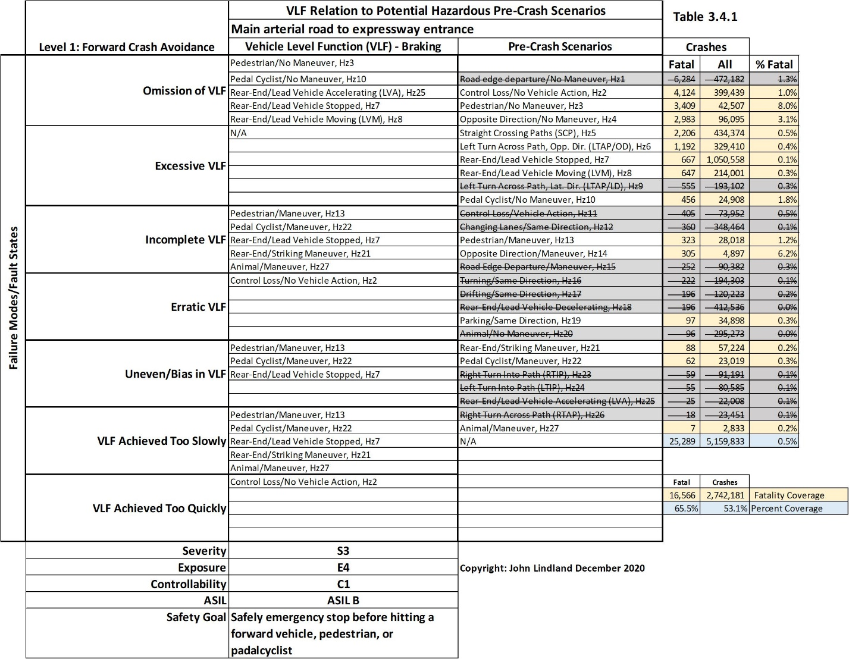
The 7FM Concept Level Failure Mode and Effect Analysis is part of the Functional Safety Concept. All Vehicle Level Functions are the System’s Primary Functions. Primary Functions have a direct impact on the driving environment for visibility, communications, and changing the kinetic energy of the AV. Steering, Throttle, and Braking actively create, change, and control the Kinetic Energy of the AV (Hazard Energy = ½MV²). The HARA form contains all primary functions, Hazard Functions, their failure modes and potential precrash scenario. The crashes, injuries, and fatalities from the NHTSA table in this example are from all roads in the USA. This first analysis across all roads is the Potential Effectivity Analysis of the HARA. The NHTSA report can be focused on the ODD by city and road category.
The report produces crash, injury, and fatality reports for reasonably representative roads. The representative roads used in the analysis will be the most complex of its representative sample. When the risks of the representative sample are solved, all other road segments of the group have been solved. The effects of primary failure modes will be covered in the chapter on the Functional Safety Concept. The effects are what is noticed by society and will include AV visibility/communication issues, precrash scenario, crashes, property damage, injuries, and fatalities. The hazards/precrash scenario are all numbered. 7FM provides the direct way to trace hazards in reverse order through the sequences and interrelations of all safety critical functions and to link each hazard to each system level function. Function based configuration will retain Hazard Traceability through decomposition at any function in a hierarchy/time-sequence down to hardware/software component level functions. Components are physical parts made up of units (dimensions of materials) and singular output purpose sequences of software units. Physical parts can be verified by Finite Element Analysis (energy density, strength, stress/strain, and toughness analysis). Software components can be tested and validated as they are written and test reports can be automatically generated by the architecture against functional safety requirements. Assembly functions are produced by sequences and interrelations of component functions. System functions are created by sequences and interrelations of assembly functions. Vehicle functions (supersystem) are produced by sequences and interrelations of systems functions. This will be covered briefly in the Functional Safety Concept. It will be covered in detail in the System Design Phase.
The precrash scenarios are reviewed and those not affected by the emergency forward crash avoidance are crossed out. If the VLF failure mode will create a precrash scenario it is added to the failure mode cell. This approach allows the team to assess the rationality of the current design requirements. The form starts with five rows for each failure mode. Add as many rows as necessary and make sure that all precrash scenarios that might be real are selected. In Table 3.4.1, the solution, if perfect will avoid 16,566 of the 25,289 fatalities for a 65.5% coverage of hazards. This analysis addresses 2,742,181 of the 5,159,833 crashes for a 53.1% coverage. For each representative road segment, delete the potential precrash scenario that are not created by emergency braking failure modes. Review the NHTSA tables and determine a rational percentage of the precrash scenario that will not be avoided.
Table 3.5 is a general table that can be used. It relates all VLFs to potential HazObs. It has three sections of rows. The expected HazObs that are included in the representative road segment are documented. The HazOb exposure in the ODD is determined by the representative road segments. The quantity of each HazOb category in the driving segment at different times of day are the exposure to precrash scenario. The HazOb locations, relative position, and trajectory compared to the AV as it drives is the specific exposure to front, side, turning, stopping, and reverse precrash scenario.
Document the HazOb-to-HazOb relationships and document the assumptions of how they might affect the flow of HazObs relative to the AV. HazOb to HazOb relations create motion constraints and limit maneuvering choices. When a driver watches traffic, they can tell if a forward car will have to move into their lane before it occurs. They can see a constraint that the other driver will need to, or want to, avoid. A human can see a pedestrian walking on a sidewalk and that the sidewalk will end. The pedestrian will likely start to walk on the side of the road. They can see a pedal cyclist riding in a bike lane and that there is a lot of debris in the bike lane so the pedal cyclist chooses to ride in the road and not the bike lane. A LiDAR can return the road surface debris/clutter (System Design Phase).
What is the physical layout of the road? What are the control devices? Where are all the objects? How are controls directing traffic (the edge of the road is a control, do not pass is a control, lights, signs, etc.), where are immobile objects? Where are the HazObs? What are they doing and where are they going (object time sequence)? What is the object going to do (micro spatial and time sequence patterns of a specific object’s attributes-eyes, hands, arms, knees, head movement, turn signals, brake lights, sudden changes in position, etc.). Be able to recreate this in a theater environment on a test track (test procedure). Modify the forms to include the team’s own “short-hand” for pattern recognitions.
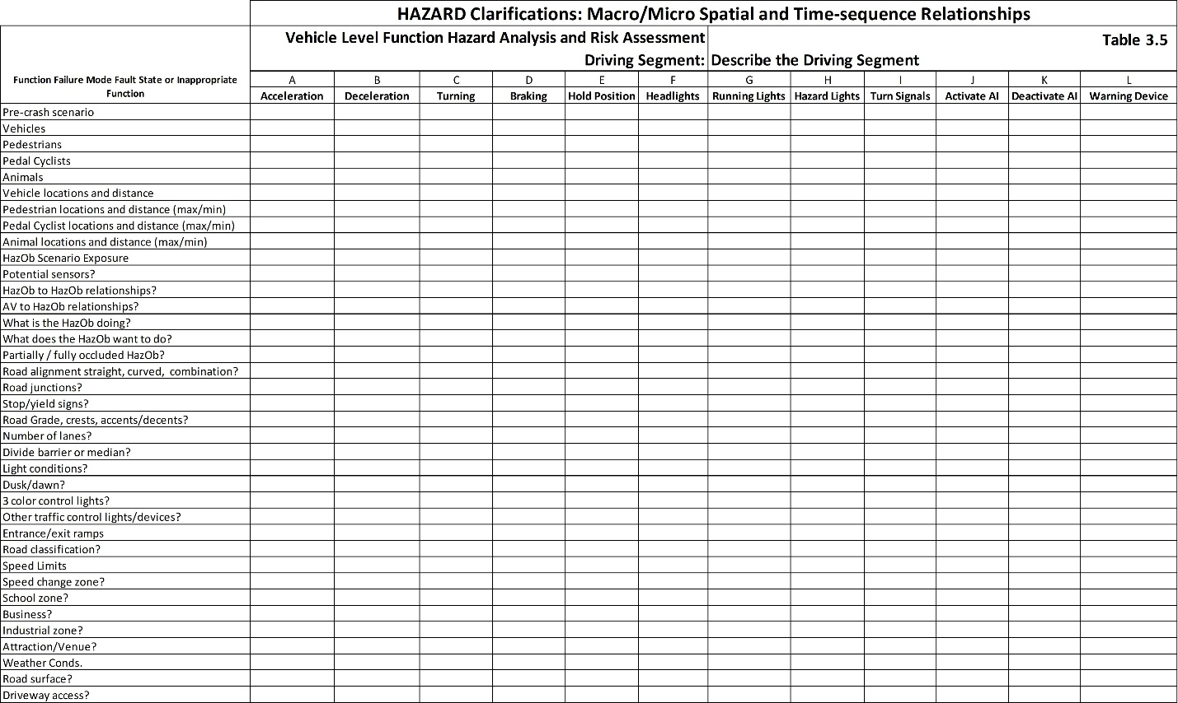
Table 3.5 documents the relationships that need to be sensed and understood. Add rows and clarifications and new concept design elements to the form as needed. Update the concept level functional block diagram (element/block, functions, and to/from function relationships). This is needed to ensure that the Functional Safety Requirements are properly and fully covered by the Functional Safety Concept. Review each representative road segment flow entrances/exits. Document what the AV must be able to sense, recognize, relate, and understand to determine its safe planned path and vehicle level functions.
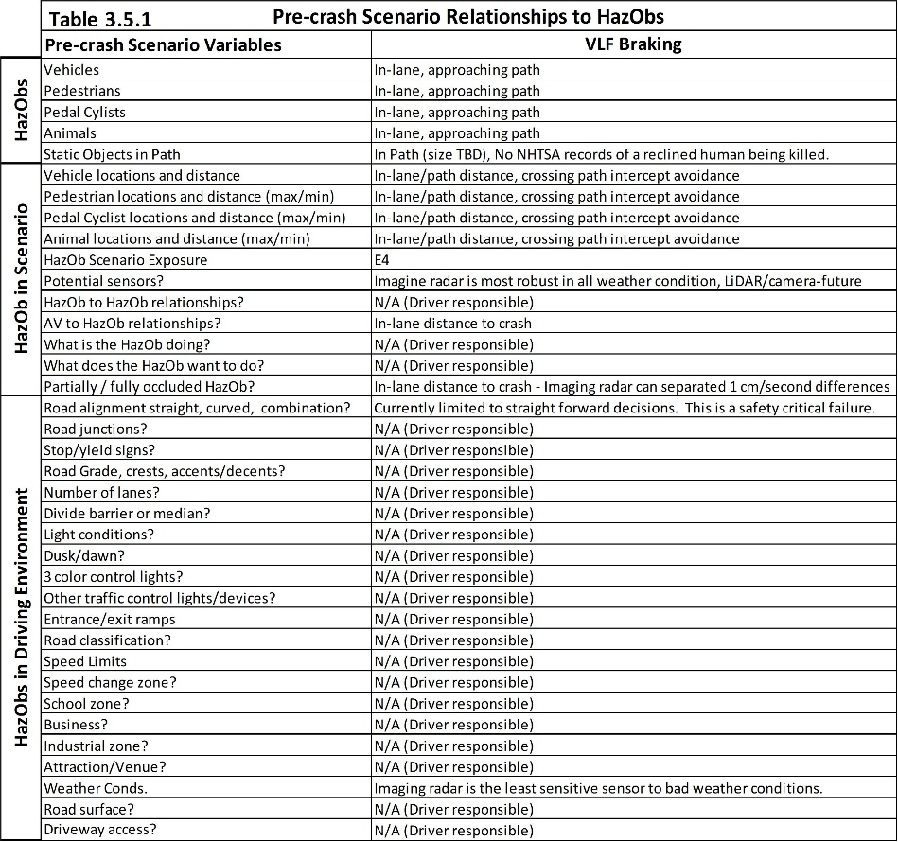
Table 3.5.1 is an L1 example for a crash avoidance system. The first set of rows defines the HazObs and objects that sensors must recognize.
This second set of rows describe the HazOb in relationship to the scenarios or driving environment and the ASIL Exposure Risks for each function. Exposure changes based upon the representative driving segment. For example, pedal cyclists on a controlled access road are extremely rare. Animals on a freeway are extremely rare in most areas of a country but are present in a few specific regions of a country. A human might be on the trouble strip of a freeway but it is extremely rare that they voluntarily step into the lane of an oncoming vehicle. With the exception of road workers and emergency responders, a pedestrian has no right-of way on the driving surface of a controlled access road.
The third set of rows considers the driving environment such as road geometries, interchanges, signage, control devices, time of day, speed limits, the type of residential/businesses being passed, and so on. These all relate to the fatality tables 3.21-3.28.
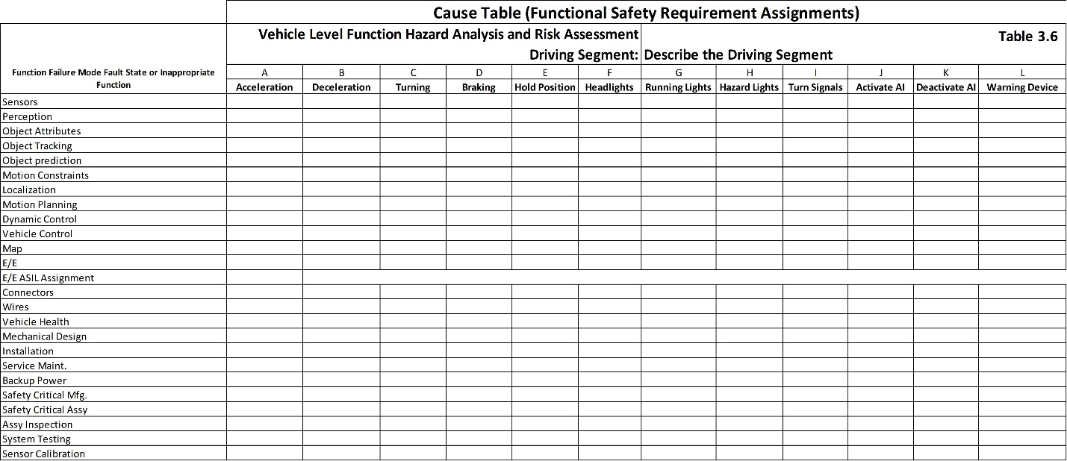
Table 3.6 is used to assign Functional Safety Requirements for each concept/system level element function. Every element is a functional block on the 7FM Functional Block Diagram. Every functional block has functions that leave the block and go to another element/block. The functional safety requirements are assigned as function’s input requirement or functional performance requirement (output). This will be included in the final Functional Safety Concept. Once all Functional Safety Requirements are assigned (system function level validation requirements), the Safety Goals will theoretically be met. Each precrash scenario and related Safety Goal receives one Table 3.6.
Table 3.6.1 is an L1 example for a crash avoidance system which autonomously activates brakes. The system monitors forward HazObs that are in lane or moving into the forward path on a simple intercept path. One of the obvious capability constraints is that the system assumes that the vehicle is going straight and all forward objects/HazObs are at risk. This is the same assumption as poorly designed dynamic cruise control systems that pick a target from the wrong lane on a curved road. The AV must be able to perform, as a minimum, basic AV current path analysis as it relates to the relative position and paths of objects and HazObs within or approaching the crash zone. At this point in the analysis the system can add feedback from the vehicle’s Steering Control Module (SCM). The steering wheel angle is either commanded by the driver or by a SAE-L1 lane centering autonomous command. The SCM publishes the steering position on the vehicle’s CAN and from this the rate of change and acceleration of steering wheel position change can be calculated (the arc is becoming larger/smaller). The steering wheel angle will allow 1 Controls (Figure 3.12) to calculate the arc of the AV’s path. The dimensions of the AV will become an overlay on this planned path (the width and length of the vehicle that might hit a HazOb). The AV will be able to predict HazObs that are on, or are moving into, the AV’s actual path. The current actual AV trajectory can be overlaid onto the iRadar’s signal. The results will be a reduced number of false emergency braking and increased number of correct emergency braking.
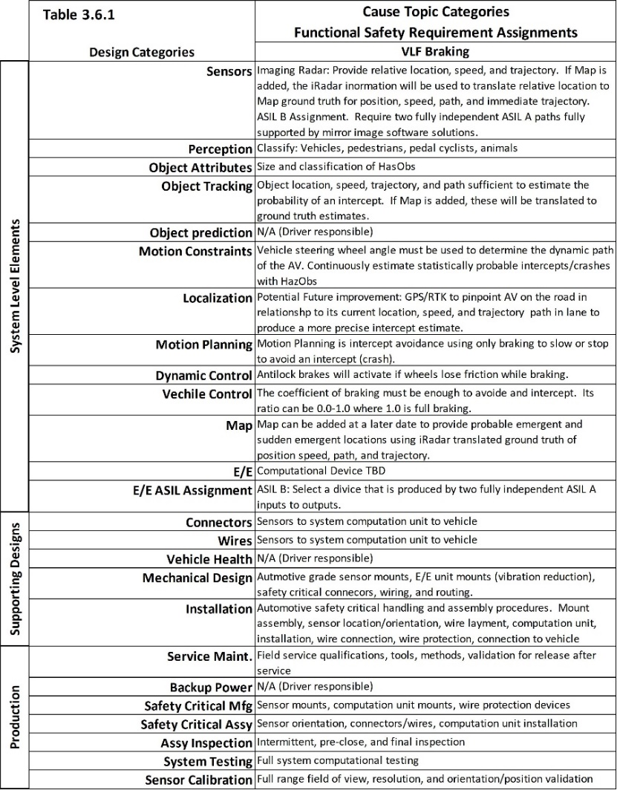
General comments on the measurement uncertainty of sensors. Correctly controlling steering, throttle, and braking requires that the AV is statistically certain of all HazOb positions and paths as related to the AV’s position, path, velocity, and acceleration. Positional Uncertainty includes measurement and movement variation (Figure 4.14) sensors/AV is the Safety Critical Variation about the planned path. This combines sensor and AV safety critical passing/stopping variation. When the AV safely passes or stops it must miss a HazOb by a minimum safe distance. The sensor measurement variation must be less than 10% of the AV_{x,y} variation about its planned path. This way, when the two variations are combined, sensor variation only adds 0.5% to the total Safety Critical Variation. This is the same argument as automotive MSA - Measurement System Assessment for measuring the dimensions of safety critical components/parts. Safety critical variation is close range (not long distance) measurement system assessment. This is the measurement system variation of each sensor at the furthest expected distance that an emergency escape path will be chosen and executed. Living real time measurement system assessment and measuring individual sensor degradations are solved with the first designs. There are two individual measurement systems. One is the GPS/RTK and variation about the AV’s planned path. The other is from a sensor to the HazOb’s relative or ground truth position, speed, path, and variation about path. Each sensor used to determine HazOb positions, speeds, and path requires its own measurement system assessment.
The next section covers the assessment of risks and the creation of safety goals. The classification of risks is based on Severity, Exposure, and Controllability and ends with the assignment of Automotive Safety Integrity Levels A, B, C, or D. An ASIL D is the most severe risk assignment. The assignment takes place in the bottom rows of Table 3.4. Safety goals are assigned to each function for each representative road segment analysis. ISO 26262 requirements are based on ASIL assignments.
ISO 26262 Part 3-6.4.3 Classification of hazardous events
If the scope of the analysis is too small, the assignment of risk will be QM safety critical and assigned to the IATF 16949 safety critical function management process. For example, a rural expressway/freeway is characterized by its laminar flow right of way driving. Laminar flow is inherently free from risks and will receive a QM assignment. All expressway/freeway situational risks such as cross traffic, sudden slow-downs, lane-reduction, forward crashes, debris in the road, roadwork, first responders, speed reduction/increase, and so on will be solved by the more complex representative urban/city and freeway/freeway exchanges. It can be argued that only ten to twenty percent of limited access roads will provide unique physical relationships and they will contain all the general risks of open highway driving. This is why the complex limited access roads are chosen as representative road segments and all rural roads are collapsed into the more complex segments. Unique rural areas are identified and studied for their own risks of weather, animals, farm equipment, farm workers, and so on. The rural freeways with exceptionally high speeds such as 85mph are unique and must be studied for this specific risk (Texas State Highway 130). Some rural freeways have extremely uneven road surfaces which cause excessive rolling, pitch, and yaw. These are measures of instability (e.g., interstate 70 between Grand Junction and Interstate 15 in Utah). These must be studied for their instability components. City representative road segments are the same way. The most complex residential roads will solve all the simple residential roads and they can be collapsed into a tractable number of representative road segments.
ISO 26262 Part 3-6.4.3.1 All hazardous events identified in 6.4.2 shall be classified. The classification will be based upon the driving segments studied in each Table 3.4. The hazardous events are the precrash scenarios described in Tables 3.21 through 3.41 and allocated to misbehaving and inappropriate VLFs in Table 3.4. The Severity of the precrash scenario will be based upon the injury and fatality rates and the HazOb Exposures of each segment studied. The level of Controllability by a driver for SAE L1, L2, and L3 designs can be assessed. Controllability is the likelihood that a driver can assume control and avoid the precrash scenario.
ISO 26262 Part 3-6.4.3.2 The severity of potential harm shall be estimated based on a defined rationale for each hazardous event. The severity shall be assigned to one of the severity classes S3, S2, S1 or S0 in accordance with Table 1 (Table 3.42 and 3.42.1). If the probability of a critical injury or death (AIS 5 or 6 - Table 3.42.2) is 10% or greater, Severity is S3. If the probability of significant injury of AIS 4-6 is 10% or greater but not an S3, Severity is an S2. If the probability of an AIS 1-6 injury is greater than 10% but not an S2, Severity is an S1. Anything less including only property damage is an S0. This produces a more objective level of severity risk.
Table 3.24 is adapted from The Semantic Scholar [semanticscholar.org]. It is an analysis of 120,532 crashes over a general domain. The table compares an older method of assessing injuries (KABCO) to the newer method of assessing the worst AIS injury on an injured person, the Maximum Abbreviated Injury Scale (MAIS). If a victim has multiple injuries, only the most severe is used and that produces the Maximum Abbreviated Injury Scale. The right side of the Table 3.24 shows that the MIAS analysis provides a smooth and real Pareto of injuries. Of these injuries, 77.5% are minor, 14.6% are moderate, 4.4% are serious, 2.5% are severe, 0.3% are critical, and 0.7% are fatal. KABCO over and under estimates injury risks. MAIS is the best estimator of injury risk.
The severity assignment for the study in table 3.24 where nationally 29% of crashes have injuries (Table 3.20), would be as follows. 29% X 92.1% = 27% are AIS 1-2. 29% X 6.9% = 2% (AIS 3-4). 29% X 1% = 0.29% are (AIS 5-6) which is less than 10% (Not S3). AIS 3-6 = 2% + 0.29% < 10% (Not S2). When the AIS 1-6 are summed, the total is the percent of crashes with any injury which is 29% and this is greater than 10% so the assignment is S1. An overly broad ODD will artificially add non injury crashes to the percent of total crashes and will lower the severity to an S1 assignment. The majority of crashes that occur involve low hazard energy. The riskiest representative road segments have the highest risk of S3 and S2 assignments. These are used to estimate the hazard severity risk of VLFs. Representative road segments are large enough to contain all driving complexities and meaningful injury crash risks. The lower risk road segments represented are not included in the estimate of risks. Underestimating risks occurs if the scope of the study is too small or overly broad.
ISO 26262 Part 3-6.4.3.3 There are operational situations that result in harm (e.g., an accident). The precrash scenarios are created when the intended safe path, acceleration, deceleration, braking, stopping, holding positions are violated. This topic is thoroughly covered in previous conversations.
ISO 26262 Part 3-6.4.3.4 The severity class is S0 if the malfunctioning behavior is limited to material damage. No ASIL is assigned.
ISO 26262 Part 3-6.4.3.5 The exposure to HazObs for each representative road segment in relationship to each precrash scenario (Table 3.4) as related to the HazObs in each segment (Table 3.5). Table 3.43 (ISO 26262-3 Table 2) is used to select an appropriate exposure for each representative road segment. The exposure for representative road segments is considered at the most complex time of day.
ISO 26262 Part 3-6.4.3.6 The number of vehicles is not part of the conversation. Exposure relates solely to the probability that HazObs are located in the areas that will be wrongly intruded by the AV’s specific VLF failure modes and their related hazards as are identified by Table 3.4.
6 ISO 26262 Part 3-.4.3.7 Class E0 is used when no HazObs are present or the conditions required to create the scenario are an “Act of God” such as a plane landing on the road in front of the AV. Act of God exposure approaches a 0% probability. An E0 assignment would be most county roads in North Dakota or Wyoming.
Exposure is further clarified in Tables 3.43.1 (ISO 26262-3 Table B.2) and 3.43.2 (ISO 26262-3 Table B.3). The goal is to select an exposure that best reflects reality. For any company an honest ASIL D solution with its supporting work product and safety case will be better in court than an argued ASIL C with less stringent requirements. The goal is to make the risk assessment objectively arguable.
ISO 26262 Part 3-6.4.3.8 The controllability of each hazardous event, by the driver or other persons involved in the operational situation shall be estimated based on a defined rationale for each hazardous event. Controllability risk numbers are defined in Table 3.44. Controllability is the ease at which the driver can assume control and avoid the hazardous events specific to each VLF failure mode’s precrash scenario (Table 3.4). The driver would have to take control of the faulty steering, acceleration, deceleration, braking, stop and hold position, and transmission controls. If there is no driver in the loop (L4 or L5) controllability is C3. A general domain L3 is a C3 because the human mind will be disengaged. As has been seen too often, current general domain SAE L3, Full-self-driving, AKA L2+ will not recognize the risks and will drive straight into a crash. The driver will have zero chance of reacting to a sudden emergent or other catastrophic failure. And it is possible that the driver has fallen asleep or is too involved in other activities (e.g., watching a movie or texting).
L1 and L2 solutions are usually simply controllable (C1) because the driver is required to monitor the driving environment and to keep their hands on the steering wheel. L3 solutions can range from C1 to C3 based upon the solution. For example, an L3 traffic jam pilot would be simply controllable by the driver. There is little chance that the driver will become so engrossed with other things that they cannot take over quickly. The speeds will be low, so the Hazard Energy will be low (very low risk of injury). The system can be designed such that an early warning system will be able to warn the driver that the system is failing, or that the system reached the maximum driving environment complexity it can resolve. Latency monitoring can be used to detect excessive complexity and activate a safety mechanism or minimum risk condition. In start and stop traffic, it is safe for the AV to slow to a stop and wait for the driver to assume control.
ISO 26262 Part 3-6.4.3.9 Class C0 does not involve a violation of a functional safety VLF.
ISO 26262 Part 3-6.4.3.10 ASIL is the relationship of risk based upon severity, the probability of exposure, and the driver’s controllability of the precrash scenario. Each representative road segment HARA (Analyzed by Tables 3.4, 3.5, and 3.6) receives its own ASIL based upon Table 3.32 (ISO 26262-3 Table 4)
ISO 26262 Part 3-6.4.3.11 When complex scenario relationships have to occur at the same time to create the precrash scenario, the probability of the event is “incredibly small” and QM will be applicable. The representative driving segment will need to have this complexity documented.
For the Emergency Crash Avoidance system, injury and fatality are considered together, the Severity Classification is S3. Exposure considers only the most complex representative road segments. In these segments, the AV is always exposed to a potential precrash scenario forward collision and is an E4. Consider that the HARA analysis suggests that 53% of all crashes relate to this study (the HARA – Table 3.4.1) which means exposure is extreme. When the system fails and warns the driver it is easily controllable which is a C1. According the Table 4 above, this combination produces an ASIL B. This update has been added to Table 3.4.1
ISO 26262 Part 3-6.4.4 Determination of safety goals
ISO 26262 Part 3-6.4.4.1 The safety goal is the goal of the ideal function. If it is achieved, the failure modes will be avoided. The majority of the AV right-of-way violations cause by other vehicles, pedestrians, and pedal cyclists will be avoided. Each VLF from each representative road segment from the HARA that has an ASIL requires at least one safety goal. The safety goal is dependent upon the VLF failure modes, their precrash scenario, and relationships to the HazObs. If the safety goal is satisfied, the VLF will avoid causing harm and the design is free of that specific unreasonable risk. VLF safety goals can be combined into a more comprehensive safety goal. The conditions that precede a specific classification of precrash scenario will have structural differences between representative road segments. The physical patterns will have similarities but distances, speeds, and road structure constraints will be different. This leads to different Functional Safety Requirement Assignments. The non-HazOb objects will have patterns that must be separated from the HazOb and drivable surface patterns. All fingerprints are different from each other but belong to the category of fingerprint. All finger prints can be detected as different from a toe print.
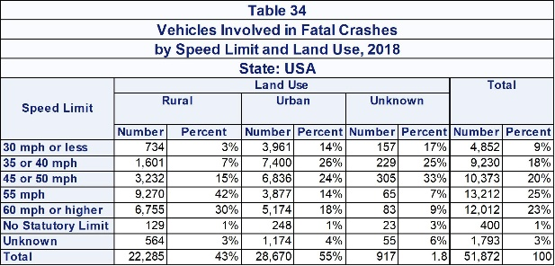
ISO 26262 Part 3-6.4.4.2 Each VLF with an ASIL receives its safety goal. The VLF receives the highest ASIL across all representative road segments. Common safety goals are combined. The failure modes for Emergency Forward Crash Avoidance relate to the braking function: Send Emergency-Brake-Command. The risky failure modes are: Does not Send-Emergency-Brake-Command, Incompletely Send-Emergency-Brake-Command, Unevenly Send-Emergency-Brake-Command (biased high or low). and Send-Emergency-Brake-Command too Slowly. The safety goal is to avoid hitting a forward vehicle, pedestrian, or pedal cyclist who based on their position or movement will have a forward intercept with the front of the vehicle. Stating this more simply, the Safety Goal is to “Safely emergency stop before hitting a forward vehicle, pedestrian, or pedal cyclist. There are four failure modes that result from design weaknesses in the functional sequences between the sensor to vehicle level function “Send Emergency Brake Command.” The Functional Safety Requirements will address every potential reason for each of these four failure modes. This goal has been added to Table 3.4.1. It is appropriate to state the percentage of crashes, injuries, and fatalities which will be reduced by the L1 forward crash avoidance solution. The effectiveness of the solution is to reduce NHTSA forward crashes by 50%. If crashes are almost avoided the impact will normally be at a slower velocity. If the impact is at a slower velocity, it means the kinetic energy/hazard energy will be reduced. If a vehicle, pedestrian, or pedal cyclist is not paying attention and suddenly and unexpectedly moves in front of the vehicle, the velocity will not be reduced. The worst injuries will still be bad, but there will be fewer of them. It is important to state the numerical reduction goals. Then test the reduction in crash velocities for the test that cannot avoid a crash. How much has velocity been reduced? Can the team estimate a reduction in injuries and fatalities? NHTSA has crash, injury, and fatality tables based upon the speed of each category of vehicle. Using such a table will provide objective estimates of injury/fatality reduction (e.g., average worse case speed is reduced by 56% (70mph reduced to 31 mph injury/fatality). NHTSA has crash, injury, and fatality statistics for 70 mph vs 30 mph (Table 34). An objective reduction of risks can be proven. In summary, if the crashes, injuries and fatalities are reduced below the target percentages, the Safety Goal of “stop before hitting” has been achieved. It is not zero. It is not possible to achieve zero.
ISO 26262 Part 3-6.4.4.3 Safety goals with their ASIL shall define specifications for all VLFs that if met will avoid creating precrash scenarios and their potential hazards (ISO 26262-8:2018, Clause 6). Lateral and longitudinal statistical capability was addressed in HARA part 2 of 3. Fully safe specifications begin when the passing and stopping distances are greater than 6σ_{x,y,z,v}. This is the AV’s 2Cpk velocity-based capability of following its planned path. The larger the linear and rotational inertia of the AV, the greater its variation about planned path. Rotational inertia is the measure of instability (pitch, roll, and yaw). Linear inertia is the product of mass and velocity and it is a vector. It has direction. It takes energy to change the vector. The larger the inertia, the larger the variation and the greater the risks. Motion constraints are any of the eight first order choices with Cpk’s < 2.0. These specifications are live/immediate and they are continuously updated for a large number of reasons. Variation changes with road surface, vehicle degradation, sensor degradation, road geometry, road grade, wind, luggage, number of occupants, and many other reasons. When all eight first order positions surrounding the AV have Cpk’s < 2.0, there are no fully safe emergency escape paths. To move into any of these positions would violate the minimum lateral and longitudinal safety specifications. There is only the least risk harm to society choice (HARA part 2 of 3). The most important 6σ_{x,y,z,v} specification is based on the estimate of variation at the moment motion planning must make a decision.
ISO 26262 Part 3-6.4.4.4 Each representative driving segment receives at least one set of tables 3.4, 3.5, and 3.6 along with notes and reasoning for the assigned ASIL to each VLF. The assignment of ASILs and their supporting reasoning/assumptions are included in the systems level integration validation (ISO 26262-4:2018, Clause 8). When the study is completed, each VLF receives the highest ASIL assigned across all the ODD’s representative road segments. In other words, if lighting receives 90 QMs and 1 ASIL A, it is an ASIL A.
ISO 26262 Part 3-6.4.5 Management of variances of T&B (Truck and Bus) in hazard analysis and risk assessment covers the base and unique configurations of vehicles as well as their unique operations/ODDs. This one paragraph covers 6.4.5.1 through 6.4.5.7. Each Item Definition defines the base design. Any T&B might have families of products with significantly different buildups, masses, suspensions, steering, throttle, and braking that create and manage different kinetic energies of the vehicle. Variation about a planned path, which means it 6σ_{x,y,z,v} velocity base passing and stopping specification limits are significantly affected by all these factors. Variation is a key component of predictably avoiding the creation of a precrash scenario. Each base product and its variants can have different stability metrics based on singular or multiple Centers of Gravity (pitch, roll, and yaw). These can lead to complex and changing moments of inertia and angular changes during normal and emergency maneuvering. Any configuration that significantly changes its variation about planned path, stability, or stopping distance must be defined. Each T&B configuration can change drastically while in use. Consider an empty bus compared to a full bus. Consider a Class 8 truck with an empty trailer in high wind compared to a full trailer in high wind. Consider a full trailer with poor mechanics/maintenance. The AV MUST be able to update their living variation based on self-measure and update both linear and rotational variation changes and how they affect safe acceleration, deceleration, turning, and stopping. They must be able to update their changed singular/multiple/conjoined Center of Gravities, Moments of Inertia, and they must be able to predict stability along their planned path before they drive the planned path (stability prediction modelling). Each configuration requires its own validation of all precrash scenario. Once completed, they can all be included in a singular safety case for the family of vehicles.
ISO 26262 Part 3 4.6 Verification
ISO 26262 Part 3-6.4.6.1 The HARA and its safety goals needs to be verified (ISO 26262-8, Clause 9). The identification of the representative driving segments needs to show that the ODD has been properly represented and this includes driving times of day and potentially weather conditions. The complexity of the driving environment in each representative road segment must be defined: road type, road geometry, straight road, curved road, up-hill, down-hill, crest of road, locations of vehicles, pedestrians, pedal cyclists, time of day, weather conditions, and so on. Tables 3.4 and 3.5 must represent the Item Definition from the 7FM Concept level Functional Block Diagram, its VLFs, and the ODD. Interrelationships and dependencies of other items must be included in the 7FM Concept Functional Block Diagram (next chapter) and the HARA performed on the Item Definition. Tables 3.4 and 3.5, the representative road segments, and the thoroughness of the analysis must be verified. How the Functional Safety Requirements satisfy the safety goals, Table 3.6, must be verified as appropriate considering the VLF, and their failure modes.
In closing, this section covered the approach that links VLFs failure modes/fault states to each NHTSA precrash scenario. It ended with the assignment of rational safety goals that define when each VLF is free from unreasonable risk. It covered a methodology to assign Functional Safety Requirements to each Concept Design Element so that the safety goals can be achieved.
Each representative road segment must be analyzed to document the HazObs present, the AV’s planned path through the segment, and how rationally predictable emergent and sudden emergent patterns form. Safety goals state the requirement of VLFs in producing measurable and verifiable reductions of NHTSA’s crash table risks. Functional Safety Requirements must be assigned to concept design elements and their functions that will avoid the risks of each VLF failure mode in each representative road segment. New elements, functions, and interrelationships between concept functions must be added. All knowable risks must have Functional Safety Requirements such that the safety goals can be achieved. The next step is to develop a functional safety concept that combines all concept functional sequences and interrelationships from sensors to VLFs. Every concept function failure mode will be evaluated and turned into a 7FM Fault State Map. Fault detections will be designed to detect every concept function failure mode/fault state. Safety Mechanisms will be designed for every detected failure mode/fault state. Fault Tolerance Time Intervals will be established. The initial E/E hardware design will be decomposed such that there is a minimum of two (ASIL A/B) or four (ASIL C/D) decomposed and fully functional E/E paths between sensors and VLFs. Sensor strengths and weaknesses will be established. Individual sensor degradation monitoring will be designed. Sensor coverage will ensure Sensor ASIL requirements are never violated by the failure of any given sensor. This will produce the Functional Safety Concept. This is the starting level system design.

