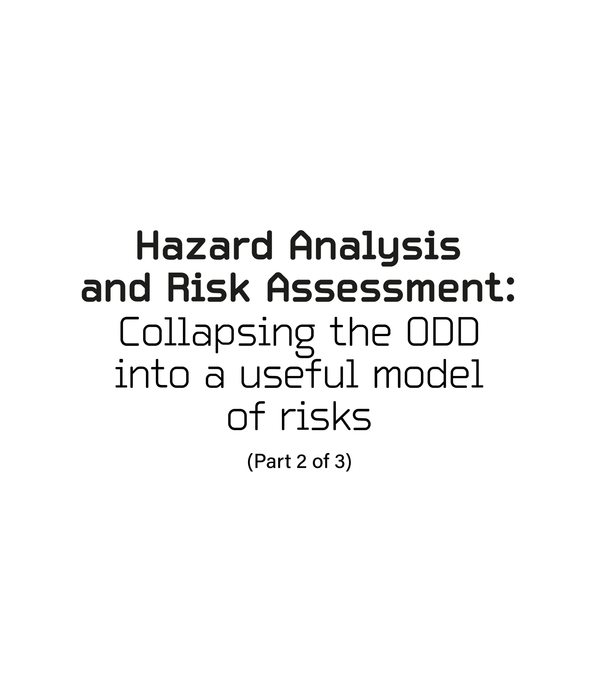
HARA Part 2 of 3: Collapsing the ODD it into a useful model of risks
Overview
When this step is complete, the HARA becomes tractable project management of studying, documenting, and summarizing all risks.
All domains can be compressed into a deFinable model which includes all risks. Solving the risk of this model solves the risk of the ODD. An AV cannot drive on a road segment until it has solved all technical challenges/risks of the segments.
when traffic flow is laminar, it is inherently safe. Situational flow has minor/moderate turbulance caused by cross flow patterns and flow constraints. precrash scenario is turbulant flow where risk is controlled by exposure (a randome uncontrolled variable) and risk managing responses (designed to avoid all risks).
7FM considers the levels of autonomy to be complextiy of solution and specfic to the need of the domaign. L1/L2 solutions are general domaing closed loop control systems. L3 solutions are narrow domain First order solutions with dirct first order responses. L4 solutions are second order solutions with second order responses and full addaptive controls and path planning. An l5 solution is a second order solution which is third order as necessary to solve a complex point on the ODD map. as necessary with third order solutions ass necessary. It is also fully addaptive an fully predictive as necessary. It also has risk reduction full path planning.
This is part two of three of the Hazard Analysis and Risk Assessment. Part-one covered the ISO 26262 requirement for the HARA and then expanded into road types, the situation analysis, and an overview of hazards (precrash scenario). This article compresses the ODD into a model that contains all technical challenges and risks which must be solved. The ODD is comprised of functional road classifications. The most complex risks of each road classification can be represented by strategically selected road segments, their transitions, and specific point risks. All knowable and findable risks are documented, summarized and ready to be linked to their vehicle level function failure modes (part 3 of 3) and begin the assignment of safety goals, functional safety requirements, and technical functional safety requirements.
Requirement Structure Supported While Performing a HARA.
- A Culture of Safety. The safety culture produces a design and safety is never compromised. A healthy safety culture would never offer unreasonable risk to society and they would follow best practices. For the Automotive OEM’s and NHTSA, evidence of a safety culture begins with registration to IATF 16949 Automotive Quality Management System which includes the scope of ISO 26262 Road Vehicle Functional Safety, as well as ISO 17025 Calibration and Testing Labs. Required Supporting Processes, product certification to ISO 26262, and full compliance to ISO 17025. This covers contractual/legal requirements from creation to satisfaction. This is a business structure and belongs to the legally responsible executive over contracts, normally the top executive. This executive is responsible for the quality and safety culture. Authority can be delegated. Responsibility cannot
- Safety Goals. Safety goals are assigned to the AV as its requirement. It will satisfy these requirements by creating elements and developing a system that directly satisfy these goals. Safety goals can relate to avoidance or attainment. They can be directional towards perfection. They can be above or below some objective metric.
- Functional Safety Requirements. Functional Safety Requirements are assigned to each risk identified in the HARA. This is what the AV must be able to observe, understand, and then produce a safe response.
- Technical Functional Safety Requirements. When a Functional Safety Requirement is assigned to one of the system level elements.
Driving environment complexities will consider 1) laminar flow, 2) situational flow, and 3) turbulent flow. Laminar flow is inherently safe driving. There is a smooth acceptance/obeyance of right of way rules and regulations. Situations have one or more small pockets of turbulence caused by flow exchanges and restrictions.
Some drivers become more aggressive as they are slowed. These drivers make sudden aggressive maneuvers which causes traffic to respond by changing flow towards precrash scenario. These patterns are detectible. Turbulent flow is the moment flow transitions into a precrash scenario. Severity and exposure risks are assigned from the NHTSA tables for vehicles, pedestrians, and pedal cyclists.
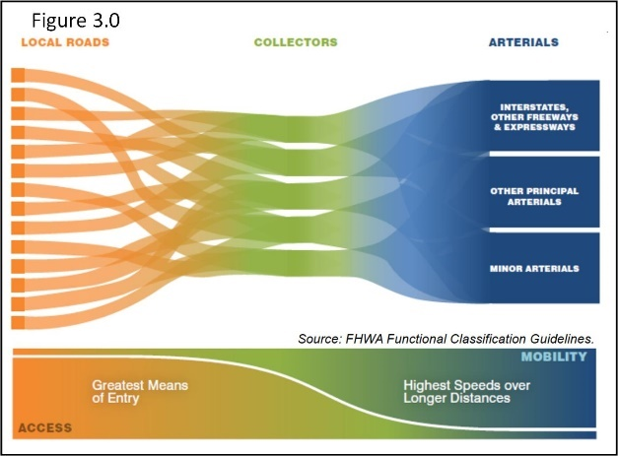
The AV will make choices about road grade access and mobility (Figure 3.0). Access is defined by the point/reason at which occupants exit a vehicle (e.g., business, parking, shopping, eating, drinking, and so on types of access. Occupants become pedestrians and pedal cyclists and will move towards or away from the flow of traffic. Mobility reduces travel time so there are fewer traffic redirections, flow crossings, situations, or cross flow risks. Mobility roads are designed to support safe laminar traffic flow, at elevated speeds, over extended distances.
Situational Turbulence. Every large city has two freeways that cross/exchange flow. These are often called “mixing bowls.” This is an example of a specific risk. Every day mixing bowls transition between all three types of Flow (Flow: AV/HazObs in both independent and co-dependent motion). This is an example of a specific point on the map risk (specific point or specific point risk). There might be many different types of “mixing bowls” across the ODD. They will not all be on a freeway. They have similar patterns of constraints. Similar patterns have similar responses (innovation). The responses must support the profile of the segment (speeds, changing lanes, HazObs, turning, inserting into flow, and so on. They belong to a similar subset of one of the Flow teams.
The HARA will provide the structure to generate validation tests. Make sure the validation testing leads are involved with every phase of the HARA. Designers design functions that are good enough. Good enough are validated against the requirements of what “good enough” means. Validation designs the tests that make a product feel as if it is in its real environment. They prove statistical capability and reliability of system and vehicle level functions.
Validation tests need to be performed in a safe controlled environment. Tests should be validated off road first (test track/recreation of situations/scenario). There must be a safety release to test or drive on the road. The release must be to the most current “as-built” technical data package of the AV. This is everything that has or should have a serial number and is responsible for directly producing, or transferring without degradation, safe functions. All configurations require “eyes-on” validation prior to release. All safety critical components of a system must be traceable and link to their validation and release approvals. All concerns must be addressed and resolved prior to release. There can be conditional releases of specific known risks that are covered by additional safety mitigation protocol.
The theater of testing includes actors, stage, and props. The theater must make the AV believe it is in the actual driving environment. Actors: AV and HazObs each with road segment entrances, navigation actions, and exits. Theater: The physical structure of the road with control devices, signs, markings, and so on. The actors play their parts as they enter, move across, and exit the stage. This creates entrance risks, cross Flow risks, and exit risks. The laminar flow the new risks are affecting are not yet at risk. Exit risks are transitions to a new segment’s entrance protocol (requirements, risks, and risk mitigation responses). It is also the general/specific point protocol for turns. Props and the positions/response from the HazObs, recreate patterns of recognizable driving situation/scenario. It must produce recognizable patterns of road structure, control devices, the location/movement of HazObs, the static/dynamic flow restrictions as required to redirect the flow into its situation/scenario. The AV and HazObs are trying to reach their respective destinations.
Humans drive by memory and developed responses. Both are required. They do not relearn and resolve the same challenge as if it is new over and over again. Humans are not ready for everything all at once all the time. This is as impossible for a computer as it is a human. The ODD will be assessed for risks and responses the way that a human would respond. Segment entry protocol is the memory and it also includes expected responses. The HARA models and prioritizes risks. The functional safety requirement explains how the AV recognizes risks and how it develops responses.
Most cities/towns have roads where pedestrians often cross and do not have right of way. Yet, all local drivers are prepared to yield to pedestrians. This is a local agreement that is not a local ordinance/regulation and cannot be connected to a venue or specific point on a map. It can only be found through local knowledge and direct study of pedestrian flow patterns. An AV can never be surprised by what is knowable and avoidable (safety goal). Every location such as this must be defined and placed in map and referenced by planning for expected maneuvers and responses.
There are homogeneous sections of roads with high volume shopping, shows, entertainment, bars, museums, and so on. This leads to being able to prove that this city block is the same as the last city block. Or, this mile of country freeway driving is like the last fifty. Master all conditions in one mile and fifty-one miles of road has been studied, mastered, and validated.
This is the collapsing of the ODD. A safety driver would be in the AV as it drove every single situation/scenario in the ODD as part of the final AV validation. Prior to this every risk has been validated on the track. All the risks of each representative segment, transition, and specific points have been individually validated on the road with a test driver, after being validated on a test track/closed off road. This is specific safety management before general risk management. The HARA knows where to find every situation/scenario in a public environment.
Figure 3.0 shows three main road purpose and it also provides an example of laminar flow, cross-traffic flow, and situational flow. Decisions to reach a destination requires connecting with sequential road segments through way-points that hand off to the next segment. Traffic Flow to a destination requires lane changes and turns/exits. Different destinations create Flow of different purpose and results in the crossing of traffic Flow. This can develop into a significant risk.
Qualified Safety - Society’s Safety Goal. When the AV is statistically safer than a human driver based upon a nation’s crash database (e.g., NHTSA) and the AV experience is embraced by its customers.
The AV must be statistically capable of managing all challenges within its ODD (statistically safe path through all traffic). The safe path is planned in ground truth from Map based on the AV’s statistical capability for what it can safely maneuver (map and road segment protocol). Near term paths are modelled using the variation at speed and a model that can fit a containable line/curve to a useful distance in ground truth (e.g., a fourth order polynomial). The actual path is fit with the same model and the variation about the actual path compared to the planned path defines the safe passing and stopping distances.
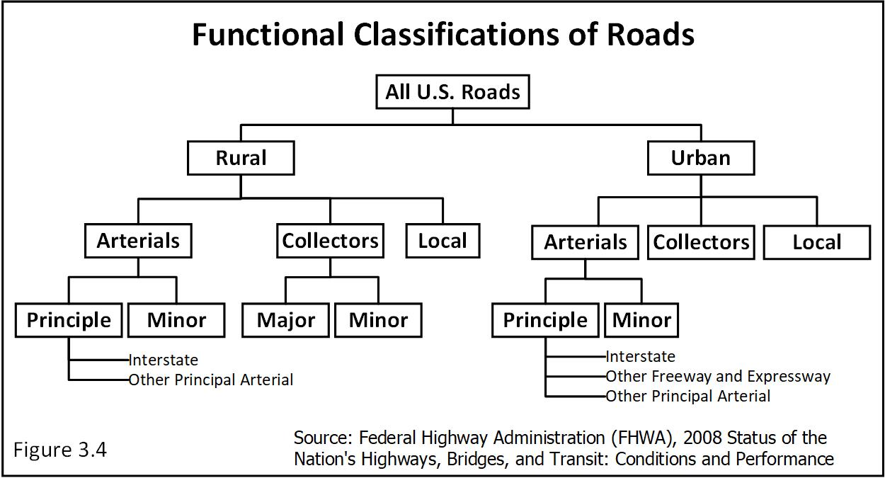
The planned path and preplanned responses of an AV must be free from unreasonable risks (probable direct interference/contact). The capability of each pass/stop along the path must be safe. A sudden emergent instantly changes the safe planned path to extreme risk. Activating a safe preplanned response would continue safe driving. Risk can only occur from a sudden emergent, which is rare and no fully safe escape paths which is also rare. Both have to occur at the same time and there are no safe escape paths. The probability of being trapped is pr {no safe escape} = (sudden emergent probability₁) X (fully constrained probability₂). How many times have you been fully trapped while driving? That is this risk. This probability is a living statistic that the AV can automatically use with almost zero extra effort because it is a simple relationship to record and the data already exists. Which areas are riskiest and why. In other words, the trip is planned and some paths are too messy at this time of day. These paths are geofenced off based on its estimated waypoint arrival time.
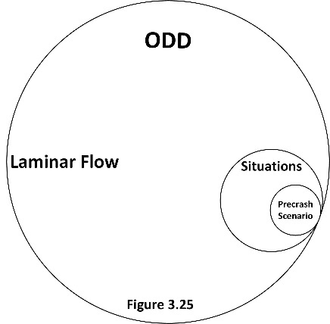
ODDs are an accumulation of functional road classifications and allowable drivable surfaces (Figures 3.25 and 3.4). The ODD includes society’s interface with the AV. Roads are assigned functional classifications by the NHTSA (Figure 3.4). These classifications define and control how the AV and HazOb’s access the varying levels of drivable surfaces. Each classification has its own crash statistics table and will be reviewed later. Each line between classifications is a transition point where risks can significantly change. These are the classifications in Figure 3.0. All roads are designed to control road-grade access. This means that each access point can produce a significant change in the nature and/or type of through-traffic and cross-traffic flow patterns.
The most granular classification provides road-grade access to residential homes. The least granular limits the use of freeways/expressways to vehicles that are powerful enough to keep up with traffic. Pedestrians, pedal cyclists and vehicles under a certain size are not allowed on freeways/expressways. This is a permanent reduction of risk. Each road classification is its own unique exit/entrance risks. Each has its own groups of destinations that gather and split choices towards pass through rather than access.
Each classification produces representative segments, their transition risks, and specific point risks. Each must have its own set of HazOb object digital signature matches (priori) listed from most to least probable (technical functional safety requirement). The map must contain the most likely situations and resulting precrash scenario patterns prioritized from most to least likely for each road segment – (technical functional safety requirement). This produces an entry protocol of restriction, relative HazOb positions, flow density, flow movement, and intercept patterns to match (just pattern from now on) each linked with their prioritized list of safe responses to each pattern. The AV will be able to emulate a human driver who has learned to be aware of risks associated with a given or specific road segment.
Transition is when the next road segment offers risks in a different way than the last road segment. It is also the points on the map with specific risks. This is the new segment’s safety protocol.
A system must properly assess and respond to the driving environment, monitor all its system level functions for failure modes/fault states, monitor the vehicle for failures, and transition to the most appropriate safe state before a precrash scenario develops.
Fatality, Injury, and Property Damage. Time and distance are safety critical constraints. Each scenario will define the probability of property damage, injury, or death. Probability is the exposure. The risk of harm is the combination of hazard energy in motion, physical overlap, and the nature of the HazOb struck. Severity is its negative impact on the probability of injury or fatality. For example, Table 2.23 shows that roughly 70.9% of all crashes cause only property damages, 28.6% cause injury, and 0.5% are fatal. Based upon a Maximum Abbreviated Injury Scale (Table 3.24), the injuries will average out to 92.1% minor to moderate (Severity = S1), 6.9% serious to severe (Severity = S2), and 1% Critical to fatal (Severity = S3).
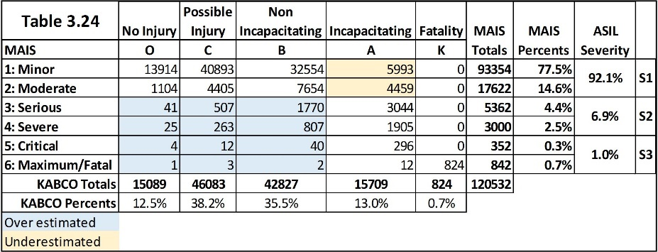
The system must be able to detect the point where situations transition into a precrash scenario (technical functional safety requirement).
Functions must be statistically capable of maintaining the AV’s right of way and avoid intruding into the right of way of others (safety goal). The AV must respect the right of way of HazObs that legally enter the flow of traffic in front of the AV (safety goal). The AV must be able to avoid reasonably common HazOb violations of its right of way (safety goal).
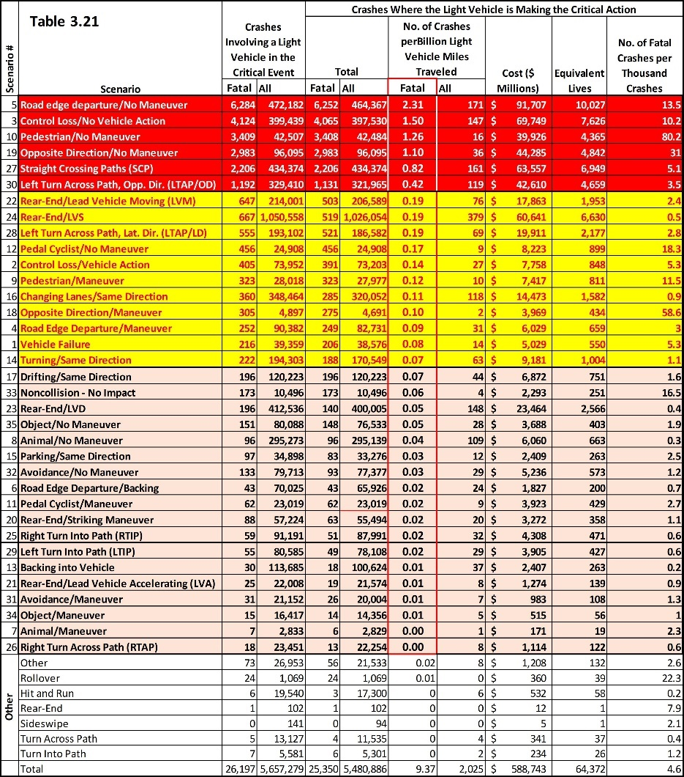
The NHTSA Precrash Scenario. Table 3.21 was produced from NHTSA’s database. It is based upon a light vehicle that either fails to respond or selects an inappropriate response to an event resulting in a precrash scenario linked to each crash. Six precrash scenario produce eighty percent of fatalities (red). The next set account for fifteen percent of the fatalities (yellow). The remainder account for five percent of fatalities. The highest fatality rate is 2.31 deaths per billion miles. This is scenario number 5, Road Edge Departure/No Maneuver which means there was no driver response (i.e., not created by a response maneuver). The AV must never drive on a surface it cannot safely define (technical functional safety requirement). The AV must never drive on a surface where right-of-way is unknown (technical functional safety requirement). The AV must never drive unless the path is on an authorized safe driving surface (technical functional safety requirement). The AV has already been assigned the safety goal of creating and being capable of safely managing path. This is assigned to the Path team and is part of the core design.
Automotive manufacturers require a Cpk ≥ 2.0 for safety critical design functions. A design capability of Cpk ≥ 2.0 theoretically produces two failures/crashes per one billion challenges (e.g., one-billion individual miles driven, each time a function is actuated, and so on).
Design capability asks two questions. 1), what is the distance/time to a HazOb, object, or physical constraint (hazard distance)? 2), how far does the AV’s variation extend in that direction from the mode (hazard variation). How much safe distance remains? Capability (Cpk) is an equation of how many times hazard variation will fit within the hazard distance. A Cpk = 1.0 means that there is just enough room/time for a perfect fit and last second changes can be problematic. This last moment in time is inescapable but risks can be minimized. Figure 4.17 shows comparable relationships between process capability and Hazard Capability (statistical capability or Cpk/Cpk_{sc} from now on).
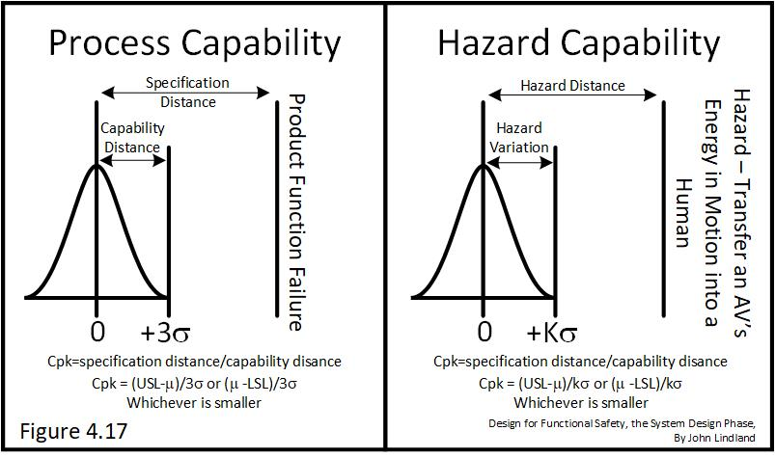
Each system function requires fault detection strategies. Some detections will compare the function to an independent reference of correctness similar to a calibration strategy, which may or may not self-calibrate. Others will detect unacceptable functions as statistical shifts of average or changes in variation (magnitude, stability, bias, linearity, or time response). This includes sensor functions. Statistically significant changes means that the AV might be unsafe.
Objectively acceptable risks, are defined by NHTSA. The crash rate exists and the public considers the risks low as they travel and bring their loved ones. There are no long-term major news stories of how driving is systemically and horribly unsafe. The public has quietly and objectively accepted these risks. They drive. They take their children with them. Everyone is relaxed and happy. Accepted risks are property damage, injury, and fatality. Occupants of any vehicle expect only the best. The worst is objectively very rare. These hazard severities and their rate of occurrence are the limits of unacceptable safety.
Hazards are estimated in billions of miles travelled. The number of crashes and fatalities for each precrash scenario are listed. Crashes are with or without a maneuver. Crashes without a maneuver – The AV did not respond to a situation or precrash scenario. It continued on its planned path and crashed. Crashes with a maneuver – The maneuver is the response to a precrash scenario and the response caused a crash. This will be covered in detail later in the material.
The NHTSA describes 36 precrash scenario are:
1 Vehicle Failure–AV crashes due to a component/mechanical problem or failure (e.g., tire blowout, steering issue).
2 Control Loss/Vehicle Action–AV loses control while performing a maneuver (e.g., passing, turning at an intersection).
3 Control Loss/No Vehicle Action–AV loses control while driving straight or negotiating a curve.
4 Road Edge Departure/Maneuver–AV departs the road while performing a maneuver (e.g., passing, turning, changing lanes).
5 Road Edge Departure/No Maneuver–AV departs the road while driving straight or negotiating a curve.
6 Road Edge Departure/Backing–AV departs the road while backing.
7 Animal/Maneuver–AV strikes an animal while performing a maneuver (e.g., passing, turning).
8 Animal/No Maneuver–AV strikes an animal while driving straight or negotiating a curve.
9 Pedestrian/Maneuver–AV strikes a pedestrian while performing a maneuver (e.g., passing, turning).
10 Pedestrian/No Maneuver–AV strikes a pedestrian while driving straight or negotiating a curve.
11 Pedal cyclist/Maneuver–AV strikes a pedal cyclist while performing a maneuver (e.g., passing, turning).
12 Pedal cyclist/No Maneuver–AV strikes a pedal cyclist while driving straight or negotiating a curve.
13 Backing into Vehicle–AV collides with another vehicle while backing.
14 Turning/Same Direction–AV turns and cuts across the path of another vehicle initially traveling in the same direction.
15 Parking/Same Direction–AV is entering or leaving a parked position and collides with another vehicle.
16 Changing Lanes/Same Direction–AV changes lanes and encroaches into another vehicle traveling in the same direction.
17 Drifting/Same Direction–AV drifts into an adjacent vehicle traveling in the same direction.
18 Opposite Direction/Maneuver–AV makes a maneuver (e.g., passing) and encroaches into another vehicle traveling in the opposite direction.
19 Opposite Direction/No Maneuver–AV drifts and encroaches into another vehicle traveling in the opposite direction.
20 Rear-End/Striking Maneuver–AV changes lanes or passes another vehicle, and closes in on a vehicle ahead in the same lane.
21 Rear-End/Lead Vehicle Accelerating (AV closes in on an accelerating lead vehicle ahead in the same lane.
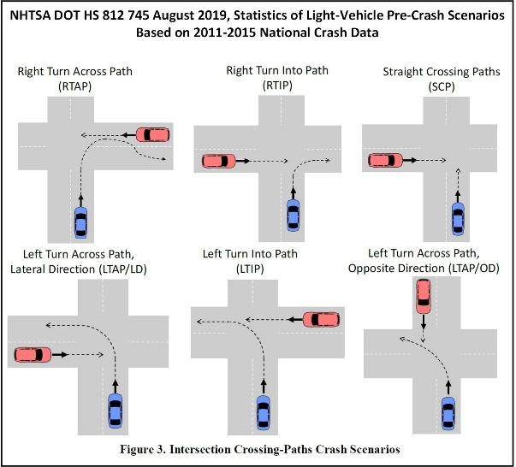
22 Rear-End/Lead Vehicle Moving (LVM)–AV closes in on a moving vehicle ahead in the same lane.
23 Rear-End/Lead Vehicle Decelerating (LVD)–AV closes in on a decelerating lead vehicle ahead in the same lane.
24 Rear-End/Lead Vehicle Stopped (LVS)–AV closes in on a stopped lead vehicle ahead in the same lane.
25 Right Turn into Path (RTIP)–AV is turning right at an intersection and turns into the same direction of another vehicle crossing from a lateral direction.
26 Right Turn Across Path (RTAP)–AV is turning right at an intersection and turns into the opposite direction of another vehicle crossing from a lateral direction.
27 Straight Crossing Paths (SCP)–AV is going straight and collides with another straight crossing vehicle from a lateral direction at an intersection.
28 Left Turn Across Path, Lateral Direction (LTAP/LD)–AV turns left at an intersection and crosses the path of another vehicle traveling in the opposite direction from a lateral direction (left).
29 Left Turn into Path (LTIP)–AV turns left at an intersection and turns into the path of another vehicle traveling in the same direction from a lateral direction (right).
30 Left Turn Across Path/Opposite Direction (LTAP/OD)–AV turns left at an intersection and crosses the path of another vehicle traveling in the opposite direction.
31 Avoidance/Maneuver–AV attempts a maneuver to avoid something while turning, passing, etc.
32 Avoidance/No Maneuver–AV attempts a maneuver to avoid something while driving straight or negotiating a curve.
33 Non-Collision/No Impact–AV makes no contact with another vehicle but it experiences a damaging or injury-producing event (e.g., fire, an occupant fell/jumped from vehicle, etc.).
34 Object/Maneuver–AV strikes an object while performing a maneuver (e.g., passing, turning).
35 Object/No Maneuver–AV strikes an object while driving straight or negotiating a curve.
36 Other–Includes rollovers, hit-and-run, and other crashes where details are missing to accurately define the scenario.
The Venn Diagram, Figure 3.25, shows where the lines of situations and precrash scenario overlap. For example, a situation common to L1-L5. The vehicle is driving in the right most edge of its lane. It drifts to the right. There is no shoulder on the road’s edge. The vehicle’s front right tire leaves the drivable surface and instantly enters into a “lane departure” single vehicle crash. Situation: Riding the right side of the lane combined with excessive lateral variation, or a path that drifts right for some reason (e.g., gps drift or following a wrong line), creates an unacceptably high probability of road departure. The Hazard Variation is wider than the Hazard Distance which is the edge of the road. Every now and then the AV will leave its lane and cause all lane departure related precrash scenario. This is the same analysis applied to all lanes of all roads. Lane departure is a Level 2 Mastery of Functions (maneuvers) failure. It is a failure for all L2-L5 designs. It is a variation at speed related test. It is also over the hill, compression, and so on. The AV will view the world from combinations of these two maneuvers (the basis of all maneuvers and responses). This is the second level of design required for L3-L5 designs.
Laminar flow includes all maneuvers, paths, traffic control devices and constraints required in normal driving. Each maneuver requires VLFs working together. Think each maneuver through to identify situations where VLFs might become unstable or have insufficient statistical capability required to avoid entering a situation or precrash scenario. Document the patterns that define the approaching situation or precrash scenario. Describe what the vehicle would have to do to remains safe and eventually return to a safe laminar traffic flow. If possible, recognize the pattern before flow is affected (a pre-match). This will define the situation/scenario that the system must detect as well as the safe response. It also contains risks that must be avoided or managed by a response that must be seen to be understood.
The AV might not be able to physically fit through specific road segments. The front corner-to-corner width of the AV while driving straight is directly understandable. The AV is wider when it is on an arc (inner center to outer corners). The inside of the arc produces side collisions. The front corner misses the HazOb and then the side of the AV intrudes into the HazOb.
The primary VLF used to drive rural freeway between transition points is steering. At normal highway speeds there is little interrelationship with acceleration or braking. Lateral controls would need to be statistically capable of avoiding the right/left edges of its lane with any side or corner of the vehicle. Equal right/left hand distances are measured at the vehicle’s longitudinal center to the right/left edges. This requires the vehicle be right of center for left hand corners and the opposite is true for right hand turns. Risks become greater when pulling a trailer or with an extremely long vehicle. The center of the vehicle’s left side will encroach into the left lane even though the tires of the AV remain in its lane. The constraint of extreme cornering capability is when the right tires are riding the right-most edge of its lane and the vehicle’s left side edge barely touches the left lane edge. The vehicle is “Arc Limited” at this point. Any road with a tighter arc must be geofenced. Many light sedans cannot directly maneuver through Grapevine Hill in San Francisco. Planning fits the planned path from map. The path is based on the hazard variation of the AV. The arc of every path is easily calculable by the system. This means that the arc of every road curve is already in map and the system is already fitting this model. Any trip planned would have to avoid arcs that are too tight to drive or dimensionally too tight to pass. This is the safe planned path that automatically avoids physical and dynamic risks. The more obvious application of a physical constraint is passing under obstacles (e.g., bridge).
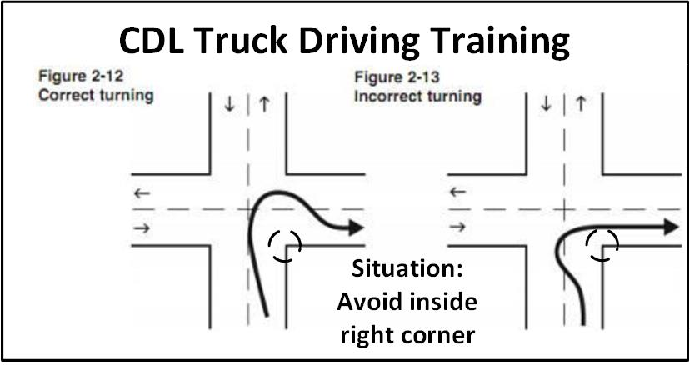
There are extreme cases where it is not possible to complete a corner while remaining within the designated/chosen lane (e.g., CDL Truck Driving Training). Dotted lane lines can be crossed when other traffic is not present. Solid lines cannot, unless it is a correctly understood response. What must the AV be able to recognize? How must it respond. Which road line rules are rigorously followed and which are not? The AV must be able to understand and adapt to human-context driving situations (safety goal). This determines when rules/laws are not going to be followed and why along with the Human Context rules specific to the road segment (entry or exit rules). Sometimes, rules are even one corner specific. Be capable of the domain. Leave the world for later.
Understand What Is Being Designed. As each segment is reviewed, describe situations that might lead to a precrash scenario. Define the response that will control or lower risks. Use Occam's razor to define situations and scenario – keep it direct and simple. An L3 solution is a direct relationship that is incapable of second order solutions. Both L4 and L5 technical solutions are capable of secondary relationships, and as necessary third order relations. The higher order relationships are often well past a third order relationship and are summarized with pre-situation, situation, and precrash scenario pattern recognitions. Each pattern has potential responses to resolve or minimize risks. Three things do not occur at once very often (a slightly blue moon at most). L4/L5 solutions will be safer than NHTSA if they solve all known secondary relationships that force HazObs to become an intrusion or sudden emergent into the AV and none of the tertiary causes are solved. This would be the cause of the secondary cause that was the direct cause of forcing traffic to crash. Specific point risks do not follow this suggestion. Many are extremely complicated and third order relationships will be the key to the technical solution.
Design leads must be directly involved in the analysis. If they are not involved, the analysis will need to be performed multiple times to answer the questions they would have answered their selves through direct observation. These direct observations lead to new questions that can be immediately and directly observed. This requires being in the field. Record a full sensor scan of each representative road segment for the design team’s review and reference (going and coming). This can lead into sensor feeds for testing perception. Pass the perception, object recognition, object attributes, motion constraints and so on. This would prove a correct understanding of the environment before validating on the test track. It would also show where sensors do not have enough signal to noise to detect and return the HazOb specific behavioral attributes to analyze for sequential and spatial risk matches. The team needs a sensor that can see further so when it is used closer, it has enough information to match a smaller portion of the HazOb. The attribute has statistically stabilized. It is stable/deterministic. It is not unstable/nondeterministic. Use all the simulated challenges as well. This would be a test of theory (verification) not validation in use. The test track would recreate each challenge and this is validation of theoretical proof in use. When all challenges have passed. The vehicle is safe to test on the specific representative road segment.
The combined knowledge and understanding in a team’s experience defines what is knowable and foreseeable by a team. The required knowledge will be from perception, object recognition, object attributes, object tracking, current/future motion constraints, emergency avoidance paths, stability prediction, motion planning, dynamic control, and calibrated vehicle control. Map and localization support most of these teams.
Twenty percent of causes produce eighty percent of the effects (Pareto Principle). Think of the AV’s that are testing and failing on public roads today. They are in the news because they are failing at high rates. Simple and every day causes are contained in this twenty percent. Basic and obvious failures are causes from this group.
Eighty percent of causes are found and avoided by a solid qualified team. This is the level of solid designs with loyal customers – This design has reached full maturity. It will be competitive with anything currently on the market. The remaining causes all have extended mean time between failures. Users will not remember the last time their product failed and the very few that fail will be the only one in a large group with that experience. Failures will be singular and a bad reputation cannot develop. This is roughly the minimum analysis required to pass The Five Levels of Mastery of Function and be explicitly proven as statistically safe.
Ninety-five percent of causes, the level of autonomy. Autonomous Vehicle teams requires the best and most experienced team members. A team of experts can identify and avoid well over 80% and approach 95% of the causes. Anything not found has not yet occurred in their collective experience (blue moon-force majeure). This is best-in-class and the design will be years ahead of the competition.
Offered as evidence. The results of well over 80% causes found and avoided is confirmed with the Chrysler Pacifica. The Pacifica received a full 7FM analysis. Experts were developed as resources and every team had a 7FM competent lead (the design responsible), guided by an expert. The design and analysis started in the spring of 2013 and the vehicle launched in July 2016. All members were competent in their field. Some were amazing experts. The analysis was active the entire three years. 7FM is a design analysis that lives with, and follows the design. It is never a form to fill out to suggest that a study has been performed. Analysis and design go hand-in-hand. No extra employees were hired to solve problems. They were avoided. There was never a risk to timing. Validations did not fail often and the few failures were solved quickly and did not violate critical path timing. There was no need for Project Managers whose focus was keeping up with solving problems. There were no extra problem-solving support teams. There were no emergency meetings with suppliers. The core suppliers were directly included in the 7FM efforts. The Chrysler Pacifica has been the most award-winning vehicle in its class since it launched the summer of 2016. This includes the PHEV and E/E controls. It launched better than Honda’s current production model. FCA deserves all its honors from this vehicle. Everyone from executives to technicians worked together and focused on results.
What must be seen? Sensor selection. What must be understood? System level functions defined by algorithms and made possible by hardware and the software that controls the hardware. What is the goal? Driving that is free from unreasonable risks.
Statistically capable functions ensure safe vehicle level commands and involve many factors such as:
- Total processing time (sensors to vehicle level functions). Transient delays are studied with every capability analysis (Cpk). All safe vehicle level functions must be commanded within a maximum defined transient time delay. Critical transient delay is when it is equal to the time required to complete an almost unsafe response (take the dust off the surface near miss).
- Each system level function Fault Tolerance Time Interval (FTTI) must be validated. FTTI are required to ensure that system level faults are safely corrected before a vehicle level function enters a failure mode/fault state and creates a precrash scenario. The threshold is when the risk of transferring hazard energy begins.
- Be certain of the expected lateral and longitudinal statistical capability at all times, speeds and maneuvers.
- Reducing the variation about the planned path directly reduces the probability of a crash.
- Lateral and longitudinal variation is dependent on speed, road, wind, vehicle size/weight, center-of-gravity, moment-of-inertia, vehicle condition/maintenance, and other factors. Mechanical and electromechanical devices change over time and the vehicle wears-out. The vehicle’s response changes. All models must age correctly with the AV.
- The statistical capability confirms that lateral (y), longitudinal (x), vertical (z) and their respective rotational variation responses about each axis remains safe for the planned path.
- Dynamic capability can be modelled and continuously updated by the system ensuring that near future vehicle level commands are free of unacceptable risk.
- A command cannot be given unless it is statistically safe to pass, slow, or stop. When dynamic variation is smaller, the Cpk =2.0 stopping/passing distance decreases. Without increasing risks, the AV can pass more closely to the HazOb. When variation increases the planned safe distance moves away from the HazOb, and again manages the maximum allowable safe risk. The two risks are statistically the same.
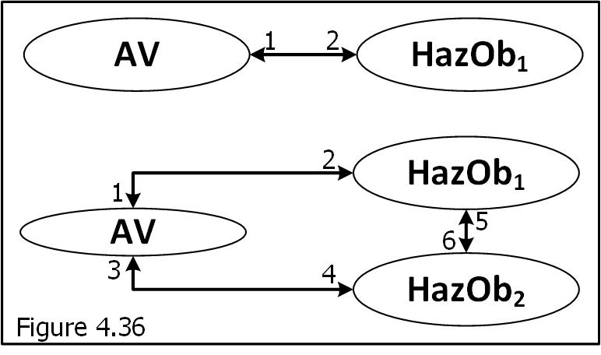
Safety Critical Processing Time. If the number of objects doubles, the processing time more than doubles (Figure 4.36). Make sure that only the constraints of the flow-patterns are used for path critical analysis (the pattern). Otherwise, the computer might become overwhelmed with non-safety-critical calculations. This is expressed over and over with AV Camera feeds that over analyzes too many things that have nothing to do with dynamic driving risks. The busier the driving the slower the system. Risks are being modelled, not the world. Third order relationships are only solved as required to produce capability so they can respond correctly to more advanced pattern matching of a wider spatial/time net. For example, a single HazOb and the AV produce two sets of relationships that affect optimal trajectory. How the AV affects the HazOb and how the HazOb affects the AV. Each relationship can be measured in distance and time which might double the processing requirement again. The number of attributes tracked for each HazOb depends on its risk. Minimum tracking is of zero risk HazObs at its ground truth location for each sensor reading (object at x,y,z,t). No risk means no analysis required. The data is available if needed. Minimum tracking allows a path to be post analyzed which might be required to assess it as a newly intrusive risk. If the AV does not use this data, it will become part of the flow team’s model. If the HazOb violates one of the “moving or trending towards an AV motion constraint” rules, it is a new risk and must be assessed. Its path and trajectory are calculated starting with the historical data previously not studied. At this moment additional HazOb spatial/sequential behavioral attributes are required. Perception must analyze these new behavioral attributes to estimate its near-term risk.
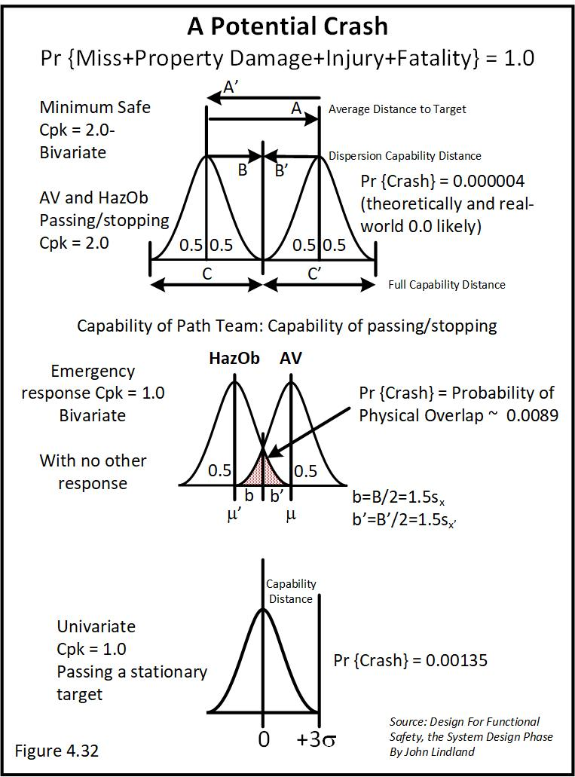
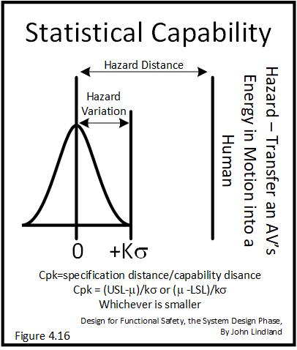
Capability, Probability, Passing, and Stopping Distances. Figure 4.16 shows the distance to hazard to the HazOb and the distance that variation extends toward the HazOb. Cpk relates to the probability of crashing while passing, stopping, or a loss of stability (Figure 4.32). A Cpk = 1.0 is acceptable only for emergency escape maneuvers. Only a forward emergent will force the AV to choose between the lowest harm hazard choices. Situation: a sudden forward stop causes a path closure with a capability of passing of Cpk = 0.1 with 382,089 crashes per 1,000,000 passes. A hard insert into the right lane has a Cpk = 0.6 with a probability of 35,930 crashes in 1,000,000 attempts. A side impact is safer than a forward impact. What are the HazObs? What are their risks of harm from hazard energy? What is the choice? The insertion is ten times safer by comparison for more reasons than the obvious. The insertion is chosen.
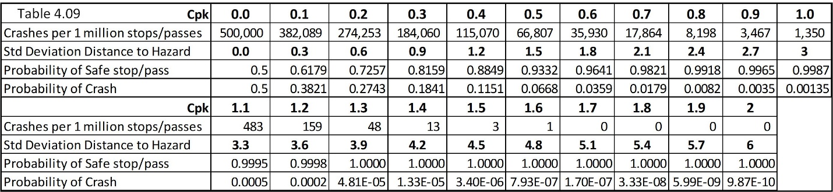
Part of the AV’s automatic decision would include hazard velocity. Lateral velocity is slow hazard energy (forced lane change). Forward hazard velocity is the full vehicle velocity. Hazard energy is ½MV² (mass, velocity, small hazard energy versus maximum). Justify the safer choice with objective data and valid statistical analysis that address least risk of harm arguments. The report must be automatically generated and saved for each choice – a simple report for risky choices and a complete report for hazard choices - Cpk < 1.0. These reports show the relationships of variables in supporting safe decisions at the moment of choice. This will be needed for review for optimization and as the starting legal defense for any crash. Post analysis, “did the AV correctly understand the environment?” Did it make a reasonably near best safe choice in response? Each of the lowest HazOb energy harm choices can be argued to be better than each other based on rational assumptions. This is not a simple Cpk_{sc} conversation. It is the risk of harm energy. This means that nobody can sort out the perfect choice from the best of these worst after the fact. Yet, all can agree that one of the least hazardous choices was objectively and correctly chosen. In a very real sense, this means that they are all arguably equal best of bad choices.
Planning must require a Cpk ≥ 2.0 for all planned paths (technical functional safety requirement: Team-motion planning and emergent response path planning). Low/some risk preplanned emergency escape paths must have a minimum Cpk = 1.0 which might be 3 inches at 5 mph and 24 inches at 60 mph.
Capability is at the shortest/closest estimated HazOb stopping and passing distance that are planned and executed along the AV’s path (physical path capability with no constraints). The transient reaction time is the current instantaneous sensor to VLF processing plus the vehicle change-in-state response time. The total transient reaction time must always be smaller than all time-to-intercept estimates (technical functional safety requirement allocated to all teams). The processing transients are allocated to elements of the 7FM Functional Block Diagram to determine critical safe transient sequence of functions. This is the safety critical response path. Its elements can be redesigned to directly increase processing power without redesigning the entire system. All rational safe escape paths must be precalculated and continuously prioritized by Cpk. This will include vehicle response time required, lateral passage/stopping/slowing distances, sequence of maneuvers to reach the new strategic position/waypoint, and so on. The goal of all responses is to lower or as a minimum maintain manageable levels of risks.
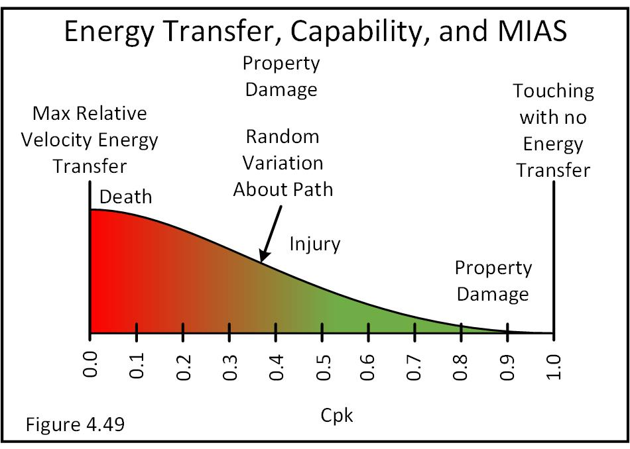
Figure 4.49 shows that knowing the nature, magnitude, and energy in motion at any moment of time, the probability of physical overlap can be used to estimate the maximum expected severity of each pass/stop. What is the worst-case relative velocity damage - Full and worst-case energy transfer (Velocity - speed and direction)? Will it knock someone over, throw them spinning, cause property damage, injury, permanent degradation of life, or death? Is there enough energy to modify the HazOb’s vehicle such that it moves into an occupant and causes harm? Is the HazOb a vehicle, pedal cyclist, or pedestrian? Which is postured at near the lowest hazard energy transfer into critical body regions: organs, senses, neck, spine, or brain?
Table 3.21-2 shows potential relationships between the NHTSA’s Federal Functional Classifications (Figure 3.4) and each NHTSA precrash scenario. SAE Levels 3-5 must be statistically capable of safely managing all risks on all road classifications in which they are allowed to be active. SAE Levels 1 and 2 must be capable of avoiding a given percentage of human caused crashes.
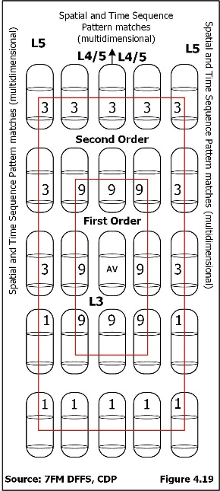
Each road classification has its own mixture of risks. These potential patterns are between “HARA Relationships” and “Precrash Scenario.” There are three relational strengths: 9-strong, 3-medium, and 1-some or weak relationship. A strong relationship is a direct first order relationship between a VLF and HazOb from or more of the 8 directions. Direct, only one thing has to happen. A medium relationship is the cause that pushed another HazOb into the AV. There are eight useful direct relationships (Figure 4.19) directions then approach the AV from one of the eight directions as direct. Think of the AV in the center of the circle. HazObs surround the AV. Something forced them towards the AV. This is secondary. In a secondary relationship, two things have to happen at the same time. This is a lower probability than direct. Three way relationships are a 1 and three things have to happen at the same time and this is normally a very low probability and as can be seen becomes extremely complicated and unlikely. This also includes the risk of E/E related failures. Hazardous relationships are caused by failure to understand or respond (looking outward) or system failures (looking inward). Forward HazObs are a far greater risk than following HazObs.
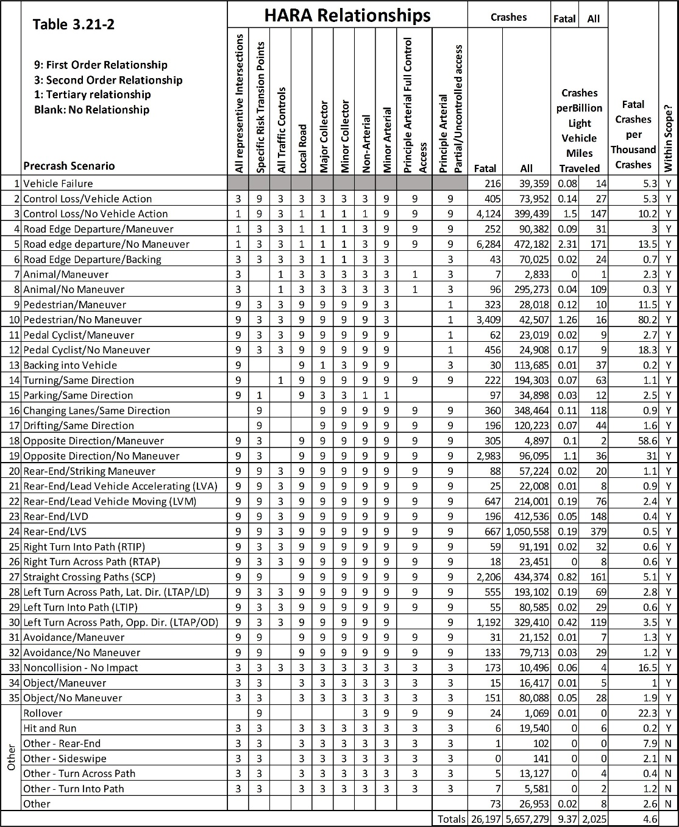
Representative Road Segments. Each road classification can be broken into groups that have similar risks based upon common/homogeneous technical challenges, and required responses. This only means that the next mile is like the last mile on a freeway. It can also mean that the next block of urban driving is the same as the last block of urban driving. It might be further summarized that 42.1% of the ODD’s urban driving risks are contained in three groups of representative road segments (example summary statement - studied, summarized, with recommendations). This would mean that a set of technical solutions is capable of avoiding 42.1% of an ODD’s risks. The vast majority of risks are avoided by a design that is statistically capable of producing and executing a safe right of way path. The majority of driving is in the laminar realm (statistically capable of laminar flow – Mastery of Function level 3). Transition risks are when one road classification changes into another. Transitions change assumptions and responses and, if not addressed increase risk. When transition protocol does not list a needed pattern Priori, the best that is hoped for is a match that is close to the top of the remaining pattern match list. This delay can be minimized but not fully avoided. It must “self-tune” or “fine-tune” as the ODD Flow models becomes more complete and fully adaptive. This is a prioritized list of HazObs, patterns, and responses in each segment and across multiple segments. This is the driving memory of the human. Things that used to be seen and are no longer seen need to drop in the list. The AV system must transition driving protocol to the new road segment before it is reached (technical functional safety requirement). Transition topics include a prioritized list of expected HazOb priori, object digital signatures, road classification, laminar flow expectations, potential situations, potential scenario, and their pattern matches linked to specific responses that reduce risk, and so on.
Crashes Versus Road Classification. Table 3.38 details the crashes versus the Roadway Function Class. The table includes hazardous cargo and other vehicles.
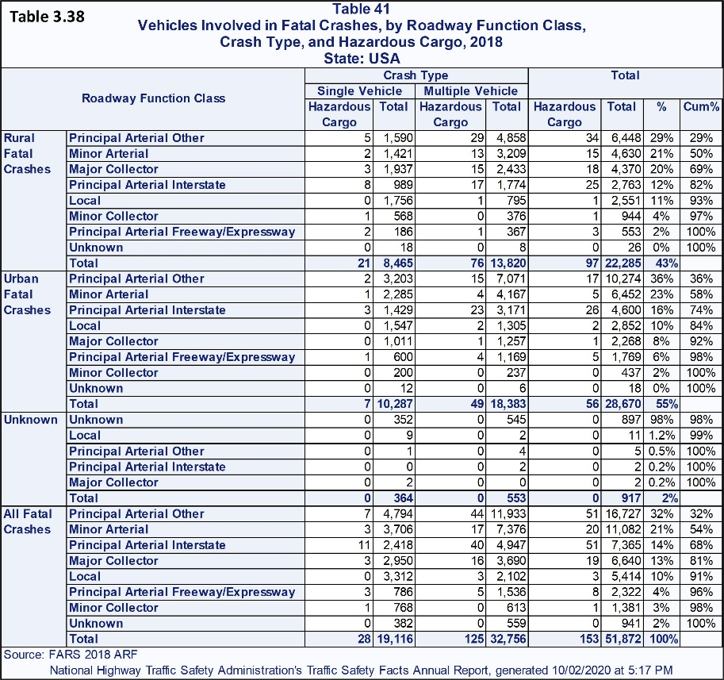
Rural fatal crashes in descending order of occurrence are, Principal Arterial Other (29%), Minor Arterial (21%), Major Collector (20%), Principal Arterial Interstate (12%), Local (11%), Minor Collector (4%), and Principle Arterial Freeway/Expressway (2%).
Urban Fatal Crash roads are prioritized as Principal Arterial Other (36%), Minor Arterial (23%), Principal Arterial Interstate (16%), Local (10%), Major Collector (8%), Principal Arterial Freeway/Expressway (6%), and Minor Collector (2%). This allows a point-to-point route to be identified on a map and then to overlay the risks related to the selected driving segments. While analyzing a given segment, the percent of crashes for the road segment are divided/allocated to specific risks based on their percent contribution (e.g., left hand turn, number of lanes, intersection, etc.). Consider, if a forward collision risk is 20,000 crashes and 10% of forward crashes occur on Major Collectors, 2,000 of the forward collision crashes occur on Major Collectors. Each refinement moves the study one step closer to a single police report.
L1/L2 solutions are general domain solutions. There is no deep analysis or ODD to solve. There are only limits of effective avoidance to determine. The lane keeping/lane centering must reduce the risk of lane departure (side collisions and road departure). Dynamic cruise control can range from stop to a set speed and must avoid any forward collision in its crash avoidance zone. Forward crash avoidance might include steering avoidance into an open space. This would be the same conversation for all following tables. From this point, the conversations will focus on L3-L5 autonomy solutions. Specific L1/L2 relationships will be pointed out if relevant.
An L3 solution is road segment group and road classification specific. The desired active segments are the domains that are studied and collapsed. The solution must solve right of way driving challenges in its ODD. It must manage all rights of way. It must have passed all Mastery of Function Level 3 validation (mastery of right of way). It must be able to detect a pre-situation, pre-scenario, or precrash scenario. The L3 will have rudimentary responses to sudden emergents. The L3 is a direct response solution (a first order solution domain). Suggested order to consider: 1-slow/stop, 2-arc-swerve, 3-slow/stop-swerve, 4-accelerate/accelerate-swerve (the direct 8 spaces). All available solutions are always solved. An L3 can only solve these direct near path solutions (send-return to lane or send-continue new lane responses).
Natural Growth of an ODD, and the AV’s level of Capability (L1-L5). Every road segment, transition risk, and specific risk will be studied in an L4 analysis. It will be collapsed into representative road segments, transition risks, and specific point risks. Risks that are common to all segments are grouped and studied for risks and solutions by defined teams. Every road segment, transition risk, and specific risks will be studied in an L4 analysis.
An L4 solution can expand its route by performing a new route analysis and solving any new risks found. This is called an Impact Analysis and expands the domain covered in the first HARA. It is a full HARA that acknowledges all risks already solved. The new unsolved risks must be solved, validated, and receive a safety release to an expanded domain. The expanded solutions with their validations become part of the larger safety case. With this approach an autonomous trucking company can start with one route and solve the sequence of routes in any direction. After a while, no new risks will be found for many new routes. The process never ends. This would start slowly and end up covering a map at a rapid rate. This would eventually reach a point where an entire country is covered by L4 routes. Yes, this includes icy mountain driving. It also includes seriously windy days and all bad weather and sudden loss of vision. From this, it can connect to L5 local ODD solutions, which have been solved. There are no “open to all map solutions.” This means that in some areas of a country, the solution is not qualified at all, is an L1, L2, L3, L4, or L5 solution based upon what has been analyzed, solved, and validated. Would an L3 solution be L5 capable in the middle of North Dakota where everything is likely a direct first order solution? Solution levels are fluid and grow in capability.
An L5 solution allows trips between any two authorized points within a validated ODD. Performing the full HARA will be a lengthy process but it can be performed, with reasonable effectivity, in two stages. The first stage is a rough draft HARA, Safety Goals, and Functional Safety Concept. The second stage completes the analysis across all road segments and finalizes the HARA, Safety Goals, and Functional Safety Concept. This fills in the blanks while avoiding large changes in the rough drafts or direction of thought. At some point during the rough draft, all teams will become developed, the design lead returns to full time design and a study lead takes over. The design lead is available as needed for new relationships.
Select 15 point-to-point starting and ending points that span across the ODD and each path might have a few alternate paths. The worst cross traffic patterns need to be included. The analysis needs to ensure that the routes transition across all road function classifications and contains the primary traffic patterns across the ODD. Testing the AV on road segments can only be performed after test track validation of all risks of the road segments involved in the test. A safety release against validation results for each “as-built”, and “eyes-validated” technical data package is required before a vehicle can be driven on the road. This would be a full safety release or a conditional safety release with specific safety duties to perform (e.g., safety driver specific to the segment risks of the validation, test on closed roads, and so on). This will reduce the risk that the AV will create unwanted public results.
In the case of injury or fatality, failure to perform valid safety releases would become problematic and the plaintiff might try to prove gross or criminal negligence. Especially if the content for a release does not support a release. A good quality management system/functional safety requirements forensic analysis can find most forms of after the fact falsification. The story of the analysis will fall apart.
Begin by gathering general road classification statistics of all expected HazObs, situations, precrash scenario, control devices, and so on for the road classifications contained in the ODD. The starting point would be similar to the tables in this article and then made specific to the ODD by the team.
L3 through L5 solutions must comply with driving laws/ordinances, rules of the road, road classifications, road restrictions and right of ways (safety goals). The AV must be able to perceive, track, and predict all HazObs within the critical zone of the AV. The HazObs within the critical zone must have stable deterministic object digital signature matches (technical functional safety requirement). The unstable nondeterministic realm must never be used to make active safety decisions. To do so would be a gross violation of safety. However, once in every great while, a dynamic object will be unmatchable (e.g., the wiener mobile, oversized-wide-loads, a military convoy, pulling an impressively large boat, and so on). This would be a never-ending list of things seen once and do not need to be solved as individuals, but as a size with a predicted path solution. The overly crazy combination of shapes is a deterministic nightmare to match and will never be completed. It ends up being a very low probability of “something is there and moving.” There will be few prediction attributes in expected locations (turn signals, headlights, and brake lights).
Before a trip is activated, L4 and L5 solutions must plan the entire trip, start to finish, with lowest risk lane assignments (technical functional safety requirement). Preplanning must ensure that the AV maneuvers to a target lane before lane reductions/constraints (safety goal). This means that the AV must prove that it can safely insert itself into the new lane during the most congested times of the day (technical functional safety requirement).
Object recognition and transient time delays. If a HazOb is not matched to a highly probable object digital signature Priori, it is identified as a dynamic/static object and the remaining list of object-digital-signatures is tested for a match. Each segment must have a continuously updating expected time of day list of HazOb digital signature Priori (technical functional safety requirement – Team Perception and Flow). An unmatched object has no attributes or probable behavior. If the object is moving it must be tracked based on its position and dynamic trajectory risks. It is high risk. In the country it might be equipment pulled by a tractor/farm-wagon. On a freeway, three panel vans following each other closely can never be interpreted as a car carrier, truck, or bus.
The system must be able to determine when processing exceeds its allocated time (technical functional safety requirement). The Safety Critical Metric automatically validates each AV choice. All hardware and relevant software functions are already solved and available. All that is needed are new functional relationships. It joins error of predicted time at position and actual time at position into the validation of each safety critical Cpk_{sc} pass/stop.
The time metric will have an error term that trends upwards as more processing is required. The AV begins to arrive at planned positions later and later. This is the most critical time validation in any AV design. The system must ensure that the AV never drives faster than its ability to complete its safety critical processing with safe vehicle commands (technical functional safety requirement). All following functions in a sequence are delayed after the first system level function delays the critical path of functions resulting in a failure of vehicle level functions. All following delayed functions are its effects and the resulting vehicle level accelerate-, decelerate-, change steering- “too slowly” failure modes will result in specific NHTSA precrash scenario. They are linked through the 7FM Fault State Map from cause to effect. The effect of this is validated from the time component of the Safety Critical Metric Statistic. When this statistic trends upwards, processing is becoming more challenged. All functions, failure modes/fault states in the sequence are traceable to delayed vehicle level commands. Slowing down can reduce a precrash scenario to a situation or even to a reasonable laminar flow. The AV must never slow down so much that it becomes a “slow forward vehicle” precrash scenario (technical safety requirement). It must perform a safe park off the driving surface first and remove itself from risk.
Sudden emergent HazObs can occur on any part of any road segment. The ability to safely avoid a sudden emergent HazOb is controlled by sensor/processing time and the time required for the vehicle to complete a response.
Sudden emergent are violations of the AV’s right of way and is a category with its own set of teams. Every flow of traffic in any lane on any road is at risk of some type of sudden emergent in front of or behind the AV. It is also a sudden side emergent. It is sometimes a sudden rear emergent. Sudden emergent can occur with and without warning. The responses are in one of the precalculated free of motion constraint eight directions of choice. If all are blocked, the choice is the least blocked direction combined with the HazOb that will be least damaged by velocity from that direction. The probability of crash is smallest and with very few limitations, the HazOb will move away from the sudden emergent AV. Do not plan on the move away. It is only a hope that others are aware and react to minimize their risks. They are not AV. They “almost-always” respond automatically. Their failure is the NHTSA crash database. Plan for the safest response. The HazObs will improve on the hazard risks that the AV offers. This is part of statistically dependent relationships. It is the “given that” between two things (pr{a|b} or pr{b|a}). What is the probability that the HazOb will swerve, given the AV is forced to intrude.
Safe precalculated emergency avoidance stopping and swerving paths are all constraint free paths or will be constraint free when activated. However, an emergent might occur when there are no statistically acceptable answers. The lowest hazard of the worst Cpk paths must be chosen.
Potential emergency avoidance paths must be listed from most to least optimal choices (technical functional safety requirement). If an emergency path solution is a Cpk ≥ 2.0 it is free from unreasonable risks and belongs with preauthorized responses and the AV is offering zero risk to society.
An emergent intrusion can instantly change a minimum forward path Cpk of 9.6 to 0.31 with a probability of p = 0.18 that a crash will occur (184,060 crashes in 1,000,000 passes/stops). This is from the normal distribution and is well within ±3σ_{x,y,z,v/t}. This is the normal distributions strongest and most useful prediction range. The AV will travel between 0.0 and 0.69 capability distance (0.0 - 2.1 standard deviations) past the point of contact (through the HazOb). At the point of contact the AV will transfer energy in motion into the HazOb before reaching a full stop. This would be a maximum 0.0-0.69 standard deviation distance travelled through the HazOb. Hazard transfer energy is ½MV² of the AV at the moment of contact while velocity is reducing to zero. A Cpk = 1.0 means time/distance is consumed by AV Variation and there is little to no energy transferred after touching/crashing slightly. Transfer energy is Hazard/Harm energy. Transfer energy is the cause of property damage, injury, and fatality.
Potential hazard energy might transfer into a HazOb anytime a critical Cpk is less than 1.0 at the moment of stopping/passing. This is the comparison between the predicted stopping/passing Cpk and the Safety Critical Metric validation of each individual decision Cpk_{sc} (The Safety Critical Metric - SCM). This means that the AV choice is in the risky to hazardous category. It might not fully stop or pass. The hazard energy ½MV² was incompletely consumed by brake friction/heat and tires skidding on the road. The remaining hazard energy is transferred into the HazOb. The AV’s momentum will also transfer velocity into the HazOb. The resulting HazOb velocity is found by Newton’s momentum equation M₁V₁ = M₂V₂. V2 is the HazOb “launch” velocity and V₂ = M1V₁/M_{2.} This returns a resulting launch vector prediction (engineering). The transfer energy will split into two responses: 1) Material modification – energy consumed in property damage, injury, fatality, and the remaining energy will 2) launch the HazOb on a new trajectory-launch at a slightly reduced impulse change rather than a full step change velocity. In plain terms, if the AV is 10 times heavier than the HazOb, the HazOb might launch 10 times faster than V₁ was travelling, minus energy transferred into physically changing the HazOb (consumed by causing damage). As an example, a Class 8 Truck at 80,000 pounds is 20-40 times heavier than a light vehicle so there would be 20 to 40 times acceleration. If the truck was travelling at a relative velocity of 60-mph to a HazOb, the crash would produce a sudden acceleration of 2,400 miles per hour into the HazOb. The point of contact will go through massive deformation for the short moment of an “impulse” transfer of the remaining force into the resulting HazOb’s launch speed.
Occupants inside a vehicle. Crash energy distributive designs modify the vehicle before the inside of a cabin. This is an extremely fast slow down and change in direction (a vector impulse force). At some point energy densities exceed material properties and material fails/folds uncontrollably into the cabin. There is too much energy. The occupant will be exposed to the inside of the cabin accelerating and crashing into them. This might be made worse by the cabin’s deformation damaging or enveloping them directly. The human floating in space is struck by its own vehicle cabin. Airbags attempt to interfere with this contact. Airbags are designed to stop a human by equally distributing the stopping force over the full head and body. This avoids sudden shear forces of sharp corners/edges from the cabin. It cannot overcome a vehicle deforming around an occupant. Even with this, Class 8 vehicles can be safely designed.
To complete the Class-8 example, A human who is loose inside the vehicle will stay stationary and be struck with the remainder of the 2,400 mph of the impulse force/acceleration. It is unlikely that air bags or crash absorption will be fully effective. The vehicle will enter a catastrophic sudden change of velocity. The stationary occupants are struck by their own vehicle inside the cabin and they are caused to accelerate by the same equations. An airbag will absorb some hazard energy. Then they bounce around inside the vehicle until it stops or their vehicle forms around them. As harsh as a crash might be, the mechanics and reality must be understood.
Mass in motion is kinetic energy. It has an equation of ½MV². Both the AV and HazOb have Kinetic energy. Their combined kinetic energy is based on their relative velocity which is vector math and is easily learnable by anyone. A reactive choice to bleed off as much speed as possible might lower velocity by 1/3rd, the impact kinetic energy has decreased from a factor of 9 to a factor of 4 (3² = 9 versus 2² = 4). The HazOb energy in motion has been reduced by (9-4)/9 X 100% or 55.5% (kinetic energy equations). 44.5% of the energy is left to transfer into an MIAS. MIAS – what is the realistic maximum injury. The hazard energy reduction is known by the AV at the moment of contact. This is a critical record and included in the safety critical reports (estimated hazard energy reduction at contact). If there are no avoidance paths, the lowest risk condition choice is to slow down as much as possible before a strike reaches the HazOb. This is fully covered in the systems design phase.
Example. What if the emergent HazOb crash has a Cpk = 0.31 and the emergent escape path has a Cpk = 0.92? The HazOb is legally responsible for violating the AV’s right of way. The AV would be legally responsible for crashes it causes on a crash avoidance path. This is a legal and ethical dilemma. Taking the emergency path means that the intrusive HazOb cannot be charged with violating the AV’s right of way as long as it is missed. If the AV misses the HazOb, it means that the HazOb provided enough time for a miss. It created the precrash scenario and produced a response. The crash was caused, “With Response” which is a precrash scenario of “with maneuver.” This is the unintended but maybe foreseeable consequences of any response. Swerve to miss the puppy and hit the unseen child might occur with human drivers. It must never occur with an AV. The AV is the cause of an emergency path crash. Based on mathematical probability, the AV must take the lower risk path which is a Cpk = 0.92 with 3,467 crashes versus a Cpk = 0.31 with 184060 crashes. It also has a very small physical overlap risk as compared to the sudden emergent HazOb. This means a smaller physical overlap to develop the offer of hazard energy (penetration velocity/distance). Automotive liability is interesting. The attorneys for the AV manufacturer might tell the AV company to hit the original intrusion so they are not successfully sued. This is not criticism. It is an extremely important position to handle early in the design phase. The attorneys should develop, and defend in mock challenges, a proactive defense for lowering risks of a crash by a specific percentage. Then be able to show that the actual percentage achieve by design was 41.3% lower than the original risk (just an example). Promise a 50% reduction of risk. You will achieve more than an 80% reduction. This is a good start for a defense because you will not release until you have the proof (the additional 30% is after launch).
Minimizing Knowable Risks at Planning. An L3 solution’s planning function can be almost nonexistent to elaborate and it can grow from simple to complex, achieve L4, and eventually L5 status. A solid L3 Planning might cover one lane on a specific road classification. An L3 rural laminar flow freeway solution is extremely tractable and easily solvable based on today’s technology. These would be continuous sets of solved representative segments with no-to-low transition risks and zero specific point risks. They would require long-range warnings for slowed or stopped traffic of any type and for any reason ahead. The L3 must manage the emergency reactions including safe park-in lane (off active driving surface if available will be more defensible in court). A driver is not going to be capable and an L3 has zero effective emergency controllability. An L3 is a simplified L4 study limited to geofenced road classifications with no physical start/stop addresses (e.g., activate while driving). However, point to point driving within the homogeneous segments can be added (address to address). It would still only be an L3 solution. Each authorized string of segments must be validated and a safety release performed before the ODD is expanded.
L4 and L5 solutions must plan the entire trip, start to finish, with the lowest risk lane assignments before the trip is activated (technical functional safety requirement). Ensure that the AV does not enter a “no-drive-zone” that has not been authorized. Preplanning must ensure that the AV maneuvers to the target lane before lane reductions/constraints (technical functional safety requirement). The AV must prove that it can safely insert itself into the new lane during the most congested times of the day (technical functional safety requirement). The map must contain expected driving constraints, transition risks, and specific point risks (risk profile). The AV is then optimally prepared to avoid/mitigate all knowable risks. The AV now has the comparable memory of a fully aware local to the ODD human driver. Risks can be a function of time-of-day to account for normal traffic patterns, venues, and rush hours. The AV must assign itself to a safe lane before motion constraints are closed off by heavy traffic (technical functional safety requirement). This is the Flow team with perception, object tracking, object prediction, motion constraints, and motion planning. When the density of HazObs/constraints increases to a set level, adaptive planning must prioritize and execute a new lane assignment sooner than the original plan. The modified insertion lowers risks as compared to the initial plan. Risks are dynamic. Final insertion is performed while the risks are acceptably low before insertion becomes a fully constrained zipper maneuver. When the road is wide-open, insertion is safely delayed until the last moment. It is safer to be in the final lane and manage the insertions before and after the AV. It is possible to design successful zipper insertions into a target lane but it is higher risk of causing property damage at lower speed. This would be lower to no harm risk if possible.
Insertions need to be assertive, calm, and deliberate into the new lane. If room is not offered, the AV must safely and slowly encroach into the new lane after each N+1 HazOb passes the AV before the next HazOb reaches the AV. This means actively creating a small restriction before the next vehicle can fully refuse an insert. They have to swerve around the AV or they will be the cause of a crash. This creates more room for the N+2 insertion. The AV will be stopped before the next HazOb arrives. Eventually, the AV will become a physical obstacle and be fully inserted into the target lane. This level of insertion resistance is normal when aggressions are higher and HazObs form a “no room to move” protection around their selves. Regardless, the AV must insert safely with what should be a lower risk than any human controlled insertion (technical functional safety requirement.
Optimizing Goals. Planning will have several potential choices to reach the AV’s destination. Choices requires the ability to weigh and prioritize. The following four priorities are offered in a descending order of importance. They are 1) select a safe choice, 2) obey the law/right of way, 3) on time arrival, and 4) lowest cost. Obey the law must be a high priority. Yet, if the choice is to crash while following right of way or to exit the drivable surface (legal violation) where there are no HazObs, the choice is to exit the drivable surface and avoid a crash. An expert driver will not hesitate to drive off a road and across someone’s front yard before returning to the road. They are always ready for an off-road path.
There are many ways to make the right choice while safely failing to obey the law or violate the right of way of others. For example, winter conditions might cover the road with snow/ice so the drivers cannot see the road. When this happens, drivers slow down and follow the tracks of the forward vehicle. Staying centered in lane is an option for L3-5 solution, even though the lines/edges cannot be seen. GPS/RTK/IMU combined with perception and map means that cameras do not need to see road lines or edges (team: localization, perception, motion constraints, motion planning).
The AV must never be out of context with human drivers (safety goal). The AV must automatically default to a human driving strategy where the lane is defined by either the forward vehicle or tire tracks on the surface (same team). Human drivers are using arbitrary lane parameters where they do not fall off the edge of the road on the right and they avoid crashing into oncoming traffic on the left. The AV would create a precrash scenario if it followed ground truth lane center. The AV’s driving rules cannot be out-of-context with human driving rules. The basic driving law is to drive at safe speeds and avoid causing property damage/injury. Drive safely based upon the conditions, follow the tire tracks and do not hit the car in front. In the absence of other vehicles, the AV must follow its normal lane center-based path. The AV will define the first set of tracks. It must set a safe path based on previous tracks set, if they are already present. A safe path might be 8 inches to the right of the tire tracks. The well used tracks might be on bare road or they might be ice covered and the snow has a much higher coefficient of friction than ice (expert winter driving rule). The path might also eliminate some of the lateral variation (smooth the corners). Work with an expert and dynamic control to adapt the stability prediction model to any such driving.
In some states it is legal to drive safely and faster than the posted speed. This is called the basic speed law. However, it is not legal to drive faster than the maximum allowable speed for a given state (maximum speed law). Drive safely and remain in full control during all driving conditions (Safety Goal). There are a few freeways around the United States where it is actually unsafe to drive as slowly as the posted speed limits. Involve the company’s automotive legal liability experts immediately, if found. This is a specialized branch of law with deep legal precedence.
Safe Stable Commands. Stability/control safety margins are needed for, max acceleration, speed, min arc, corner-accel/decel/brake, road frictions…and so on. Fully self-driving vehicle must have stability prediction models that ensure all upcoming commands have already been predicted as stable and safe (technical functional safety requirement). Dynamic control is responsible for maintaining full control of the vehicle during all maneuvers. Stability prediction models can predict the safe vehicle response over an entire trip. However, they are most useful for detecting near-term stability changes from norm or a gradual degradation from norm. It can predict the expected success of driving a near-term sequence of road segments based on current weather and road conditions.
Both the road and the vehicle will degrade. This is not a question of if. It is a question of when and how suddenly instability and loss of control will occur. Prediction must be solved if inclement conditions are contained in the ODD.
Vehicle Degradation/Changes. The AV must be able to detect mechanical degradations of its vehicle. This includes tire pressure and the stability metrics of roll-rotation about the x-axis, pitch or tip-in/out – rotation about the y-axis, and yaw – rotation about the z-axis. Tracking and studying stability responses will detect sudden and gradual structural failures/degradations of the vehicle. A single corner of the vehicle might be permanently low or its travel might be slow and extended (rides like a boat). Steering can become unstable when components wear. Steering vibration can be matched with steering angle. Road vibration is transient. Vehicle vibration tends to be cyclical in magnitude and repeatable in nature (a growl, chatter, thump, tone, and so on). This would likely be a team of mechanics and engineers deciding on the few mechanical failures that produce 80% of the crashes and developing detection and response strategies. The remaining many that produce 20% of crashes are ignored in the first design. The AV is not designing the vehicles they command. The AV must detect the most dominant electro/mechanical and structural failures as well as a human and execute a predefined safe response (technical functional safety requirement).
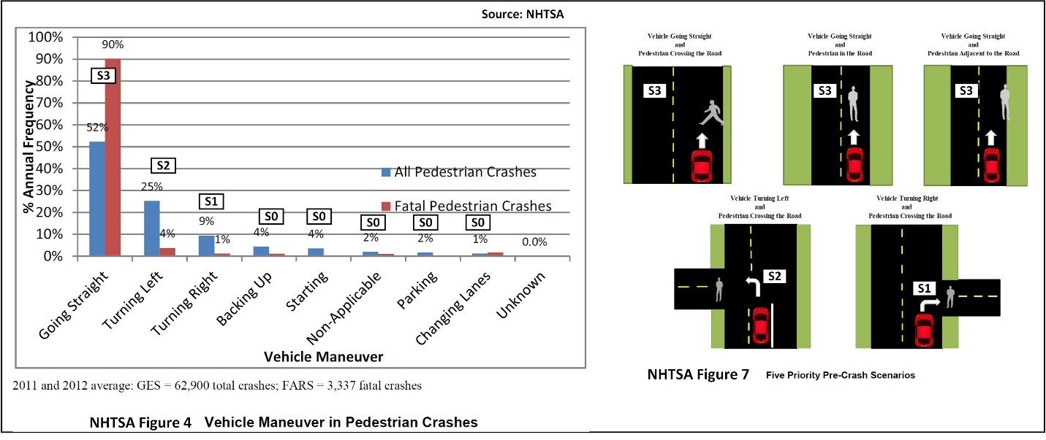
Conversation on Pedestrians. Pedestrians include walker/hikers, runners, skaters, scooter riders, skate-boarders, wheel-chairs, or any other form of non-pedal-cyclist based transportation. Performance wheel-chairs belong to pedal-cyclists with the low-profile bike category. NHTSA’s Figure 4 (DOT HS 812 312, August 2016) shows that a vehicle going straight with a pedestrian crossing the road, in the road, or on the road’s edge accounts for 52% of the pedestrian crashes and 90% of the fatalities. Turning left and crashing into a pedestrian crossing the road accounts for 25% of the crashes and 4% of the fatalities. Turning right accounts for 9% of the crashes and 1% of the fatalities. Backing up accounts for 4% of the crashes and 1% of the fatalities (aggressive reverse). Changing lanes accounts for 1% of the crashes and 2% of the fatalities.
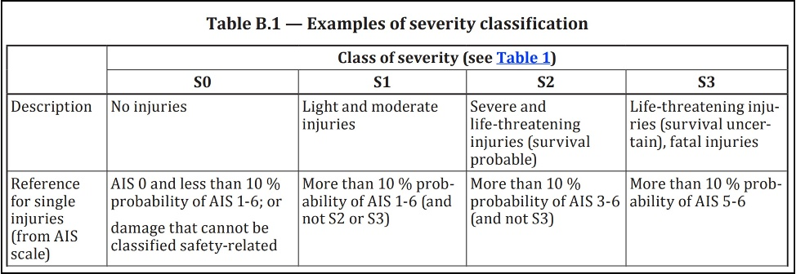
Each of multiple injuries on a single patient are assigned an Abbreviated Injury Scale (AIS). One person might have eight injuries and each receives an AIS. Each injured person receives one maximum injury score. This becomes the Maximum Abbreviated Injury Scale (MAIS). There are six levels of injury: 6: Maximum/Fatal, 5: Critical, 4: Severe, 3: Serious, 2: Moderate, 1: Minor. The MIAS estimates can relate directly to ISO 26262 Road Vehicle Functional Safety Severity (S1, S2, and S3: ISO 26262 Part 3 Table B.1). Table 3.24 shows that 1% of all injuries are S3, 6.9% are S2, and 92.1 are S1, no injury is S0 (property damage only). Pedestrians have no protective barrier – distance travelled into their physical envelope transfers energy into harm (injury/fatality). A movement three inches into a human’s envelope can burst organs and break bones. This would be an unsafe lateral passing with a Cpk < 1.0 which is a possible partial physical overlap collision – straight or on a curve. The velocity of the AV, the point of impact or ability to change the point of impact (lower injury/fatality), and its ability to slow or stop are all safety critical. All of these will become some type or combination of technical functional safety requirements.
Create a reasonable relative hazard velocity, max overlap, by HazOb crash table. This article provides all the information needed to get started. Reasonable is a rough approximation of risk. Avoid trying to establish a perfect model. That will take place automatically through the Safety Critical Metric (SCM). The link of this table is to the percent overlap and the estimated kinetic energy transferrable into harm from the SCM relationships. This is based on the relative velocity at the moment of contact, the known mass of the AV and an estimated mass of the Hazard. The AV knows the hazard energy at any moment, even the moment of impact. This would be an ordinal Likert table based on the MIAS hazard table. Use 0 for property damage and 1-6 for the increasing risks of harm. This resolution is more useful than the ISO 26262’s 0-3 severity categories. This Likert table has seven ordered groups (0-6) against each HazOb and against all relative velocities (5, 10, 15, 20, 30, 40, 50, 60, and so on mph for velocity). It is an expected percentage of harm at relative velocity for each HazOb.
An expected 10% of those injured must be MIAS 5-6 to be an ISO 26262 severity risk S3. This is the path to creating a hazard energy risk translation to ISO 26262 table. This would produce safety case evidence translated into ISO 26262 terms and be automatically estimated and recorded by the AV. All the functions are already available. These are only new relationships. The approach will be expanded later in this material. The MIAS Likert scale is more powerful for AV decisions. The ISO table is required for safety cases.
The HARA needs to identify and understand road segments where pedestrians often cross a street in the middle of the block. If the pedestrian is standing on a corner or side of the road, they are not walking somewhere. They are waiting for something or preparing to move somewhere. They are an unknown risk and they might become a sudden emergent. They might become pedestrian flow. Pedestrians can stand between vehicles to either enter a nearby/passing vehicle or cross the street. They are responsible for stopping, looking, and staying safe. They also need to be avoided if possible. Pedestrians have motives that attract them to move. This is part of a pedestrian flow analysis. Pareto suggests that 20% of the venues get 80% of the business (church, restaurants, stores of all types, schools, work, and so on). Most traffic passes through sequences of straight segments. The remaining exits are cross flow traffic with an increased chance of an intercept/crash.
Pedestrian attributes. Human body language that telegraphs intent comes from the direction of their eyes, eye movement, head movement, chest direction, arm movements, hand movements, finger movements, and the movement of their knees which tends to commit the pedestrian to a direction. Consider, the chest-turns, head-turns, eyes-target AI phantom driver, arm motion, hand signal, followed by knee direction indicates a new committed trajectory. When the pedestrian does anything like this, they are telling the driver they have enough time to stop because they are going to cross in front of them. Start to slow with the earliest match or combination of pedestrian prediction attributes. The pedestrian will have a time sequence of body language behavioral attributes to interpret. For example, there might be three attributes in sequence and if they all say slow down and the AV slows only to find it was a false or wrong conclusion, it could waste time and fuel. If all three prediction attributes where 50% effective there will be an expected 12.5% safe, yet unnecessary, slow-downs. A sequence of seven attributes in series is expected to produce 0.78% false signals. In this example, every attribute is right/wrong 50% of the time. Two warnings would be false 25% of the time if observed together spatially or in sequence. Three warnings would be false 12.5% of the time. When the eyes purposefully target the driver there is only a 20% chance the pedestrian will not cross in front of that specific vehicle. The “looking for a path” searching attributes happen first (stopping, walking while turning chest and head, narrowing the turn seeking pattern to a moment (the path is found), the eyes seek the driver, the knees move, there is zero doubt. This pedestrian has politely screamed at the top of their body language voice, “I am cutting in front of you.” The probability of being wrong will return less than 100% certainty until a commitment attribute becomes positive motion on a new path. The knees commit to direction and they move towards the critical zone. Research, study, develop useful attributes that are consistent with decisions and choices. Without attributes there is path and proximity and the first warning suggests to start slowing for a stop before the rough position of the pedestrian is reached. The pedestrian might provide confirmation of the AV’s choice with a wave. Continue the stop unless the pedestrian sends cancellation body language “wave of the hand to pass” telling the AV not to slow and stop. If the knees move towards the intercept, the pedestrian has committed.
There are many studies that conclude that an extremely large percentage of pedestrians seek eye contact with the driver as they walk/run before the vehicle. Eye contact is the line perpendicular to the center of the ocular plane of the pedestrian’s eye. They would look at the AV’s headrest.
The direction of the human eye. This will be covered in detail in the system level content. The Human is a Bayesian window in the camera image which is the largest Bayesian window. Part of the human window will be human and Part will not. The human object digital signature is in this window. Behavioral attributes of the human are chest, arm, hand, head, eye, knees, etc.). The eye window and object digital signature is in the head window. The cornea is a window in the eye window. The eye direction is in this window. Each imbedded window has fewer pixels. Pixels at distance is the camera requirement (signal to noise). This describes the reason for more pixels. It also describes the process for finding clarification/behavior attributes.
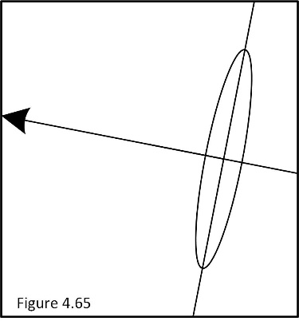
The camera is an x,y measurement grid on its face with a natural logarithm distance from the virtual horizon for measuring distance (not ground truth). Each pixel has width and height at distance. The pixels are a measurement device. If the cornea is close to a circle, the pedestrian is looking directly at the camera (it is the ocular line). If it becomes an oval, it is not. The oval lengths (ratio: short/long) will return an angle reference from the line from the cornea to the camera. The line of the longest part of the cornea oval is used for the angle reference to the camera lens. The relationship between the long part and short part of the oval lines is the angle from the lens. This ratio, by itself, can be used as the angle statistic from the camera’s line. When it is 1.0 it is the ocular line. A GR&R must be performed and relationships validated (covered fully in the system design phase). Then, how many times did the cornea ratio approach 0.8 - 1.0 (search pattern that includes the AV)? What was the time between searches? Did the ratio stabilize over 0.7 for a moment just before the knees moved? If so, this is the last dwell before commitment. The dwell at 1.0 is the pedestrians “pass in front of AV.” A dwell at 0.7 might be a vehicle close to the AV. All vehicles will slow in response to the pedestrian’s committed choice. The ratio is meaningful after a GRR returns useful results. The final look lingers. Find the ratio that can be used to count the number and lengths of these looks. It is a powerful attribute. The only reason the AV is analyzing at this depth is because the pedestrian triggered one of the increasing risk rules. Eye rules are secondary only to the actual path dynamics of the pedestrian.
One human can glance at another human and instantly know where they are looking. The AV must be as good. How close does a camera have to be to the eye to return the direction of an eye (signal to noise)? This will relate to critical distance and time and is something that will be covered in the system phase conversations. Question: Does the AV need to show a “Do Not Walk” warning even though the AV has the right of way? Or would the AV manufacturer’s legal counsel call that an admission of guilt? This is not criticism. It is part of the world in which we live. Design for capable safety and send the warning. Be able to statistically prove all choices.
The HARA needs to have objective metrics for pedestrians approaching, stepping into roadway, crossing the road (with/without right of way), getting into/out of the street side of vehicles, stepping out from between parked vehicles, as all of these will require sensors, perception, object attributes, object tracking, motion constraints, and so on. What new attributes are needed? What risk signal will tell the AV to switch from simple HazOb at x,y,z,t recording and start to collect object risk prediction attributes? One approach is that the pedestrian’s distance to the road is consistently shrinking. This trend plus a “start recording” distance might make a rational start of a plan. Another approach is to add a mid-buffer zone of collection and a full collection near the road. Both would work most of the time and fail when a pedestrian starts running for no foreseeable reason (a new behavior model that is rare … prediction attributes?).
Flow metrics can be accumulated as the AV or Map vehicles drives the ODD. For example, every time the AV drives a segment it is a sample of how many pedestrians are present, where they are, how they enter, pass through, and exit a segment, and what they are doing. Each segment can provide pedestrian flow and destination/choices statistics. This is a post analysis of driving statistics. Once the statistics have updated the model, the data is no longer needed. Develop a rational FIFO record retention (for all records). IATF 16949 control of quality and safety records must develop records retention policies for all recorded information. Records are for legal evidence of conditions and decisions, the company’s importance of the data for future use, and fulfilling each contractual deliverable. Only the portion required to assess and manage risks is used by the AV. The samples are added to the Flow model until the model can infer probability over the most driven parts of the ODD. At this point preplanning can select paths of lower risks, while optimizing arrival time.
Critical distances for objects and their attributes. What does Perception need to understand from the HARA? What does a 300-meter iRadar, LiDAR, and camera actually mean? Risk assessment requires spatial and time sequence patterns that predict a HazOb’s immediate intent.
Perception begins with an object/obstacle – The question begins with, “is something real there?” Followed by, “what is there?” At what distance must HazOb attributes be understood in order to predict behavior - the current and future state of each HazOb? The team must never conclude that a sensor cannot detect what is needed. This technical limitation requires working with sensor providers in a development interface agreement relationship (DIA) – Shared/overlapped safety cases. Your team receives better capability and the sensor provider receives almost free research, a more marketable sensor to sell, and a story of its first application. Never use the lack of a sensor as an excuse for not having sufficient risk attributes to make safe decisions. The AV is not authorized to drive that stretch of road. If this overly limits the ODD, your team must get a sensor developed. This is safety mandatory. A lack of a safe solution is never accepted. This requires solid, documented evidence of tangible efforts, with a summary report and recommendations. At what distances based on speed, must these be deterministic (stable)? Attributes are used to fine tune current and future behavioral predictions, and produce safe and correct VLFs. This could be the moment a pedestrian changes course to create a front center of the AV intercept. This might be when the knees of a pedestrian commit the direction with an early indication of speed (knee velocity extrapolated to feet) of a pedestrian. The distance claims of a sensor must define the size, shape, material, resolution, and detail that can be detected at its distance claims. At what distance must a camera be able to read speed limit signs? At what distance does it need to distinguish between left and right turn signals? At what distance must it be able to determine eye direction?
Safety Critical Metric (SCM), the capability of forced choices. A sudden emergent restricts the safe planned path and no other path is risk free. The planned path’s Cpk < 2.0. the other seven choices are all Cpk < 2.0.
Risk free plan: Planned path and precalculated response paths all have Cpk ≥ 2.0: Free from unreasonable risk. Normal trip records.
Forced choice-risky: A forced activation of a 2.0 > Cpk_{sc} ≥ 1.0: No risk near 2.0 and low to moderate risk near 1.0. The type of HazOb avoided becomes safety critical near Cpk = 1.0. A Safety Critical Metric and decision factor record is required.
Forced choice-hazardous: A forced activation of a Cpk_{sc} < 1.0 solution path. Property damage near Cpk_{sc} = 1.0 transitioning to full HazOb Energy transfer at Cpk_{sc} = 0.0. An automatically generated Safety Critical Metric, Statistic, and Safety Report record is required (retention is 15 years past the end of the decommissioning of the AV’s production line).
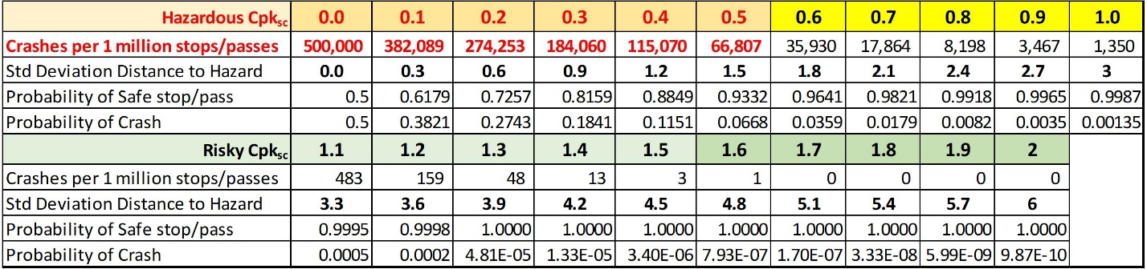
The SCM is the closest measured pass distance D_{sc}, of each HazOb_{sc}. It has a distance and a time statistic. The distance (miss) statistic is the smallest distance measured of the HazOb_{sc} pass/stop minus the forced selection path’s Cpk_{sc} estimated miss distance which is the Cpk_{sc}’s numerator D_{Cpk}. The prediction is at the forced moment of decision. The confirmation is the sensor measured closest distance at passing/stopping.
SCM Statistics - Critical Safety Distance (CSD) statistic is CSD = D_{sc} - D_{Cpk}. It has an expected value of zero. When there is a statistically significant change (SPC Charts: expected value, variation, trend, linearity tests), there is either passing/stopping bias forming or variation is increasing between prediction. This means that the ability to predict and execute is compromised by the amount of the change. There is a difference between statistically significant and safety critical. What if variation is increasing by 1.24% per minute? What if bias is growing at 0.31 inches per minute? What if the variation of safety critical passes suddenly doubled and this was found by sampling normal SCM passes. What if the drifts and changes were all detected before a safety critical challenge? This is closing the loop and removing uncertainty. Detect a bad change before the HazOb_{sc} challenges an emergent path. The SCM must sample safe passes to ensure that the system is stable and capable for safety critical challenges of distance and time (technical functional safety requirement). Each signal requires a preplanned risk mitigating response from the system.
SCM Statistics - Safety Critical Time (SCT) statistic is SCT = t_{SCR} - t_{Cpk}. It has an expected value of zero (reality agrees with prediction). This also has extreme safety importance and needs SPC (comments above apply). It requires a removal of processing constraints to lower this number (e.g., better sensors, better attributes, earlier detection, lower the processing load, reprioritize/reassign resources, or get a faster box). When this metric grows to a critical point, safety critical processing is compromised. The AV must slow and potentially execute safely exit driving decisions.
Under normal driving conditions the lowest passing capability is Cpk = 2.0. This is the shortest safe distance and time. Safety become critical at Cpk = 1.0. Each Cpk has both distance and time statistics. There are six standard deviations time or distance to the HazOb.
There are only 3σ_{x,y,z,t} of time available at the worst case to complete the fault time tolerance interval (FTTI) in order to maintain a minimum Cpk_{sc} ≥ 1.0. This means that FTTI is a variable based on time. Variation of time is a variable of velocity. FTTI is no longer a theoretical construct. It is a specific and controllable value that has rationality and reason. The larger time at faster velocities is the exact same risk at slower velocities (ratio of time variation).
SCM Statistics – All safety critical predicted values can be used in its own form of SMC Statistic (pass metric-prediction metric: expected value is zero or a constant). All the predicted responses can be estimated and their results physically validated at every pass. This would include estimations of time, position, velocity, acceleration, roll, yaw, pitch, or any critical metric developed or found. Regaining control, when it is added will predict and avoid instability and predict the stability at passing or a point of full recovery. Instability is a special cause variation from stability SPC. The special cause value is the trigger for recovery. All axial rotation is known. How the AV responds to changes in steering and velocity is known. Regaining stability requires that each vehicle level function reverses to eliminate axial loads at the same time the wheels are pointing the right direction. Model the expert driver responses – solve this empirically, and ensure the model is adaptive to vehicle aging). Develop, estimate, and execute a stability retention plan. The statistic = actual – prediction value for each of roll, yaw, and pitch. When any of these are a safety critical component of decision, it must be SCM validated. Any time there is a critical potential loss of control, the related statistic must be used as factual validation of choice. Most of this will be modelled and designed during the system design phase. This is all a natural extension of creating a safe design. It requires zero extra work as long as it is designed into the core design from the start.
Transient delays are often moved to the prediction of the AV such that the AV is sending commands that are expected to be current at location when processing is complete. This can be a static offset or a dynamically adjusted offset to account for processing latency. If this adjustment is dynamic, the time bias and variation shift detection can be added to the dynamic offset and the SPC rules comments above apply. If the time bias adjustment is static the SPC can be added. This will tell the AV that the time shift is no longer valid. The same SPC rules would apply.
Both time and distance are the direct expression of hazard energy. They are safety critical and dependent on speed. This means it has variation at speed not across speed and capability studies are performed at speeds, across the range of speeds (capability at speed). The AV must automatically predict the closest HazOb passing/stopping distance from the planned path and validate each pass/stop challenge directly with AV sensors. Post analysis must confirm correctness of analysis after each test. The AV must use variation at speed for each Cpk_{sc} estimate (e.g., σ_{x,y,z,v} standard deviation at speeds of 5, 10, 15, 20, 30, 40, 50, 60,…). Have the AV automatically model variation across speed for the standard deviation at speed equation estimate. Ensure that this is an adaptive model with automatic remodeling rules (covered later). Each HazOb risk is measured/validated at the critical moment hazard energy is offered to each HazOb (closest predicted distance). The sensor measurement is confirmation of the moment of predicted risk. It is after the fact critical risk history. The AV’s safe planned path, sent to Dynamic Control, predicts each safe pass/stop Cpk. The SCM Cpk_{sc} validates each safety critical prediction.
- In its success form it is the physical time and distance of all misses with some type of a summary “capability of decision” proof metric (road function classification performance).
- In its failure form it is the potential distance intruded into the HazOb. It is the Hazard Energy - ½MV² at moment of contact that might transfer into an object, location of impact, estimated hazard energy transfer, property damage, injury, life altering change, and death. Predict the magnitude of potential damages. The goal, at this critical moment in time, is to estimate the magnitude of the harm offered so the least harmful estimate can be selected and executed automatically by the AV. Unfortunately, there are no guarantees. However, excellent models produce by solid team members, will have objectively defensible arguments. This will be made official with reviewed validations and official safety releases.
Track the SCD and SCT statistics in process control/time variant charts to ensure stability and lack of bias drift. The stability and bias of validation passes and stops needs to be tracked on its own statistical process control chart. This can include all passes/stops (the fully closed loop approach) or just those resulting in the range of risk (Cpk_{sc} < 2.0) which is the validation of forced choices.
The team must develop extremely clear response rules for every special cause variation signal used (shifts, variation, trends, linearity). The Safety Critical Metric must never become safety compromised (Safety Goal).
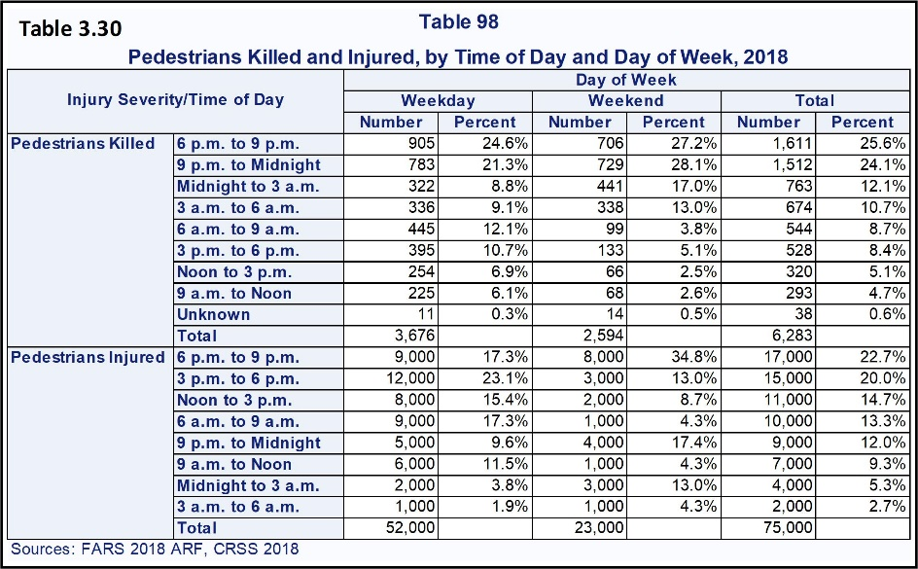
Closing the safety critical loop. The system failure mode/fault state detection must detect faults and execute a safety mechanism for every system level failure mode/fault state (the inner world). This fault must be detected and corrected before the SCM statistic detects a fault (special cause variation). When the system executes a safety mechanism, it is in the presence of a specific system level cause and the adjustment to manage the cause is the safety mechanism. The SCM is tested as closely to this moment as possible. This is rational sampling in SPC. Optimize the chance of finding a change (the safety mechanism is a specific cause of change). Minimize the chance that a sample is across a change. This would be a sample that includes readings from before/during or during/after the change. This would include variation from two sources so the variation is artificially large and its average does not belong to either group. The sample is not independent. It is not singular. This is the topic for the team and statistician. The AV must use the SCM to validate a controlled safe decision (it is a specific safety record). The cause of the fault is either a faulty world understanding (external) or system (internal system/vehicle). In the absence of internal system faults, the remaining causes are world and vehicle faults. World is a faulty understanding and the inability to predict. This will be validated as safe by the Five Levels of Mastery of Function. The remaining risks of the design must satisfy Qualified Safety.
Time of Day. Table 3.30 shows the time of day where pedestrians are most likely to be in a crash with a vehicle. Roughly 49.7% of pedestrian fatalities are between 6 p.m. to midnight (the night activity time). The table is general across the USA. Where pedestrians are walking to/from work, school, events, dinner, the bar, the beach and so on. The majority of these crashes occur in urban environments.
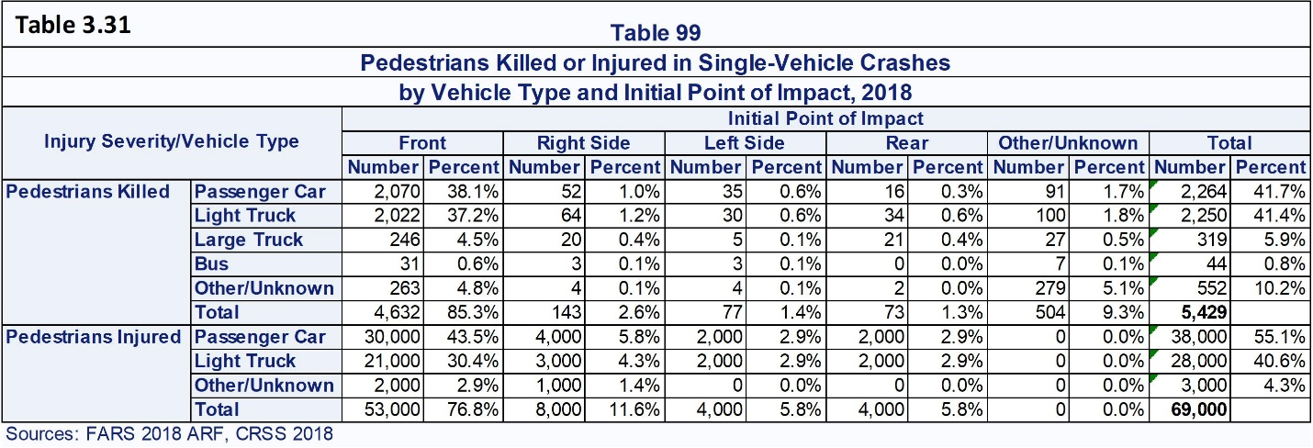
Point of Vehicle Impact. Table 3.31 shows that overall, 85.3% of pedestrian fatalities were struck by the front of the vehicle. 2.6% of pedestrian fatalities are struck on the right side of the vehicle. The right-hand side of the vehicle has more exposure to pedestrians standing, walking, stepping out from between vehicles and so on. If a pedestrian is standing and a wide mirror on the side of the vehicle strikes and kills them, this is the side of the vehicle. It can also be the violent rolling of the pedestrian as they strike the side of the vehicle when associated with an AV right of way violation).
Solutions need to avoid a defined percentage of crashes based on the NHTSA crash database (safety goal). Create crash avoidance/impact solutions that will reduce MAIS 1-5 injuries. The safety goal might be to lower the MAIS by a factor of 1, 2, 3, etc. Validation direction suggestion: State the reduction goal and validate it by comparative validation passing/stopping impact test results over time (improvements year to year would be strong). The tests are the same but the critical distances shrink as capability grows (crash car dummy sensor – hazard energy measured tests). Each year would have a pattern of energy transfer. Year after year energy moves closer to the center of the planned path and validates or predicts a general average reduction in hazard energy that will be offered for damage (summary: year after year). This could be a nice radial chart of capability at speed distances as well as capability at the end of each year for each statistic. The chart would compare the risks of passing/stopping at speeds. Every year, less of that set distance is used by the AV. This would produce a zone of “we do not penetrate this far any more” type of a chart at each speed (10, 20, etc.). Comparative samples are the new AV tested and released. How much has the hazard distance shrunk is the amount of room added for emergent escape paths. This might help display that all functions are summarized by these relationships. This is improving capability in order to reduce the probability of causing a hazard energy transfer. Risks offered to society are reduced.
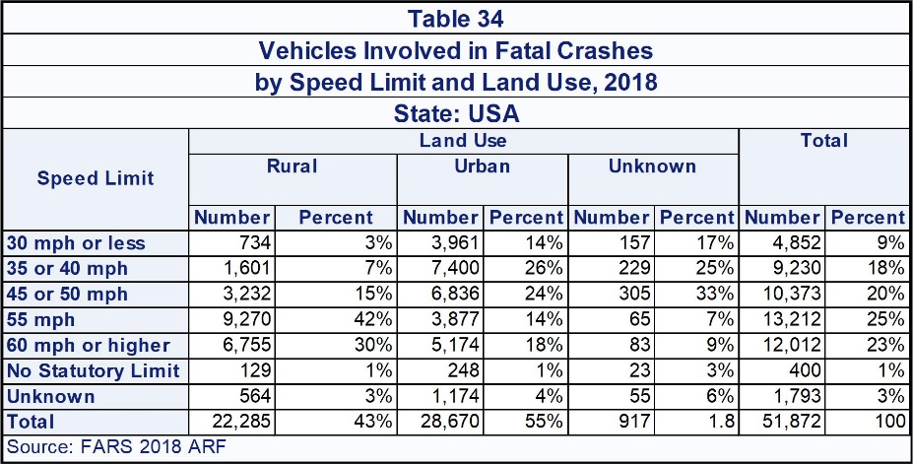
The risk of velocity relationships (speed and direction) belongs to the Flow Team and the Core design team. The expected damage at Cpk relationship for each HazOb should be estimable from existing government/industry tables and all that is really needed is a useful model to make decisions. Table 34 from the NHTSA crash database shows the start of the path. Notice the difference between rural and urban. Urban shows much higher fatalities at lower speeds. Higher probability of fatality means a higher probability of hazard energy penetrating a human (factually higher hazard energy transfers). This suggests that the lower speeds of urban driving have higher relative velocities (one very slow and one much faster). It also suggests a more effective or complete transfer of hazard energy. This is a more direct hit (e.g., Cpk = 0.0). Urban driving includes higher traffic density and the majority of pedestrians and pedal cyclists. Develop basic relative velocity, point of impact, completeness of impact, versus HazOb decision guidelines that are included int the AV’s Hazard Path selection guidelines. A rough relative velocity table used well will provide excellent directions for design. Use relative velocity (speed and direction) between objects for all determinations (same direction, cross direction, opposite direction, and the 45° angles). Argue minimum MIAS decisions as part of the Cpk_{sc} decision.
More advanced systems must be able to perform an emergency stop and also turn to avoid impact with the front left/right corners of the vehicle. Whenever possible, minimize the energy that can transfer (slow as much as possible). Minimize the physical overlap while avoiding a focused point impact (e.g., a corner). Redirect the energy. A general area impact has more energy but lower localized energy densities than the high energy density created by a corner. A corner shear can be very violent. This needs to be studied an is a fine tuning nearer the end of design application after more direct risks have been solved (special response team). The challenge would be to change a 4-inch corner shear into an extremely fast swerve to miss a pedestrian with a corner. Then swerve back to join the original path. This can be an extremely fast reaction if the swerve dimensions were sent directly to the AV’s vehicle control to be spliced into the current command (e.g., swerve lateral left of 10 inches starting at x,y,z,t with a longitudinal distance of 45 feet. The pedestrian is passed at the middle of the arc. This would avoid having to splice a swerve into the current commands and waiting for them to reach the vehicle.
The special response team can be most effective after the volume of design changes slows and they have a stable design to study. Involving them too soon can create a mess of design changes that never catch up with their selves and break any technical data package’s integrity. The design is not speeded up as desired. It is thrown into chaos. This would mean unknown relationships and risks are included in the AV and any safety release of this broken package is unknowable and unsafe.
The remaining detections are of the violation of right of way by the pedestrian. For example, a crowd of pedestrians crosses the road where they do not have the right of way. The AV must be able to sense and determine that slowing down and stopping at a safe distance is required (technical safety requirement). Pre-scenario pattern matches are needed. Masses of people get out of a concert, rodeo, opera, townhall meeting, the largest bar in town just finished last call, and so on. This is a specific risk attribute. How and when should the AV use slow, timed, assertive movements to move through a crowd (conditional pattern match approved responses). The HARA must identify all such specific risk locations as well as their scheduled high traffic venues. The same for public/private schools. Normal business hours for employees. Largest crowd times for breakfast, lunch, dinner. Largest crowd times for going to the beach and so on. The road segment will identify all points of interest. Flow analysis will confirm points of interests at times of day. All points of interest have their information available on-line. Google Maps already has the expected number of people that go to all types of destinations at any time of day and might be used by the AV. They also have complete flow models for much of the world (vehicle, pedestrians, and pedal cyclists). There needs to be a venue team likely represented by Map, Perception, supported by flow modelling – including swarm as needed. This turns into pattern recognition of groups, an interface of two masses (vehicles and pedestrians) under pressure to move across each other’s path. There must be an extremely clear understanding of the flow controls and rules designed or locally accepted into that stretch of road. The remainder are the localized rules of passing. Team: Object/attribute recognition, HazOb Tracking, HazOb group movement pattern recognition, motion constraints, potential responses, and so on.
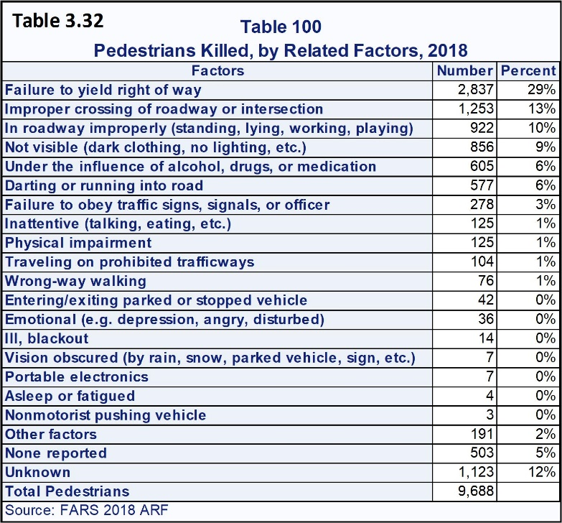
Pedestrian Caused Fatalities. Table 3.32 Shows that 29% of fatalities were caused by the pedestrian failing to yield the right of way to a vehicle. Pedestrians walk and move as they do because they think they are safe. Many people believe that pedestrians always have the right of way. Pedestrians can become absent minded and step in front of a vehicle. Sometimes a pedestrian will step in front of a vehicle as if they are daring the vehicle to strike them. It is rare that a pedestrian will display zero attribute warnings/body-language signals of intent. Rare means no warning attributes and late detection. This is the sudden emergent conversation and is covered. The AV must be able to model the risk of any pedestrian that might enter the critical zone (technical functional safety requirement – current and future motion constraints). Risk analysis requires either historical attributes from AV memory or new near-term attributes must be gathered.
The pedestrian has the right of way at a stop sign when they are walking between the crosswalks. They have the right of way when they have the walk light. A pedestrian violates the right of way when they cross a street against a red light and they are hit. A pedestrian has no right of way if there are no cross-walk markings and signs. This does not mean that the driver will not be sued and lose. It means that the driver is not legally at fault. A civil suit can award some type of wrongful death verdict. The AV will be judged more harshly than a human. The AV records must be able to show that no human could have missed the pedestrian AND that it interpreted the world correctly AND it chose a statistically optimal response as well as considered the hierarchy of hazard energy protection choices: vehicle (damage must reach human) –> pedal-cyclist (position above impact-legs and knee damaged, helmet minimized head injury) –> pedestrian (direct exposure). Use this as a starting set of priorities and modify it until it fits your company’s risk acceptance/avoidance position. The AV controls must mitigate, as in choose the lower risk of harm as much as possible (safety goal).
Thirteen percent of pedestrians die because of improper crossing of roadway or intersection. 10% die because they are improperly in the roadway. The system must detect and avoid pedestrians on or entering the roadway (technical functional safety requirement). 9% are killed because they are hard to see at night. The system must be able to detect and avoid pedestrians regardless of lighting or weather conditions (technical functional safety requirement). 6% die because they dart or run into the road (the sudden emergent conversations). This would include pedestrians who appear suddenly in the road from between cars or are making an insane attempt to catch a Frisbee.
The system must be able to detect pedestrians between parked cars, vans, trailers, and trucks (technical functional safety requirement). Between vehicle detection will be an imperfect, but risk reducing HazOb risk predictor. Imaging radars have the ability to return a ghost image that exists beyond thin sheet metal. They can see through the sides of most semi-trailers. Military grade iRadars can see inside shipping containers. Walls are seen as an object and the penetrating energy reflects back through the wall as a ghost image of what is inside. This seems to be a special, and much needed focus, of many of iRadar companies. A powerful pulse of a penetrating frequency is added between the other frequency/range pulses. It does not need to be sent with every cycle. This can reduce both power drain and heating of the transmission posts. The decision is what is between or on the other side of something. The decision of that pulse is the ghost image or what is past an object.
I was stationed at the US Navy Advanced Electronics School, in San Diego. I was the only “fresh boot” student ever assigned there (1976-79). I was not assigned as a trainee. I was general support for all electronics. I was also lead metrologist and held their highest certification. I went bowling and played ball and learned from the Navy’s top experts, who were my friends. I spent the last year on a destroyer supporting a cryptology air search radar. I was also general support for everything electronic on the ship.
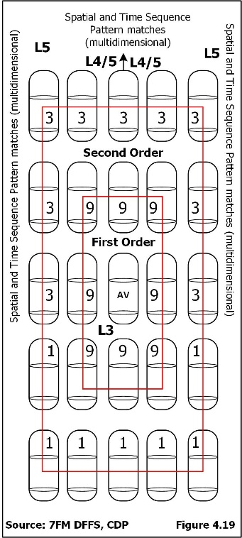
Many of the advanced sensors are innovated military solutions for public road application. The sensors are smaller and more limited in power and resolution. It is amazing how transferrable technology is, especially when it is an answer to a required innovation. Sudden emergents will reduce most of the risks. Solve this after launch. This is a direction growth for safety that must be solved. The goal is to see the secondary HazObs (the cause of a first order intrusion - Figure 4.19) at the same time or before the first order HazObs. that the HazOb sees their direct cause. The AV can react faster than the HazObs around it. The important point is that auto correlation and dependent relationship statistics would no longer be required because the secondary is already directly measured. This greatly reduces required processing load of relationships. It also means that the dependent secondary relationships would be the time delay confirmation of what the AV already knew.
Pedestrians fatigued or asleep is an extremely small risk on the road surface. This risk is combined with objects and debris on the road. There are strategies to sort out a human from clutter (infrared vision, iRadar body mass return. This is an after-launch solution which means, understand this risk when road debris is analyzed and apply any human related tests as part of “things/objects over a given size higher than the surface of the road (the bare background). This is a risk that can be reduced. There are many larger HazOb caused problems that can be solved more directly. Rationalize the remaining list. Solve core and emergent paths first (solid core design). Solve all solvable emergent responses second (the call and return from the core). Solve the similarly grouped specific point risks third. Asleep on the road is specific. It has no specific point and it has zero relationship to flow. It is something in the road that is more important than anything on the road surface. Part of it will be solved with road debris. The remainder of the risk belongs to the HazOb. They are responsible for their life. They are violating the right of way of the road. Drunk, on drugs, sick and in need of an ambulance, just very tired, afraid, and alone, whatever the reason, somehow, their life led into a final last decision. Make rational design choices and do not solve force-majeure risks (act of God). It would cost many times more than a fully certified design to fix all the crazy things that “might” happen. And the job would never be complete. The sole purpose of this paragraph is to show a rational counter-argument to the human urge, most of us have, to solve all problems. Failure to solve this problem would mean a potential trip to court, four times in one-hundred-billion miles. This is safer than commercial air travel. Years ago, a man jumped a fence into the Greenfield Village in Dearborn, Michigan. He stood in front of the mini-train, was hit, sued, and won. He, “just wanted to see if the train would stop.” He lost on appeal. You cannot protect this man.
Maintain a list of the things considered and not solved. This is legal defense so it is a controlled record managed by functional safety and stored with the legal department.
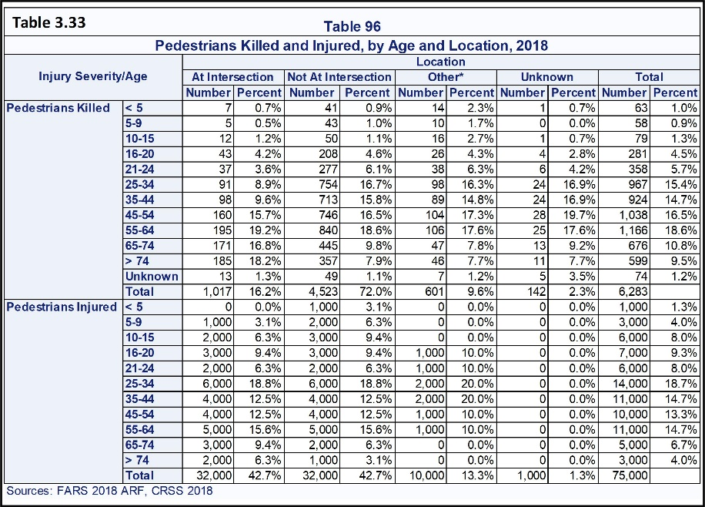
Pedestrian Fatalities by Age. Table 3.33 shows that pedestrian movement, not the age, of a human is the controlling factor of pedestrian crashes. School age children spend their days in class, working age adults travel to/from work, and so on. Pressures, destinations, and decisions/actions are three factors that will cause a pedestrian to assume risks they think are safe and they violate the right of way of vehicles. 16.2% of pedestrians are killed at an intersection and 72% are killed while not at an intersection. Pedestrians in motion have a trajectory. Pedestrians who dart across the road believe they have made a safe choice. Does the intercept estimate of the AV agree? If yes, there is no reaction as the darting pedestrian is not at risk. The risk of a stumble is real and is statistically conditional (smaller than the individual probability) and belongs to the pedestrian’s choice to risk life and limb. However, slowing down is required as a safety margin because of a potential stumble. The AV can adjust its course to miss if possible. This would be similar to a dependent move away from an encroaching HazOb and should already be an available sudden emergent Cpk_{sc} choice. 42% of injuries occur at intersections and 42.7% of injuries are not at an Intersection. 42% of injuries are at an intersection and 16.2% are fatal. This is a speed relationship. Drivers are either going slower or are prepared to stop. 90% of pedestrians are killed by front impact while the vehicle is going straight.
Conversation on Pedal Cyclists. Pedal cycles include any wheeled structure that uses pedals/gears to transfer force from hands or feet to the wheels. This includes the elliptic-cycles (stand and walk/ride). A safety critical consideration is the expected height and position of the pedal cyclist’s body and head. The body of an average cycle design places the critical body parts above the plane of most impacts. The critical organ/head exposure of the average pedal-cyclist position is less exposed than an average pedestrian. This is a specific risk mitigating attribute when making a “Which HazOb has the least risk” decision. If the rear wheel is struck, the pedestrian is moved before the vehicle strike. A head that is low to the ground is more exposed to fatality than a body standing. Expect that a low-profile bike as well as a performance wheel chair will be driven over rather than thrown aside (specific HazObs with higher risks avoidance rules – specific responses to pattern match).
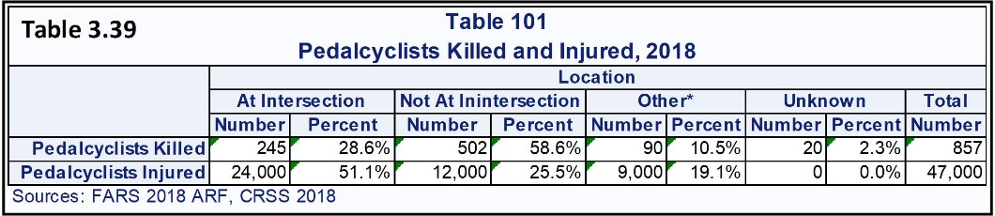
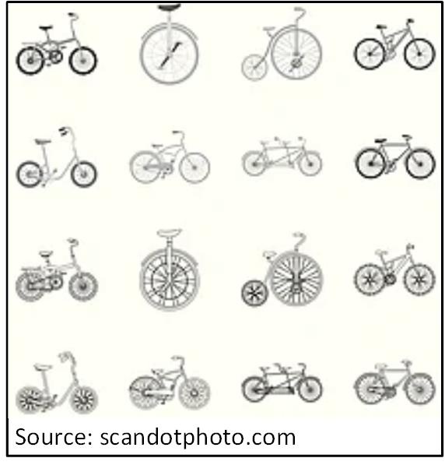
Table 3.39 covers pedal cyclists killed and injured. It shows that 58.6% of pedal cyclists are not at an intersection when they are killed. This means that they were on or near the road riding in available spaces or riding along the side of the road in a designated bike path and so on. 51% of pedal cyclists are injured at an intersection. 25.5% of pedal cyclists are injured while they are not at an intersection. This is a similar conversation regarding vehicle speed as with pedestrians. The AV must have early pedal-cyclist risk matches sufficient to slow the AV and provide a capable intercept miss/passing for all cyclist at all relative passing speeds/vectors – to/from any direction. Vehicles have a larger chance of driving more slowly at intersections with signs and control lights. Drivers are likely to be more prepared to brake and avoid a pedal cyclist at or near an intersection. The category “other” means that the scenario was uniquely different. It also means there were no witnesses and no facts available to explain any portion of the crash but the end. Some police reports lacked content. Bike lanes that are along the side of the road have exposure to a vehicle strike. The AV or Pedal Cyclist can depart from their lane. Other is a significant 10.5% pedal cyclists killed and 19.1% injured. 28.6% of pedal cyclists are killed at intersections. All sensing, tracking, and reaction conversations for pedestrians apply to pedal cyclists.
L3 through L5 solutions must be able to recognize pedal cyclists, track the trajectory, model the pedal cyclist paths, and understand the HazOb’s variation around its path (technical functional safety requirement). The solution needs to determine a safe path that reduces risk of a crash as the AV passes the pedal cyclist, to be confirmed by the closest passing distance SCM-Safety Critical Metric. The maximum lateral and longitudinal statistical variation of both the AV and Pedal Cyclist need to be understood and the system must ensure that the AV is statistically capable of passing and stopping before a pedal cyclist is hit (technical functional safety requirement). This is when the pedal-cyclist activates any “additional risk analysis required” tests. This level of challenge is only for near-term safety critical constraints (full analysis).
Pedal Cyclist Forced out of Path. The system must be able to detect (pattern match) and understand constraints in a pedal cyclist’s path. Constraints limit choices, the AV must be able to predict the most likely path the pedal cyclist will take to avoid constraints (technical functional safety requirement). The system must use the prediction to detect potential intercepts precrash scenario caused by the pedal cyclist avoiding debris and obstacles in its path (technical functional safety requirement). A human can see the debris and obstacles in a pedal cyclist’s path and they will be able to predict when a pedal cyclist will have to intrude into their lane. However, the human only looks for the reason after they notice this behavior or the obstacle is obvious. A human can, without significant delay, notice and understand debris, pylons, end of path, or a pedestrian/animal/cyclist blocking the path. This means a pattern recognition for the nature of the pedal cyclist’s motion constraint: surface debris, larger debris, people, and so on, if any exist. It might be that no pedal cyclist constraints can be determined at the current level of sensing/small targeted attribute detection and pattern recognition capability. This is a commercial refinement of ground clutter analysis used by air systems when targeting an air target or they have to match a target shape on the ground (the Camera, iRadar, and LiDAR sampling of ground shapes). What an Unmanned Air Vehicle would see at 15,000 feet would be the relative size of rocks and pebbles on the ground from an AV’s field of view. The AV can apply the military technology to a different application. This is a direct innovation.
If the pedal cyclist is statistically capable of staying in their path (modelled by the AV) there is zero risk they will become a sudden emergent HazOb. This is safe laminar flow. Perception and motion constraints need to determine if there is a physical reason that the pedal cyclist does-not/cannot remain out of the AV’s path. The aware driver automatically avoids risks by avoiding a situation and remains in laminar flow (pre-situation match). Potential responses: A driver will safely drive out of their lane to avoid the pedal cyclist, the AV must either slow down and follow the pedal cyclist in lane, or safely go around the pedal cyclist even if this means safely and momentarily encroaching into the oncoming traffic lane. A driver will see that a bike path on the right side of the vehicle ends and crosses the street ahead of the AV. Any forward pedal cyclist will cross the road in front of the AV. If this is a marked bike path, the pedal cyclist has the right of way unless their motion is controlled/metered by traffic control signs/lights. This is the same pattern recognition and response as many other controlled/uncontrolled cross traffic with any HazOb.
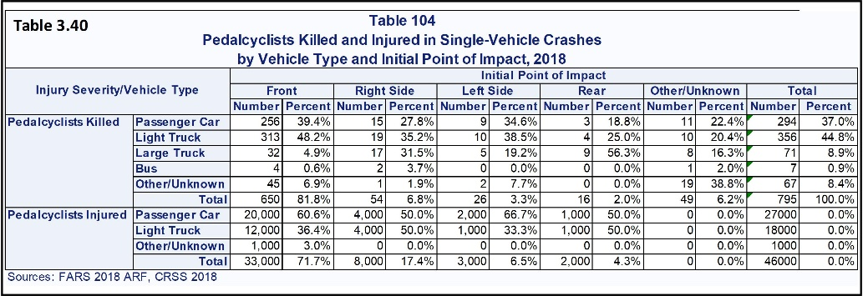
Vehicle Type and Point of Impact. Table 3.40 shows pedal cyclist crash severity by vehicle type. 1.7% of pedal cyclers who are injured die (795*100%/46,795=1.7%). 81.8% of pedal cyclists are killed when they are struck by the front of the vehicle. 6.8% strike the right side of the vehicle (right turn across the pedal cyclist or right intrusion). Crash avoidance must prioritize intercepts with the front, the front right, and the front left of the vehicle (technical functional safety requirement).
According to Forbes (www.forbes.com/wheels), Light trucks make up 57.2 % of the vehicles on the road and produce 44.8% of the fatalities. Large trucks are much safer than light trucks and passenger cars. Light trucks and passenger cars seem to have similar risks of causing Pedal Cyclist fatalities. Large trucks count most of their miles on limited access roads where there is no access to pedal cyclists/pedestrians. Buses have a panoramic view for the driver and drivers use extreme defensive driving techniques (very low risk).
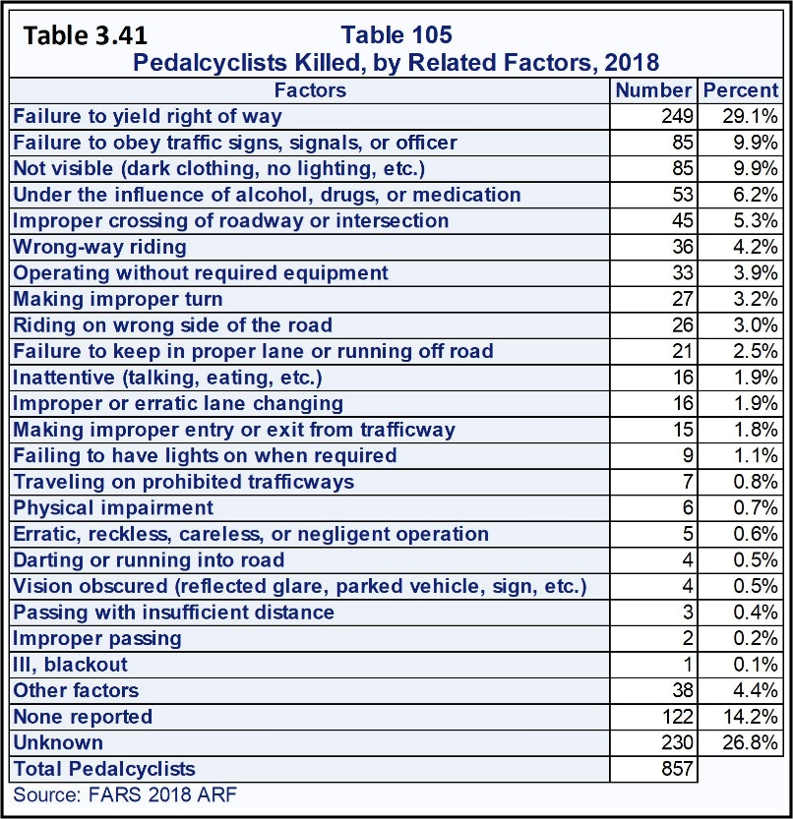
Pedal Cyclist Caused Fatalities. Table 3.41 shows the pedal cyclist caused crashes. These are emergent (response) or sudden emergent (safety critical response) based on the ability to pattern match attributes. The AV cannot know that a pedal cyclist is under the influence of sickness or the many forms of legal and illegal substances. Only the pedal cyclist’s behavior is observable and detectable. The point of impact table will relate to detectable spatial and time sequence patterns (Table 3.40). Many of the related factors in Table 3.41 are directly detectable. Consider this table and find prediction attributes if possible and begin to think of the responses where practicable. These related factors explain how the pedal cyclist position their self to be hit by the AV.
The precrash scenario risks in descending order are 29.1% of fatalities are caused by pedal cyclists failing to yield the right of way. 9.9% fail to obey traffic signs, signals, or officers. 9.9% cannot be seen at night and are hit. 5.3% of fatalities are cause by improperly crossing the roadway or intersection. 4.2% are caused by riding the wrong direction on the road. 3.2% die by making an improper turn. 3% of fatalities are cause by riding on the wrong side which violates the right of way of all oncoming traffic. These are the same conversations as the pedestrian self-caused fatalities.
Advanced solutions will not assume that the Pedal Cyclist will obey the right of way. They will analyze the pedal cyclist’s trajectory and lack of intent to slow down. When the pedal cyclist passes a rational slow down point, they are not going to slow down. In some parts of a city, they never slow down and all vehicles expect this. And, there are no signs or bike paths. Predict and avoid pedal cyclists who violate the AV’s right of way (technical functional safety requirement). A pedal cyclist’s critical failure distance is when there is not enough time to fully stop or swerve. If there is a critical error on the pedal cyclist’s part, swerve in the direction from which the pedal cyclist came even if it means going over the curb, if it is safe. Pedal cyclists must stop at the stop sign or red light. Many do not and few are issued traffic citations for running red lights. When the pedal cyclist is riding in lane with traffic, drivers following the pedal cyclist must yield to the cyclist just the same as they would yield to another vehicle. The cyclist can be in their bike lane or they can enter a vehicle traffic lane for their own reason. The cyclist must safely enter the traffic lane in front of the vehicle.
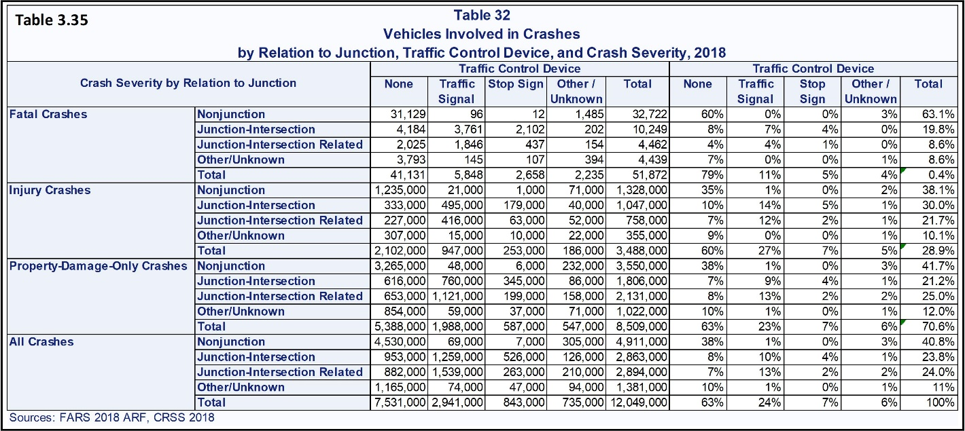
Conversation on Vehicle Crashes. Table 3.35 shows that 38.1% of injury crashes and 63% of fatal crashes occur at non-junctions/intersections. This suggests a relationship between speed and driver attentiveness. Junction/intersections are HazOb exit/enter points. Intersections range from simple to extremely complex. Junction and intersections with or without control devices have a limited number of physical combinations. These can be studied and grouped for common technical challenges and risks.
Intersections, with and without control devices are a specific set of challenges common to all road segments. Representative samples are selected and validated to contain all challenges and are studied by the Intersection/cross Flow teams. Otherwise, every team will be working on intersection solutions and will solve the same problem with different technical solutions. The common problem of protected and unprotected left hand turns across traffic belongs to a single set of teams. Bike path and pedestrian path crossings are subsets of this team.
Driving straight and curves is the statistical capability to define and maintain a lane (mastery level 2). This is the start of the core design. Mastery of level 3 has the statistical capability to master all normal right of way driving challenges. The L3 must be statistically capable of producing a safe path and safe first order limited emergent response path. This is one of the eight direct positions surrounding the AV. Level 4 must be capable of all first order, second order and pattern match emergent responses. Level 5 is Level 4 with a broader general open start/stop domain.
The same is true for continuous flow intersections such as round-a-bouts and any type of entrance/exit ramps. Some intersections will be a unique point risk such as a five-point intersection controlled by lights with a fire station exiting one of the points. Protocol affinities/similarities will create natural groups of homogeneous risks. The intersections that cannot be fit are specific risks.
Thirty percent of injury crashes and 19.8% of fatalities occur at junction intersections. 21.7% of injury crashes and 8.6% fatalities are junction-intersection related locations. Drivers are more aware when they approach or maneuver through an intersection. Most drivers are prepared to slow down, swerve, and stop (emergent responses with Cpk ≥ 2.0 preapproved paths). 35% of injuries and 79% of fatalities do not involve traffic control devices. Precrash scenario are defined by the AV motion and the physical constraints caused by HazOb positions, road geometry, and other factors common in any police accident report. This will help explain why crashes develop differently at intersections versus non-intersections.
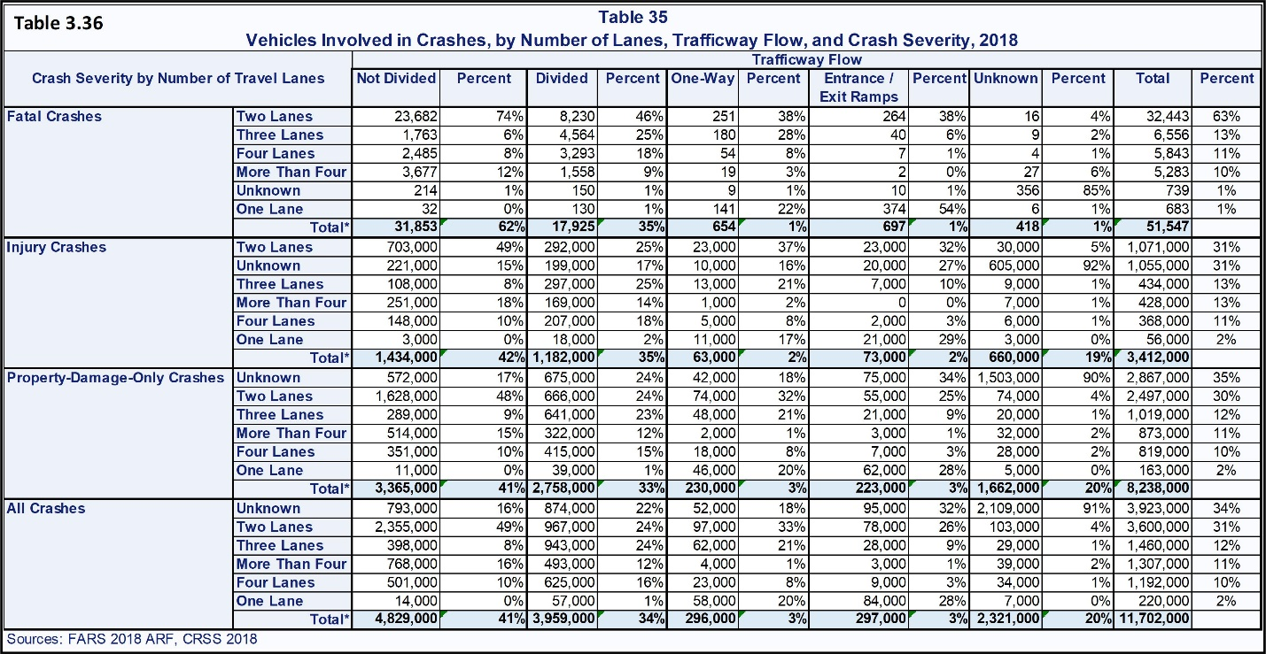
Functional Road Classification Risks. Table 3.36 shows exposure and severity for road classifications that are/are-not divided and with multiple lanes. Cross-traffic flow patterns are a subset team of Flow. The Flow team includes motion constraints and motion planning supported by traffic pattern recognition and flow models. Flow reduction is a specific risk regardless of the number of lanes at reduction or road classification (e.g., 5 to 4 lanes or 2 to 1). Flow reduction is a specific set of solutions that need to be managed by a subset of the Flow team.
Sixty-three percent of fatalities occur on two lane roads, 13% on three lane roads, 11% on four lane roads and 10% on more than four lane roads. 62% are not divided and 35% are divided. One-way and entrance/exit ramps each have 1% occurrences.
Every lane and turn is designed with right-of-way rules. The goal is to minimize flow restrictions, and sort traffic between access and mobility. This is a combination of metered and natural flow relationships. Metered flow gathers and releases groups. Every lane has a finite number of ways it can be entered or exited.
The driving environment complexity increases with the number of lanes. Lane position is a suggestion of intent. On a two-lane road, right lane suggests a local access exit or a turn onto a connecting road to the right. The left lane position is for through traffic and left turns and exiting on the left. A vehicle in a left lane voluntarily moves to the right lane without forward constraint is going to slow and turn right soon, or drive through. Someone who enters the right lane, accelerates, and moves to the left lane (sequence) is going to flow through or turn left. A vehicle who joins the forward group intends to flow through. A vehicle that hangs back will make a relaxed and safe decision to continue or turn left. When the left turn is from the left lane, flow through traffic will change to the right lane, pass the turner, and move back into the left lane. A HazOb will either follow or change lanes. Both are intent.
The center-lane of a three-lane road is the normal speed for the segment (e.g., the speed limit, +4 mph, +9 mph). It should be noted that this has the same relationships and patterns as the two-lane road with a bike path on the right. In this case a vehicle is in the right lane and not a pedal-cyclist. The same patterns. Same math. Similar choices. The left lane is expected to be faster. The right lane is expected to be slower. The left lane is for passing, making left hand turns, and flow through. The right lane is for entering, flow through, and exiting the road. A group of similar drivers will pass on both the right and left side. They approach, maneuver position, pass other vehicles. Groups will separate into different speed. Speed limit (relaxed), +4mph (cautiously optimistic drivers who are -1 mph from a ticket), +9 mph (drivers who think they are -1 mph from a ticket), +14 and beyond are under pressure with a few that just love to drive fast. Sort the different types of drivers and suggested intent as they approach the AV from behind. All +4 drivers will safely maneuver and pass. The +9 mph drivers will smoothly position their vehicle in the lane that is passing other vehicles. Some of the +14 mph drivers will push slower drivers out of their way and some just love to drive fast.
Every time a HazOb reaches a forward vehicle, they have a 50/50 choice. From this, lane choices, positioning, and speeds, can form probability of intent positioning (sequence attributes ending with a spatial attribute). A HazOb will leave active driving, turn, or pass through. For example, in this segment, what if the expected values are 91% drive through, 2% exit driving, 7% turn onto different paths. Match behavior/position to choices and probability. The behavior and attributes will sort out who is going where with specific statistical probability. Work with a solid applied statistician. This would be the probability of road grade access (destination), turn to new road, or drive through.
Consider a four-lane road with two lanes in each direction. The AV is in the right lane and a HazOb is passing the AV on its left. There is a car in the lane forward from the AV that is slowing to a stop. The HazOb passing on the left is not slowing. It has passed the expected slow transition point and only has one choice left. This is the point of commitment. It is a Commitment Attribute just like the knees of a human. Spatial and time sequence attributes state that the driver is going to insert in front of the AV and pass its forward constraint on its right. The HazOb is not slowing which means it cannot see the slowing vehicle in front of the AV. The AV is already slowing for the stopped vehicle. The HazOb made very wrong assumptions. It was a field of view error in assumption (open road). The two parts of this pattern are recognizable on every classification of every road. The AV must understand the faster driver will insert closely in front of it and immediately slam on the brakes. The AV is already slowing. It needs to increase its braking and allow room for the newly inserted HazOb as part of either a safe planned path or a Safety Critical Metric response (risky/hazardous).
To stress the point, the response is to slow/stop which is one of only eight directions of choice. Another choice would be to change lanes (move left, speed-up and move left, slow-down and move left) as the HazOb changes lane. Going left would mean following the HazOb’s old constraint past the stopped vehicle and the newly stopped HazOb (the go left choice). Change lanes more aggressively than the HazOb and slow at the same time in case they change their mind to avoid the stopped vehicle and rush back into their old spot. The HazOb’s old lane removes the need to risk a hazardous stop. If the HazOb swerves hard back into its old forward vehicle it will immediately accelerate after its old lead vehicle. They will accelerate and follow the forward vehicle. This choice is the most optimal. Decision: There are only two driving surface emergent responses which are stop in lane and go left and slow faster than the HazOb. It would be a specific technical functional safety requirement – pattern match response: slow down if safe, change lanes and slow down if not. Changing lanes is 2% of fatality crashes. A Cpk_{sc} ≥ 1.0 hazard escape path estimates that the 2% is not present. There are only so many patterns created by these eight first level or direct to the AV constraints/responses. The free directions are available for responses.
The AV must be able to recognize/match the patterns-of-constraints, patterns-of-situations, and patterns-of-precrash scenario with its free of constraint and almost free of constraint response choices. How HazObs will respond to restrictions is predictable. The team must document a prioritized list of preferred responses for each situation and precrash scenario (technical functional safety requirement assigned to motion constraints and motion planning).
L3 solutions, initially, must be limited to joined road segments of mostly laminar-flow and homogeneous transition risks. This would be limited to a specific lane assignment on a single road classification of validated and nearly homogeneous risks. The L3 must be designed to be capable of every “mind-off” risk in what should be a narrowly defined domain of strings of homogeneous road risk segments.
A traffic jam, once it has developed, is a fully constrained laminar flow with low risks of injury and fatality. The L3-L5 AV must be able to detect that a traffic jam is developing and slow as safely as possible and stop before causing a forward crash. The AV is at extreme risk when it is the first vehicle to reach a sudden stoppage. If the AV is following a forward vehicle, that vehicle will force the AV to slow down safely to the limits of the hazard risks of the NHTSA crash tables. This is where its longer-range sensors and decisions are challenged to avoid a Maximum Hazard Energy Transfer. Detecting a traffic jam too late causes a sudden slowdown, and a crash into the rear of the AV. The AV would have created one of the most severe sets of precrash scenario (hit slowing forward vehicle, hit forward vehicle, hit stopped forward vehicle) because of late sensing, matching, path closure determination, and hit the brakes as hard as possible too late. The system is not capable and should not be on the road. This is failure of an obvious. All of this is created or avoided by AV Design and Validation decisions. All such reasonably avoidable crashes belong to the AV design.
The L3 solution manages its speed and the distance to the forward vehicle, and reacts to changes, encroachments, and intercepts in its lane. L3s have limits to its processing power which is only sufficient enough to manage the safety of its authorized and limited functionality. This would be lower risk and single lane driving as a minimum but can be more advanced. The L3 must know when it has reached the limits of its responsibilities and authorities or ability to find safe solutions (technical functional safety requirement). The AV must exit autonomous driving before it becomes unable to process safe solutions.
All Driver Controllability assumptions (L1-L3) must be supported by a design capability analysis that includes takeover response time in all conditions and after long delays, by normal drivers. Controllability is the quickness and correctness of a driver’s response. Capability of path and time are studied together as a single test and provides information for both capabilities. The studies must be designed to produce explicit evidence of safety of path and time response (objective evidence of capability).
The Risk of Maneuvers. Table 3.37 shows the risks of Vehicle Maneuvers.
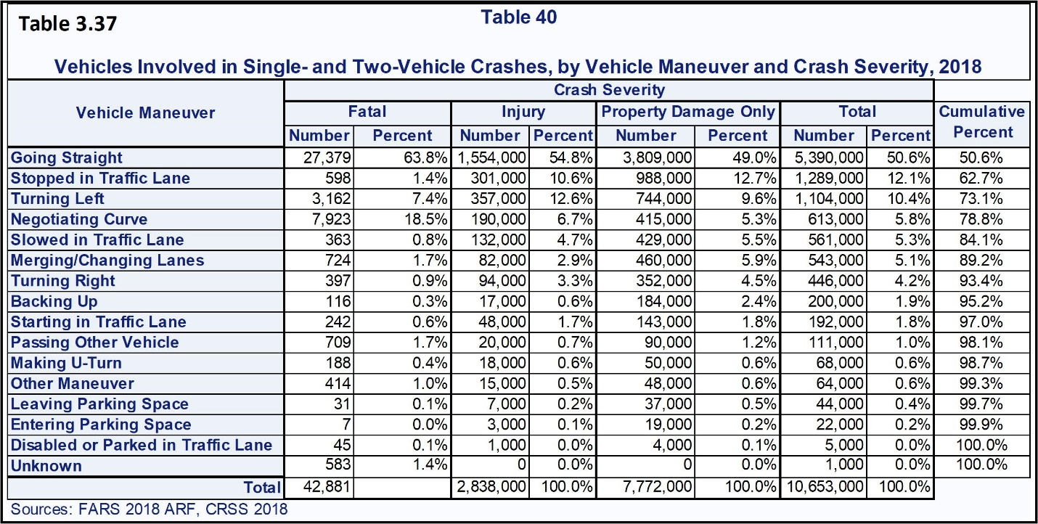
Most of this table belongs to the core design team. The Core design is the capability to define and following safe planned and managing all safe response maneuvers for all driving challenges in the ODD (third level of Mastery of Functions). This is the requirement of an L3 solution-with the emergency stop requirements added.
HazObs will fail these maneuvers and place their vehicle in a position to be struck by the AV. The AV must recognize restriction patterns, time sequence patterns, and out-of-context patterns (new construction, forward crash, new traffic control devices, vehicles are not following the lane lines, and so on).
Always have a safe way out. This is one of the Smith CDL safe driving rules. There are only eight first escape choices. Maintain path would mean that the current path, however unsafe, is the least hazardous. It is not a choice that lowers risk. The choices are to speed up, slow down/stop, speed up and go right, speed up and go left, go right, go left, slow and go left, and slow and go right. Which sequence of these need to be strung together to stay safe? How much physical passing distance will there be while escaping the situation?
Is the AV responsible for HazOb reactions to the AV’s safe way out choices? In the form of offering the safest of all possible choices, yes. Most HazObs will have a dependent move away from the AV. This is the dependent HazOb’s risk reduction response to an intrusion. There is the cause of the precrash scenario and there is the cause of the crash. They are not always the same. However, no solution can depend on HazOb responses. The AV will encroach. The HazOb will respond. This is a “given” or dependent statistical relationship (AV|HazOb or HazOb|AV).
The driver must be in control before a situation turns into a precrash scenario. Work very hard on pre-situation matches (both spatial and time sequence matches) and the driver must assume control of all situations. This way controllability changes from responding to an emergency and becomes responding to a developing situation. An L3 solution must never enter a pre-crash scenario (technical functional safety requirement). The L3 must exit normal driving and stop off the driving surface before a Precrash scenario develops (technical functional safety requirement). The driver can be allowed to assume control during a controlled stop. They must not be allowed to take over during a sudden emergent stop.
Fatality columns: 63.8% of fatal crashes occur while driving straight, 18.5% negotiating curves, 7.4% making left-hand turns. These three are plan and execute right of way failures with 90% of the fatality risk and represent the center of the design’s statistically safe path.
Fatalities while driving straight means the vehicle is at fault of all forward and sideways crashes including a single vehicle crash and there is no safety/correction response (lane departure and forward collisions). The remaining maneuvers are all less than 2% in contributing factors. This is the same conversation as for Table 3.36. For L1 and L2 solutions, the driver is responsible for viewing the driving environment and avoiding HazObs. L3 solutions must have 100% capability for developing and executing safe commands over all maneuvers for which it is authorized. L4 and L5 must be capable of assessing all HazObs, obstacles, changes in the environment, and safely performing all vehicle maneuvers (safety goals).
L3-L5 solutions need to have maps that contain all important road dimensions, surface shape/physical parameters (e.g., normal road friction range, driving patterns, and so on.). The L3’s map is like a “starter set” for an L4/L5. It does not address complex relationships. The map needs to contain rules for safely negotiating each road segment, intersections, bike paths, pedestrian/pedal cyclist crossing, and so on. It would be beneficial if it also contained a fair approximation of the clean map background in some of the more technically challenging specific points on the map. This way anything closer than the expected background is an object of some sort (contrast decision).
The Society of Automotive Engineers identified two minimum risk conditions (MRC) when catastrophic system failures occur. There are four meaningful combinations of this covered in the 7FM System Design Phase. In short these are catastrophic failure with/without power and with/without sensors and the conversation is very detailed.
One of SAE’s suggested MRCs is the highest and deadliest NHTSA precrash scenario (stop in lane). Their second MRC recommendation removes the AV from all risks. This is to stop off the driving surface (elimination of all risks). Stopping in lane is safer than driving blindly out of control and it is an extremely professional choice as compared to the bad hazards it avoids. What if the AV executes a stop in lane and there was an off the driving surface solution? The first answer is, the choice satisfied the AV designer’s intent. The second is it did not conform to automotive safety practices of what is objectively safest. The choice created a fully avoidable rear end collision.
The safety mechanism “Stop in a Traffic Lane” represents 1.4% fatalities, 10.6% injuries, and 12.7% property damage. The safety mechanism commands “Slowing in Traffic Lane” relates to risks of 0.8% fatalities, 4.7% injury, and 5% property damage. The term “minimum risk condition” states that the final decision is the lowest of available decisions. It is not the safest response of those developed so far. It is knowing that there is a safer solution and requiring it be solved and validated. Stopping in lane is only minimum risk when there is no off the active driving surface parking available.
One critical stop in lane moment is to be the last to arrive at a sudden slowdown traffic jam. This is a normal risk that does not relate to any type of failure. All other cars slam on their brakes. The expert driver brakes hard early, watching for rear end collisions, so they are moving and have options while approaching the stop. They want to be able to move out of the way if someone behind them is not slowing. This is a specific and severe hazard. Slow down as early as possible. A slow moving forward vehicle is a lower risk than a stopped forward vehicle. If at all possible, collect/arrive with other vehicles behind the AV. The AV has also reduced their risk of a more severe crash. This has the additional advantage of protecting the rear of the AV with other vehicles. Design the response to offer lower risks before the final risk.
Simply stopping without understanding the real risks might not survive an “Is this really the lowest risk choice possible at design review, safety review, and safety release” set of questions. Design for safety and design for legal defense at the same time…with no extra work. Legal review and corrective actions occur before any safety release review.
Choosing a minimum risk condition means having objective data that explicitly proves one choice has the lowest fatality and injury rates of all possible and rationally solvable choices. NHTSA or some other government supported summary needs to be used as an independent point of reference.
A large portion of the AV’s validation requirements/structure is defined during the HARA. The team that validates the system/vehicle integration needs to be part of the HARA team. They have to design a theater to recreate each risk in a test track environment. The AV can be tested on the road safely only if it has solved all the risks of the road segments tested (safety release of an “as-built” and “eyes-validated” technical data package). Validating system/vehicle integration is one of the final steps prior to authorizing the start of production.
The system is integrated with the vehicle. The design teams work with validation to define and plan the testing. Safety case validation is always performed by those who are independent of the direct responsibility/management of the AV design community. Validation must comply with ISO 17025 Calibration and Lab Standard as is required by IATF 16949 Automotive Quality Management Systems. This way, the design team develops a technical solution that masters both the driving environment and as a result validation. And, the validation meets ISO 26262 safety case evidence standards.
It is not enough that a function is appropriate. It must be appropriate for the right reasons. This is part of the post analysis for all tests that seemingly passed. They have not passed until this step is cleared. Were all HazObs, control devices, the road geometry, and so on all properly identified with fully rational decisions?
The 7FM DFMEA with its resulting Design Verification Plan and Report (DVP&R) will consolidate all validation testing into a well-defined and comprehensive test structure. The safety team must work with the design teams, validation, government interface, and quality to perform a safety review and release for road/testing. Road testing must include risk assessment and mitigation planning. A safety release is against each AV’s complete and latest “as-built” and “eyes-verified” technical data package. There can be no open holds or functional concerns. The AV must never be released for testing or use on the road without a safety release review (Safety Goal).
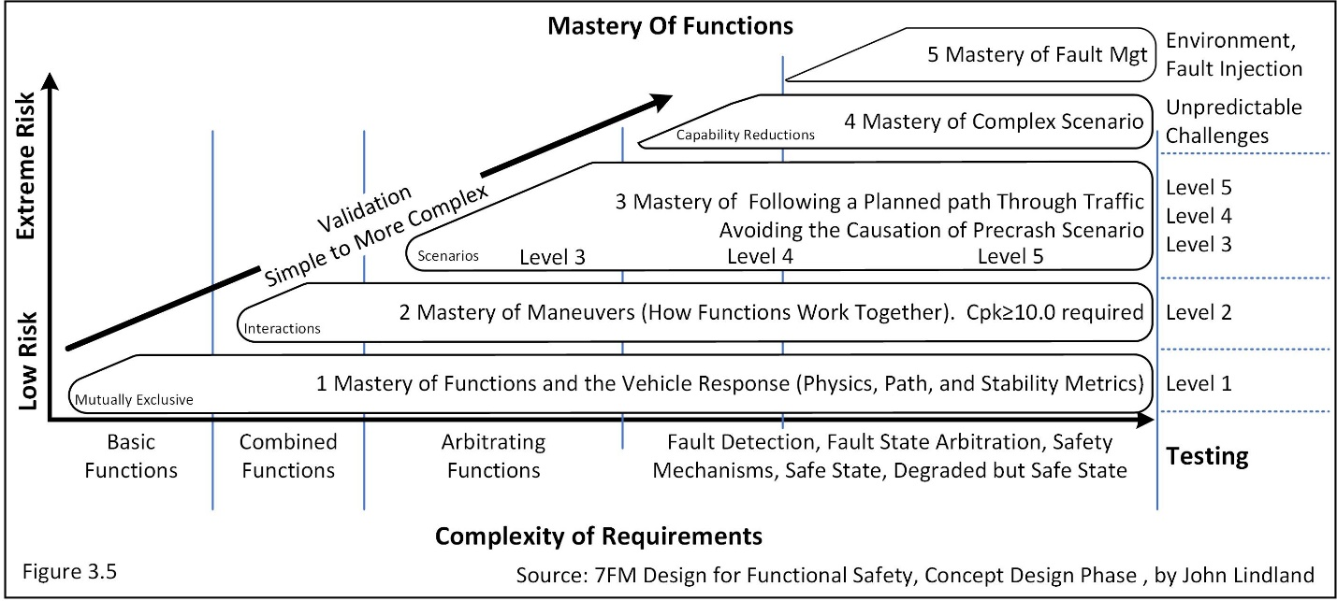
Figure 3.5 shows that Mastery of Maneuvers is the second level of mastery of functions. Maneuvers are how well two or more functions work together. Following a planned path requires linking maneuvers into seamless time series of safe vehicle level commands. L3 is the design that achieves the firs portion of the 3rd Level of Mastery of Functions. Going Straight, Negotiating Curve, and Turning Left account for 90% of all fatal crashes, 78% of all injury crashes, and 71% of property damage. Merging/changing lanes accounts for an additional 2% fatal injuries, 7% injuries, and 5% in property damage. Passing another vehicle adds 2% more fatal crashes, 5% injury crashes, and 6% more property damage. The third level means that the AV can plan and execute and honor all right of way decisions. It has solved all complex driving within its ODD with the exception of sudden emergent responses. This is the mastery for L3 autonomy for the roads authorized. This means it can manage limited transitions.
Weather, Light Conditions, and Road Friction. This team is represented by sensors and dynamic control. Dynamic control is extremely interested in road friction degradation. Sensors are concerned with distance, field of view, and the signal-to-noise ratio of returned or captured signals. Sensors are extremely concerned with degradation in the distinctness-of-image/signal-to-noise of any HazOb, control device, sign, road geometry, and transition from good to bad road conditions. Weather and night conditions have significant degradation relationships with cameras. It is possible to use UV-B headlamps to double the significant target reflective return distance at night. UV-B has great distance penetration and is not hazardous to the human eye. They reach far and reflect at a lower frequency that is more visible, yet some return is still in the UV range. Cameras are not restricted to the human visible range (a system design phase conversation). Cameras are filtered and tuned to the human range. Reject this limitation and use the extra frequencies. The camera and computer can see what a human does not.
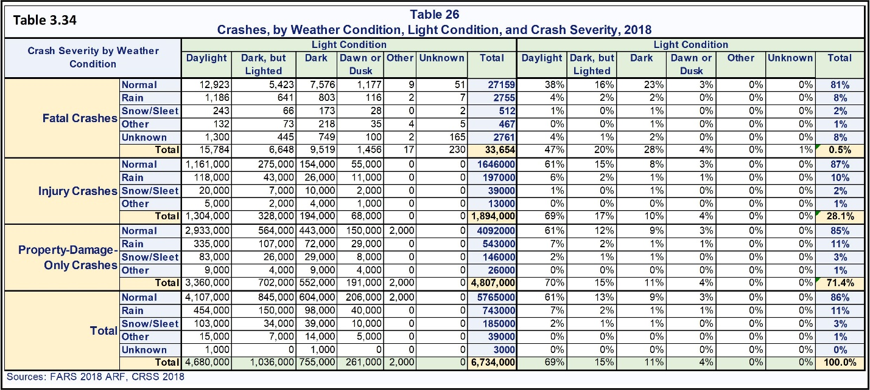
LiDARs are affected by any type of loss of visibility (particulates in the air). There is little to no effect on iRadars. Radar waves develop a signal in the mass of a target. Particles in the air are micro noise-targets and will consume a tiny part of the signal and return meaningless white noise to the receiver. The rest of the signal travels to and from the HazOb with little degradation. The AV must be safe in all authorized weather conditions (safety goal). The AV must safely adjust its speed based on visibility, traffic, and road conditions (technical functional safety requirement). Road friction, lines, dimensions, edge of road and so on might be significantly degraded. Table 3.34 shows relationships of lighting and weather conditions. The percentages on the right side of the table are for the total of each row category (e.g., fatal, injury, property damage as well as the percentages of the category total). The percentages of the total are the same as for the original 36 precrash scenario (e.g., 0.5%, 28.1% and 71.4%). Over 80% of crashes occur in normal weather. Roughly 10% occur during rain. 2-3% occur during snow/sleet. There is likely a correlation between the percentage of time it rains, snows, and sleets to crashes. It is also a fact that much of the USA does not receive snow very often.
The AV must continuously monitor the health of each sensor and accurately estimate sensor degradation caused by any ambient condition (technical functional safety requirement). Each sensor’s health must be tied to a safey mechanism.
Driving next to an iron mine with all the iron/metal particles can coat and deaden an iRadar. Metal develops electromagnetic energy. Cameras and LiDARs perform reasonably well in light to medium sleet and rain. The effective distance of both sensors degrades proportionally to the loss of vision/percent opacity of moving/suspended particulates in the air.
When the topic is LiDAR, there is no “echo” returned through the rain. It is a portion of the signal returned by the target. The non-echo is the degraded signal. It is the sum of all lost information. A slight haze can block the view of the horizon over a long enough distance and a camera receives no intelligently ordered reflected light past a certain opacity distance. It cannot see a thing.
Sensors of any type need constant monitoring of the distinctness of image it can return. This requires an independent point of reference, which is the same requirement for calibration. An independent point of reference can be a flag pole or an internationally recognized standard. One of the largest steel manufacturers in the world calibrates its mass spectrometer from a heat of steel from the 1930s. The spectrometer is tuned to a known profile with nothing more than a stake in the ground. It works. After almost one-hundred years and following the changing measurement technologies – brilliant. The point is that the flag pole is the best standard to use to find out if the sensor can still recognize a flag pole at distance. The chemical properties from an outstanding heat of steel are the best targets for mixing a current heat of steel. Any degradation from the standard is objective degradation with an absolute zero of no information returned. It is a percent ratio metric. Many static targets per mile can be stored in map and recalled by perception to challenge each sensor’s distinctness of image. These targets can be almost anything such as lamp posts, street signs, lights, corner of a building, and so on. A few times per mile map could automatically request a perception challenge of each sensor to validate the quality of its distinctness of image at distance. Map could challenge cameras to capture written signs of known relative font size and require that the sign be read to validate the AV’s eyesight at an AV’s 20/20 eye-test equivalent. A sensor must never unknowingly fail to achieve distinctness of image matches (technical functional safety requirement). Static sensor targets must have a known shape, object digital signature, x,y,z location, and percent image match versus distance table for decisions. Map can store and dynamically update the expected percent match for each sensor against each test object across all capture ranges of distances.
For example, a light post is observed to have a match of 77.1% at 50 meters. The historical 50-meter calibration match stored in map is 82±6% with a 99% level of confidence. The confidence interval of the sensor is 76%-88% with a 99% level of confidence. The sensor challenge was within this range of normal random variation. It can be trusted (e.g., it cannot be rejected as statistically different). However, if the match was 60%, the sensor has experienced a statistically significant degradation. Its effectiveness is (60%/82%)100% = 75% of the original capability.
The reading does not belong to the sensor and cannot be used to update the expected reading or range (average/standard). This prevents bias and loss of sensitivity.
Question, is there a need to reduce speed? The answer is no if it is sensor specific and function flow automatically changes to the backup field of view sensor. The answer is yes, if it is a general technology failure (lighting/visibility has changed). The system must be able to detect individual as well as general sensor failures and mitigate the threat. Sensor technologies would be camera, LiDAR, iRadar, and so on. Sensor degradation/failure is covered in fault detection and safety mechanisms. This is a large topic and will be covered in detail in 7FM Design for Functional Safety, the System Design Phase.
Rain is a rare occurrence in most locations of the United States. It rarely rains the entire day. Consider the ODD and research the percentage of time that it rains or snows. The 8.2% of fatalities and 10.5% of injuries that occur when it is raining is averaged across the entire United States. Oregon averages 43 inches of rain over 156 days (this does not seem like rarely). California averages 15 inches of rain over 36 days each year. Florida averages 52 inches of rain over 114 days each year. Arizona rains 8 inches of rain in 37 days a year, which is rare and the rain is torrential (called the monsoon season). Oil that drops off cars collects in the rough texture of the road surface. The first few minutes of rain will cause the oil to float to the surface and it becomes slippery until it is washed to the side of the road. Rain can be like snow in many ways. States that do not have snow on the roads have a large number of accidents when it snows. States that have a lot of snow also have drivers that have learned to drive safely when it snows. The first few snow/rain days are the riskiest in any region.
The AV’s ability to stop and turn must never be compromised by lower-than-expected road friction (technical functional safety requirement). In which areas of the ODD would the loss of road friction cause the most unsafe conditions and why? The AV must be able to estimate the friction of the road one-hundred-percent of the time the AV is in motion (technical functional safety requirement). All vehicles with four wheel speed sensors can estimate road friction.
For L3, L4, and L5 solutions, road friction estimates must be used to determine the max safe acceleration, deceleration, turning, and braking (Technical Functional Safety Requirement: Team-Dynamic control with Map support). Dynamic Control sends these max numbers to planning. These are the maximum values that can be used to solve the safe planned path. All combinations of throttle, braking, and steering are safe and under full control. Planning must never calculate a plan that is unsafe for Dynamic Control to execute (Technical Functional Safety Requirement).
Friction can drift to lower values and it can change suddenly (snow, ice, sleet, rain, smoke, dust, sand, and so on). Critical friction is where an optimal trajectory cannot be honored/safely-controlled by road friction. All of dynamic controls friction limited commands must have a friction safety margin. The AV must be able to safely recover control from a sudden reduction in friction (technical functional safety requirement). This means that the change can be so fast that the AV’s most recent commands are causing a loss of control. Can the AV recover from a spin-out? The answer is of course but it is not part of the first sets of solutions. Avoidance is the first set of solutions. Failure (recover from a spinout) can be added after release to production if made necessary by specific ODD risks.
Dynamic control and the stability prediction model must produce stability recovery commands to retain control before it is fully lost (technical functional safety requirement). This is where the advice of an expert driver, in the fully loaded and instrumented AV, along with recording their recovery moves would be beneficial (mass, center of gravity, moment of inertia, throttle, steering, braking, IMU-axial responses, GPS, and so on). The AV must be able to safely negotiate sudden changes in road friction, sensor degradations, and loss of sensors (technical functional safety requirement).
If AVs are driving during a snow/ice storm and these solutions have not been mastered, the AV manufacturer could be linked to negligent, gross negligence, and even criminal negligence in their broken or non-existent automotive-grade safety-release. The question would be why did the safety release process break? The point is that the AV must be able to measure and respond to road friction even if it is to slow down after the fact (a lowering of friction response). Like most drivers, this would fail to maintain control during sudden changes. However, most drivers recover and become extremely careful looking for and avoiding future risks (they respond and predict). A friction only answer will fail every sudden transition. The stability prediction model is likely the strongest way to avoid rather than respond to all unstable conditions. This is foreseeable and a portion avoidable to the limits of time and physics.
The AV must be able to predict all environmental transition points that will affect opacity of air and road friction (technical functional safety requirement). This includes when relative humidity and temperature have a relationship for creating fog. Ice forms around 0°C plus and minus a few degrees. It’s temperature changes more slowly than air temperature. Once ice starts to form it can continue to freeze even when the ambient temperature rises above freezing. The latent heat of evaporation of water, is the same mechanism used in air conditioners. Breezes can amplify this mechanism at or near freezing. Ski resorts “blow snow” when it is 4°C as long as it was blowing snow below 0°C before warming (a micro-climate). Nature has micro climates. Is their water on the road and is it close to 0°C? This is the critical bridge freezes first zone.
Level 4 and 5 solutions need to be capable of safely driving in snow and on all other naturally occurring slippery roads in the ODD (technical functional safety requirement). There will be days of snow covered or ice-covered roads with low tire/road friction and low distinctness of image of road markings and contour. The AV might require a minimum safe friction. Speed is limited by each of the safe acceleration/deceleration, steering, and braking levels. The estimated max safe throttle, braking, and steering values must be continuously updated and sent to planning. Planning sends updated dynamic control commands, with a safety margin, and ensures that the AV automatically adapts to maintain laminar flows, remain in full control, and avoid all precrash scenario. This is part of the fourth level mastery of function – managing complex scenario under the worst natural conditions. Consider that an AV is safely driving on an ice-covered road and approaching a hill. The AV stability prediction model applied to the assent calculates that the AV must accelerate by 5 mph before the assent and the AV will exactly reach the top of the ice-covered hill, under full control, with little speed left at the top. However, stability prediction cannot identify a safe way to control the AV’s decent down the opposite side of the ice-covered hill. The most that could be hoped for would be “guided drifting turns” and these are not under positive control. The AV cannot be allowed to reach the top of the ice-covered hill. It is not a safe sequence of road segments. The AV must find a different safe path or develop and execute a minimum risk stop and hold position. Stability prediction ensures that all vehicle level functions are safely controllable. Describe risks so clearly, they can be solved. Describe the solution. As a minimum, describe what the solution must achieve (a new requirement looking for a technical solution).
Radars or Imaging Radars are less sensitive to snow, rain, and dust than cameras and LiDARs. There can be a snow or fog “white-out” or rain/sleet down-pour and the radar will only slightly degrade. Cameras and Lidars can only detect “glowing lights centers.” The glow center is at a known relative position and HazOb interfaces with iRadar to see if it can relate a predictive attribute to the HazOb such as turn signals (spatial glow center), warning lights, and so on. The iRadar will be able to track HazObs and static ground truth landmarks. The GPS/RTK/IMU will provide its localization, speed, acceleration, orientation and so on, input and feedback functions. The AV will be able to slowly and safely navigate the road and keep surrounding HazObs safe. The AV can continue to drive at reduced speeds. It is better to drive safely and slowly through these conditions if at all possible. Other vehicles will see brake lights of a forward vehicle and they will drive towards a stopped vehicle believing it is in motion and they crash into what they thought were tail lights. If those tail lights are not moving, the stopped car often gets hit. A normal driver is advised to stop, keep their feet off the brakes, and turn out all lights, and even hazard lights become a target. Hazard lights warn moving traffic. If the AV continues to drive slowly, it can guide all following vehicles through the no visibility zone. This reduces the risk for all. The AV must be able to safely drive through low visibility events (technical functional safety requirement).
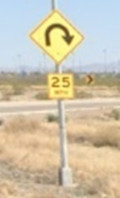
The Situation Analysis and Hazard Identification (ISO 26262 Part 3 clause 6.4.2). Each road classification and how it controls the flow of traffic defines the lowest possible risks for a road segment. Poorly designed road structures receive bad reputations from local residents. Really poor road segments are close to a situation and ready to tip into a precrash scenario at all times. For example, a 1957, short 25-mph (the actual sign) clover-lane entrance ramp to a freeway that has a posted speed of 65+ mph has an unsafe speed differential at all times. Every entrance with traffic on the freeway is a situation that is on the close edge of a precrash scenario. The 25 mph is a hard arc just before the freeway so only performance cars are equipped to race the corner at high speeds (~50 mph with tires whining). The AV would be the slow forward sudden emergent causing a rear end crash. The speed differential at insertion (zipper maneuver) is tragically unsafe. To make matters worse, it is a blind entrance where the freeway cannot be seen until 50 yards of entrance ramp remains. And it gets worse, the freeway exit ramp uses the same 50-yard entrance ramp as its exit ramp. The exit clover leaf is 25 mph shortly after the 50 yards. There is no way for an AV to plan a safe accelerating insertion. It is a specific risk that must be avoided at times. The only choices are to 1) accelerate as much as possible and be ready to drive on the trouble strip until an insertion can be achieved. If the AV stops, it will have to accelerate from a stop using the emergency strip anyway, or 2) stop, wait, and hope for a long open spot in the driver’s rear mirror. The AV must be able to safely manage this entrance if it is within the ODD. This is a third level mastery of function with low traffic (right of way driving) and a fourth level complex scenario with medium or higher traffic. The AV must know when there is a conditional moment of time where there are no solutions, the protocol for waiting, and the protocol for proceeding. Rush hour traffic causes a line-up of cars stopped on this ramp waiting to attempt to insert into 65+ mph traffic, from a stop, with less than 50 meters to accelerate. At the same time, some vehicles are trying to get past the stopped vehicles to exit. This is a specific point on the map that, until it is solved, must be “blacked out” as a path option between the hours of 7-8:30 a.m. and 4:30-6:30 p.m. (estimate from the study). This means that the AV cannot manage the risks so it avoids becoming a known cause of a precrash scenario and resulting crash. This should result in some type of geofenced blacked out of the entrance based on the AV’s estimated time of arrival to the entrance waypoint. The AV does not know this path is available and produces a safe solution (avoids known problems).
Describe the operational situations and operating modes in which an item's malfunctioning behavior may result in a hazardous event. Operating modes includes normal autonomous driving, car wash, being towed, maintaining position, parking lots, parking, through tunnels, over/under bridges, pulling into traffic, and so on, across all roads/drivable surfaces contained within the ODD.
Example situation: The AV is driving the right lane of a divided two-lane local collector at forty miles an hour. There is a bike path on the right side of the road lane. The road is divided with trees and bushes on the median and left lane turnouts for U-turns and left turns. There is a sidewalk to the right of the bike path. There are no bushes or parked cars to block the view of pedestrians or pedal cyclists. There are no pedestrians. A pedal cyclist is forward of the AV driving on the left-most edge of the bike lane closest/adjacent to the AV’s path. The pedal cyclist frequently enters the AV’s Lane by eight inches at most for short distances (5-15 yards). There is a pickup truck passing on the AV’s left 3.4 mph faster than the AV. The truck is a lane change constraint. A four-door sedan is 100 yards behind the pickup truck, in the left lane, driving 5.1 mph faster than the truck (a near-future left-hand constraint). Planning cannot find a statistically safe path to pass the pedal cyclist. It is forced to slow down. The AV must pass the pedal cyclist by a minimum 36 inches (a minimum safe distance constraint). The AV cannot move to the left. The pickup is riding the right side of their lane. The first event is a constrained forward path with no option for a lane change. The precrash scenario risk is to hit the pedal cyclist on the front right of the AV likely a front right corner contact. In this case a situation creates the match of the precrash scenario unless a correct response is applied. A forced emergent response, which this is not, would be to intrude into the pedal cyclist’s 36-inch minimum passing distance but never closer than a Cpk < 2.0. This would be an emergent response that has a very large 36 inches of extremely low risk distance. The AV must pass by 36 inches plus its capability of path distance (3σ_{x,y,z,v}) under normal driving conditions. Safety is always chosen over legal. The AV must understand the constraints and select the safest response. Only a sudden emergent could force the AV to authorize a risky or hazardous pass/stop. In an emergency, the AV could miss the pedal cyclist by a Cpk_{sc} ≥ 1.0 distance which might be 8 inches at speed. The normal lateral variation of the biker must be part of the equation so this would be a “move with the hazard if they encroach” maneuver emergency response. Moving away from encroachments must be included in all automatic safe transitions to safe responses or safety critical emergent escape path (1-move with/away path, 2-merge with safe/escape path). The risk is that the AV would be squeezed into a crash on its left.
Resolving a situation into a safe laminar flow is the optimal goal of a Response. In this situation, the safest AV response is to slow down and let the encroaching car pass before it moves over to make room for the pedal cyclist. After the left lane is clear, the AV must calculate a new Cpk ≥ 2.0 passing path (plus 36 inches) and drift slightly into the left lane while passing the Pedal cyclist. The 36 inches is to allow for normal bike variation while passing. Only drift with the pedal cyclist if they are going to intrude into the AV’s Cpk = 2.0 hazard variation. This response will either be before or after the four-door sedan passes the AV on its left. The AV has resolved a situation to resume risk free laminar flow driving. When a HazOb violates the AV’s right of way, the AV must be able to avoid a crash within its time-latency limits (technical functional safety requirement). Conclusion: There is a risk of forward and forward right crashes into pedal cyclists (two potential scenarios).
Vehicle Integrity. The driver/human caused crashes from NHTSA scenario address 94% of precrash scenario. The remaining 6% of crashes are caused by vehicle structural and electro-mechanical failures. Much of this 6% Can be addressed by autonomy. Drivers avoid almost all vehicle related failures well before a crash. The 6% not avoided are from the vehicle’s E/E, electromechanical, or structural systems that will degrade and fail. It includes the drivers who knowingly drive an unsafe vehicle as well as the drivers who are less sensitive to recognizing failures until they are catastrophic. Sometimes drivers cannot afford to maintain or even fix the vehicles they feel pressured/forced to drive. The vehicle cannot fully honor or produce some of the commands it receives. This results in unsafe vehicle responses to what should be safe and capable AV commands. When the vehicle fails, the AV cannot produce the expected commands from the AV and it is not the fault of the AV’s E/E. This does not include vehicle system functions required to directly support the AV’s system. These are all under the umbrella of autonomous driving (function tree hierarchy of system functions down to power and all electromechanical connections). The AV must detect all the structural and electromechanical safety faults detectable by a normal driver (technical functional safety requirement): Team – expert driver, mechanics, sensors, senor signal pattern recognition, dynamic control and planning once detection is validated and response determined.
An extremely good driver can detect small changes in the vehicle response to their commands. The vehicle must suffer a sudden and catastrophic failure to cause an expert to fail (e.g., catastrophic control-arm or a ball-joint failure at freeway speeds → control loss of a front wheel). The expert driver perceives by feel, sight, smell, and hearing the slightest change from norm. They are like a gymnast who has perfect center of mass, moment of inertia, and body control. The expert driver’s senses include the body in motion of the vehicle. Most of the time, the expert can identify the likely failing components.
To emulate the extremely good driver, the AV can monitor VLF responses for signs of degradation. The AV sends throttle, steering, and brake commands. The vehicle sends back sensor feedback from these commands. The IMU/GPS/RTK sensors and vehicle sensors provide a six-axis response feedback. TPMS sends the tire pressure from all wheels. The vehicle has sensors for measuring the actual steering wheel angle. The IMU measures linear acceleration on all three linear axis. The IMU measures rotational position, velocity, and acceleration around the three linear axis (x,y,z). Steering, throttle, and braking commands are controllable factors. These can be correlated to vehicle sensor feedback, the AV’s IMU/ GPS/RTK which each provides precise vehicle response feedback. This returns extremely clear statistical response models. Changes can be detected extremely quickly. Brake degradation to a given percent command can be measured. All normal responses can be modelled: changes in acceleration, deceleration, steering, and braking (the commanded functions) and their linear and rotational responses estimated. Drifts in these responses suggest that the vehicle is going through normal or unexpected degradations. When vehicle integrity is in question, autonomy of any type is in question. Time response, linearity of response, bias, and magnitude of these response can be monitored using statistical process control and significant shifts, drifts, and catastrophic changes can be detected with an extreme level of statistical sensitivity for both changes in the variation of response and shifts in expected value of response. The AV can detect and predict most of the vehicle level mechanical and electro-mechanical failures.
The vehicle’s steering, throttle, and braking E/E controls must send the AV their fault codes. The AV must know how each fault code affects the commands they receive. Consider as an example, a vehicle planned to enter traffic from a side street. There was plenty of time to cross traffic and turn left onto the road. The vehicle was extremely sluggish upon acceleration. It did not clear cross traffic as expected and was hit. It violated the right of way. Post analysis found that both right tires had low air pressure. The OEM’s safety strategy for an unstable vehicle caused by low/soft tires on one side was to limit the ability to turn aggressively and compress that side (roll over). Unfortunately, only a low tire pressure warning was shown. There was no engine warning. The driver had no way to know that a critical failure had already occurred likely during the last trip or while parked and the fault was never challenged. This required a safety limit of both acceleration and speed. If an AV knew of these limitations (fault code and the parameters of the limited function), it could take extra care with the first few accelerations until the new response was modelled. From that point, all future commands are predictable and the only maneuver the AV should perform is a safe park.
The stability management designed into the vehicle caused the crash. The vehicle stability controls must never compete with the AV’s commands. Antilock brakes MUST be allowed to perform and this must not cancel autonomy. They were invented for the sudden loss of friction risk. This will minimize but not eliminate a potential loss of control. Antilock brakes are an autonomy level 0 solution and is beneficial to autonomy. The dependency of autonomy on anti-lock brakes must be documented in the Item Definition. The other stability commands that the vehicle will send to steering, braking, and throttle must be turned off during L4/L5 autonomous driving. An L3 design might choose to interface with the vehicle’s stability controls to compensate for its lack of capability. This is in the legal portion of a DIA between autonomy development, the OEM, and the suppliers of braking, throttle, and steering systems.
Stability of vehicle response. Each VLF command creates a Newtonian linear and rotational reaction of and around each of three axis. There are six degrees of freedom. Three move directionally. The axial rotation stores and releases wasted rotational motion about each axis. It stores radial energy in the shocks, mounts, and frame of the AV. The body/frame changes shape while driving. When a vehicle’s 250 hp engine is replaced with a 600 hp engine, the engine will bend the frame and the vehicle will torque turn (skate board turn). The stored energy releases in either a dampened controlled fashion (shock absorber and spring) or it can become an uncontrollable path.
The AV can detect statistically significant changes and degradations (trends) of the linear and rotational responses. Statistically significant and sudden shifts or gradual degradation signals can link to specific fault codes and required responses. For example, “The front right corner’s suspension is structurally compromised based on excessive variation of travel as well as an average tilt that is unusually lower to the ground.” Any IMU can return this answer. The response would be to take slower left hand turns and monitor the degradation (derate turning). The degradation over time might predict an upcoming unsafe failure and the decision is to continue to drive and to stop at a safe place before an unsafe failure occurs. The AV could also automatically send the faults to home base and have a corrective action team initiate a fast response. An appropriate safety mechanism/response must be developed for each fault code. Response variables include but are not limited to: orientation, position, velocity, acceleration, tip-in/out AKA pitch (rotation around the lateral y axis), roll (rotation around the longitudinal or x axis), and yaw (the tendency of the AV to spin-out or jackknife and lose control around the z-axis).
Rotational metrics are measures of instability. The amount of time required to reach maximum rotation is a measure of a structure’s stiffness. This is the amount of time to fully load a structure with the wasted energy of rotational force. Once rotation is mechanically loaded, all energy in that direction creates linear change (longitudinal or lateral). The least controlled structure is free liquid. It behaves similarly to a broken stabilization spring/shock. It does nothing until a violent bang is created at the end of travel. A one-half full unbuffered liquid container carrier with 50,000 pounds liquid with a container weight of 10,000 pounds will accelerate as if there is no liquid. The liquid does not want to move. It is not forced to move. It is left behind. The vehicle will accelerate at 10,000 pounds trailer weight. The water will collect to the back of the container and slam into it with 50,000 pounds of force. The back wheels of the tractor above the king pin will be pulled off the ground and it will crash. This is caused by the axial rotation response about the y axis – tip in or a downward pitch where the front is pushed down and the back of the tractor is pulled up by the king pin. The time from 10,000 pounds to 50,000 pounds pulling weight is the measure of instability. There were two crashes and only one is called an accident. The vehicle caused the first collision with 50,000 pounds of liquid inside the container. The acceleration was wrong for open liquid which is stable with full container. This is a longer story. An AV can manage this.
Responses can be modelled and produce a path with known variation about its expected value (the path prediction of the next reading) up to the point where the vehicle is significantly worn out but not physically broken. This means, if the methods suggested in this article are mastered, the vehicle can drive with a statistically predictable level of safety. However, it might refuse to drive through some of the tight spaces it used to maneuver.
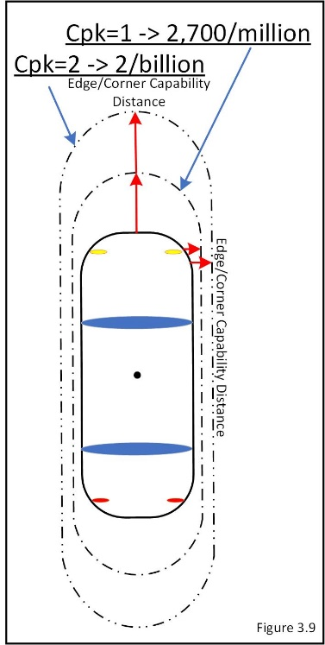
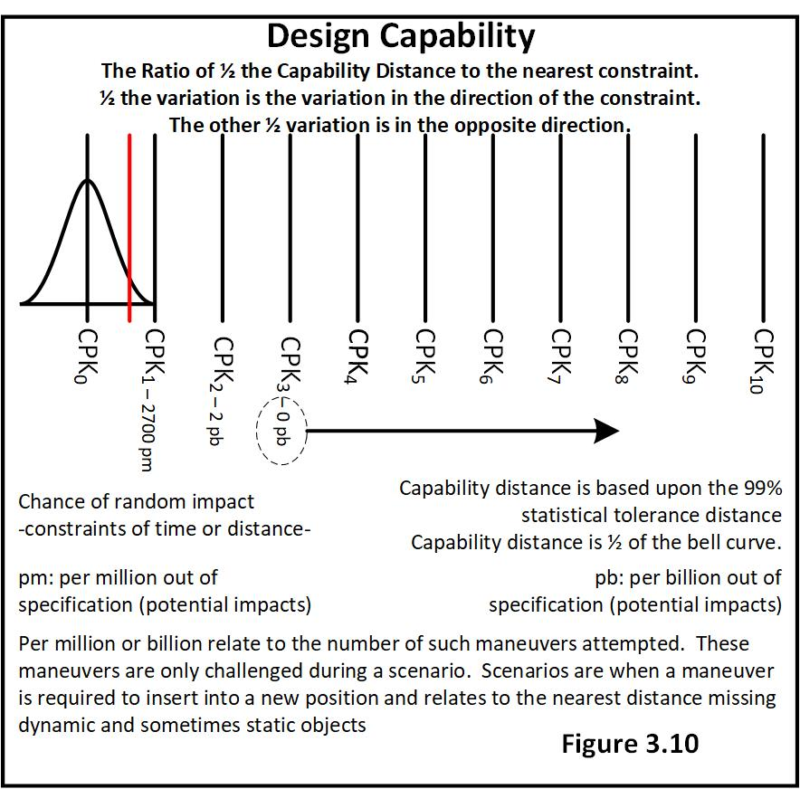
All safe passing and stopping distances pass and stop with a Cpk ≥ 2.0 (Figure 3.10). The distribution will have a central tendency, shape, and dispersion (spread). It can be modelled and predictions made. Variation extends in two directions from the mode. The capability of both normal and nonnormal distributions can be modelled and risk base equivalent capability calculated (Cpk = hazard distance/hazard variation). This way Cpk is a direct and comparative measure of risk regardless of its underlying statistical distribution. This point has been covered from many different directions. The reason is that team members must learn to view the domain through the eyes of expected position, response, and variation. They have to understand the factors that require change, and the capability of the change.
The AV is statistically wider and longer than its physical dimensions (Figure 3.9). So are HazObs and for the same reason. Each has a position with variation about a travelled path. Statistical uncertainty requires that a safe margin is placed about the AV’s physical dimensions. This turns into simple statistical calculations which directly infer risk. There are independent challenges of uninfluenced responses and there are affected responses or challenges given the behavior of something else (the | or “given that” between AV and HazOb). It answers the question, “What is the probability that the AV and HazOb will try to occupy the same physical space at the same moment in time, given that one of the two causes the other to react. The team must understand when the AV and HazOb behave independently and when they are no longer independent. This Cpk risk can be adapted/changed to support the safety culture of any company. The objective results of decisions must be safer than the NHTSA’s database of crashes. The same strategy ensures that the AV never loses control (stability prediction model).
The Adaptive Model. Capability must be dynamically modelled from recent/current response to VLFs. Vehicles degrade with time. Variation only increases with time. Maintenance removes the effects of time and energy so variation can be managed over time. However, assuming maintenance that affects safety is not realistic. Assuming variation that is out of context with reality is unsafe. Many owners do not maintain a vehicle per minimum requirements. The model needs to be able to adapt and update itself quickly as the vehicle ages and the load of fuel, passengers, packages/baggage change. These load/sudden changes can be detected by comparing the first 15-30 new trip linear and rotational responses to the model used at the end of the last trip. This is extremely important for trucking applications. A new trailer can be unfit for use. A new load might have been improperly placed. The load might come loose during travel and the truck will have to determine if instability is caused by road, wind, mechanical failure, or a loose load. Any statistically significant physical changes will be detected, if real. These are the combined mass of the AV, center of gravity (COG), and its moment of inertia (MOI). The MOI wants to resist rotating or continue rotating once started. It is the mass of the rotational energy equations. This would automatically recalculate the change in the AV’s total mass, COG, and MOI. A statistically significant change requires that a new model start with these 15-30 samples so stability predictions and vehicle rotational/linear responses are current and adaptive controls applied. The old model is statistically invalid. The AV must look for potential predetermined fault code violations, unless the resulting model change fits with normal and expected change categories (e.g., fuel, load, and so on). The dynamic model will ensure that capability will always be current and a Cpk = 2.0 is predictable and a broken AV will not be driven. The AV has expected acceleration, deceleration, braking, and steering profiles. Each of the three axial rotations are stable and can be modelled.
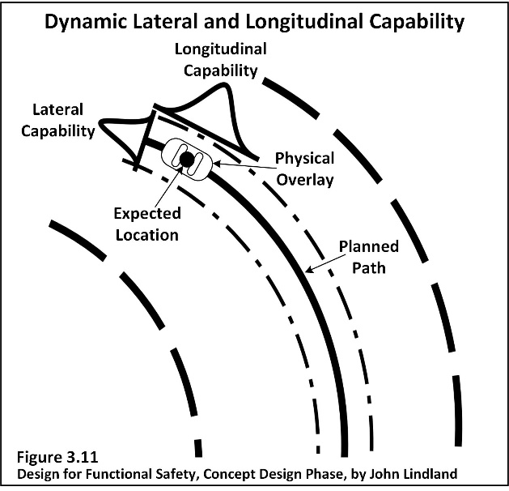
Figure 3.11 shows that at any moment in time (a function of time), the vehicle will have an expected location, velocity, acceleration, and orientation. This is the system’s statistical capability of being able to honor its safe right of way path. Generally, the GPS/RTK is the center point estimate of position. The physical location of the sensor is anchored to an oriented vehicle overlay of the vehicle’s size and shape.
The Safety Critical Metric can perform a safety validation review of every decision. This is a living revalidation of the five levels of Mastery of Function Levels 1-5. The AV is a perfectly instrumented lab that records all physical changes and degradations of the vehicle over its entire useful life. It even measures the variation reduction after being rebuilt. This is perfect recording of performance and reliability of every production vehicle. Mean time between failures. Every AV is a perfectly instrumented lab.
Reliability. After the five levels of mastery of function have been passed the AV is statistically safe for all defined risks. A final reliability test is needed to prove the results will be stable and predictable over time. Work with a reliability/statistical expert and determine an efficient final system reliability validation.
The following assumes that the System V-Diagram required validation of components before assemblies, validation of assemblies before system, validation of system outside vehicle. There are many reliability distributions that fit known applications. Reparable Systems -Exponential distribution, Mechanical assemblies, valves, and solenoids – Raileigh distribution, electronic – lognormal distribution, and so on. The question is what is a reasonable sample size to look for something that is in all likelihood not going to be found? This was extremely true for the Chrysler Pacifica Launch, which followed this strategy very well. Much of the automotive world uses the assumption of the Raileigh distribution and applies it to a system or assembled vehicle or a more complex AV. The sample size is based on the Raileigh distribution. The data is analyzed with a Weibull analysis which will fit the AV’s actual model (not assumed to be Raileigh for the analysis), unless it is log normal. The goal was to have and validate a decision model. The Raileigh’s sample size is “in the middle” the many different potential models. Its strengths and weaknesses are known and it has proven useful in practice.
How big does the fleet need to be and how many lives does it need to survive (the AV system, not the vehicle). The starting test is a Reliability of ninety five percent with a ninety percent level of confidence (R95:C90). It requires a fleet of 45 units each surviving one life with no failures. This is a required and final challenge of all new element relationships - mechanical, electro-mechanical, and E/E device interfaces through one life’s accumulation of energy. If all 45 units pass and if there are no indications of degradation or pending future failure, the test passes. Analyzing the variation of all safety critical functions at 0%, 25%, 50%, 75% and 100% of life and looking for function drifts and increases in variation is extremely powerful and statistically efficient (plot and review all results). The AV’s can automatically perform these calculations while it is in service (system design phase topic) and the company would actually have population statistics at all times on variation, degradation of function, and reliability. There is always a tear down and inspecting of each and every system element regardless of pass or fail. Teardown inspections are required to detect indications of damage accumulation over time. Do not tear down purchased components or E/E devices. These must have been validated at ISO 26262 and IATF 16949 automotive requirements before purchase. System-vehicle validation reliability is of the interface functions between elements. It is not what is inside a box. This will be covered in detail, with alternate considerations, in 7FM Design for Functional Safety, the System Design Phase.
What is one design life? It is the accumulated change cause by “in-use energy” which is the energy passed through a function with all heat created, and it is “environment in use” material attacks, heat damage, energy-flow/movement restriction accumulation and such created by degradation factors (temperature, vibration, chemicals, inert debris, radiated energy, etc.). Vibration is the number one degradation factor for electronics.
Is one life the warranty period of the vehicle? Is it the time between system rebuilds? Is it in Arizona the third week of July or Bemidji Wisconsin the last week of January? Is it when the system tells the user that it will complete the current trip and turn off (a predictive actual end of current life solution)? Where is the ODD and what are the automotive environmental tests for that region? Where will the design be challenged? How long must the design be free from unreasonable risks? If the solution will expand to all parts of a country, all final automotive environmental and degradation tests are required (OEM/SAE). It is unethical to validate and certify to one environment and apply the solution out-of-context to its validated environment. This would be viewed as “buying a safety certificate.”
AVs with safety drivers are not as safe as a normal driver. For L3-L5 solutions, the AV manufacturer not the drivers or other members of society, are responsible for all property damage, injury, and fatalities caused by the AV’s design release decisions, when it is significantly higher than the qualified safety and societies accepted level of risk (e.g., NHTSA).
In closing summary, this article covered a strategy to summarize/compress all ODD risks into sets of representative road segments, transition, and specific point risks. More importantly, everything the design must solve is documented and how it must be solved clearly defined. There are no “blank sheets of paper” or “bare screens” at which to stare. This is the single most important activity of any AV design. Define and understand what must be designed. Any well-defined problem is just about solved. Another extremely important point is that 7FM is an active process used to understand and create designs that are the best in the world. The practices begin with concept, are performed throughout all phases of the design, and are followed into production. The methods are seamless and no effort is wasted. 7FM is continuously applied throughout design and production. In other words, it is a continuous process. It is not a form that is filled out. Solid design, manufacturing, and production practices never stop. Perform this well and the total design time will be more than cut in half and wasted money and time will all but be eliminated.
Driving complexities/risks consider 1) laminar flow, 2) situational flow, and 3) turbulent flow (the start of a precrash scenario). Laminar flow is inherently safe driving. There is a smooth acceptance/obeyance of right of way rules and regulations. This is the third level of Mastery of Functions. Situations have the beginning pockets of turbulence caused by flow restrictions that evenly or unevenly collect into groups of HazObs. Turbulent flow is the moment that laminar or situational flow becomes one or more of the precrash scenario. Mastery of functions through all precrash scenario, sudden emergents, and weather is the fourth level of Mastery of Functions.
Severity and exposure risks are assigned from the NHTSA tables for vehicles, pedestrians, and pedal cyclists. The risk of vehicle level functions is the inverse of each function’s statistical capability and reliability. The HARA is the primary source used to develop the system-vehicle integration Design Verification Plan and Report (DVP&R). The DVP&R will produce explicit evidence that the AV is capable of safely defining and following a planned path even while experiencing each and every system level failure mode/fault state.
The HARA produces the understanding required to design a nearly flawless design from the start. The final and third part of this HARA series will provide a relational table that directly correlates every vehicle level function failure mode/fault state to their related precrash scenario (hazards). These will link to each function/failure sequence from sensors to VLFs.
Each form is a single study of a precrash scenario of a single representative sample. Each has exposure, severity, and controllability determinations as well as requirements for each element of the design. Potential responses are also documented. It has a secondary table that defines the information needed to fill out a police report as if a crash actually occurred. Each response to avoid or minimize risk has an individual safety goal. Individual safety goals form affinity patterns and become the AV Safety Goals and the full set of risks that must be addressed by the Functional Safety Concept. Once this has been completed, the team has an extremely strong starting point to engage the System Design Phase. An extremely strong resource requirements and design plan can be developed.

